Shabbos stories anthology for Chanukah
Printed L’iluy nishmas Nechama bas R. Noach, a”h
For a free email copy, please forward your request to keren18@juno.com

Compiled by Daniel Keren

Kislev 5779/November 2018
A Project of the Shabbos Stories for the Parsha begun in 5770/2009 and the Brooklyn Torah Gazette begun in 5777/2016

This anthology is being dedicated to my very good friend Shmuel Finck and his wife Miriam. Shmuel Yaakov ben Sara has recently been diagnosed with the dreadful ALS (Lou Gehrig’s disease.) Please read this anthology as a zechus for his complete recovery.

Chanukah Table of Contents

Shabbos Stories for Chanukah 5779……………Page 3
Shabbos Stories for Chanukah 5778………...…Page 36
Brooklyn Torah Gazette for
Chanukah 5778…………………………Page 60
Shabbos Stories of Chanukah 5777……...…….Page 77
Shabbos Stories of Chanukah 5777 – Part 2…..Page 91
Shabbos Stories for Parshas Mikeitz 5775…...Page 108
Shabbos Stories for Parshas Mikeitz 5774…...Page 110
Shabbos Stories for Parshas Mikeitz 5773…...Page 121
Shabbos Stories for Parshas Mikeitz 5772…...Page 136
Shabbos Stories for Parshas Mikeitz 5771…...Page 148
Shabbos Stories for Parshas Mikeitz 5770…...Page 165
Shabbos Stories for Parshas Vayigash 5775…Page 179
Brooklyn Torah Gazette for
Parshas Vayigash 5778………………Page 198
Brooklyn Torah Gazette for
Parshas Mikeitz 5777………………..Page 205

Shabbos Stories for
Chanukah 5779
Volume 10, Issue 16 25 Kislev 5779/ December 3, 2018
Printed L’illuy nishmas Nechama bas R’ Noach, a”h

For a free subscription, please forward your request to keren18@juno.comPri

Opinion| OP-ED CONTRIBUTOR (12/12/2017)
Lighting Hanukkah Candles Under the Swastika’s Shadow
By Daniella J. Greenbaum

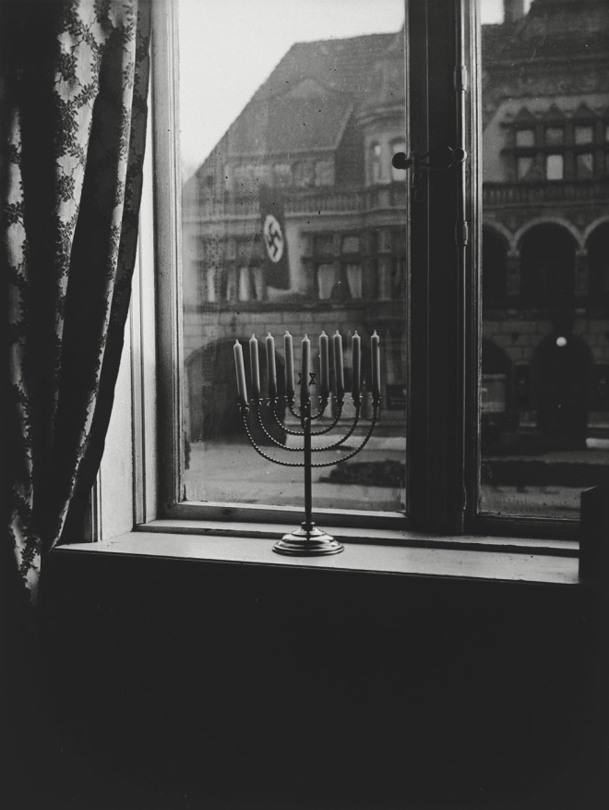
Photo Credit - Shulamith Posner-Mansbach/United States Holocaust Memorial Museum
Tonight, and for the next seven nights, millions of Jews around the world will light a menorah to celebrate Hanukkah. Akiva Mansbach will be one of them. But his isn’t just any menorah. In its multigenerational life, its light has also touched the darkness.
In Kiel, Germany, in 1932, Rabbi Dr. Akiva Posner and his wife, Rachel, lit the menorah and placed it on their window sill. Directly across the street was a Nazi flag.
One of the essential components of Hanukkah is “persumei nisa,” or publicizing the miracle — the miracle being the triumph of a small band of Jews, the Maccabees, who led a revolt and conquered their Seleucid persecutors in the second century before the Common Era. As tradition has it, when the Holy Temple was being rededicated and its golden menorah lit, there was only enough oil to last for one day. Miraculously, the small supply burned for eight.
The Talmud contains detailed guidelines of how to publicize the miracle, with extensive commentary on where the menorah would be most visible to people walking by. The rabbis also discussed foot traffic in marketplaces: They wanted to make sure that people lit their candles when pedestrians were flooding the streets.
There’s one more crucial detail the rabbis insisted on: In a time of danger, they said, the lighting of the Hanukkah candles can take place in one’s home, on one’s table, away from the gaze of the hostile outside world.
But this escape clause didn’t suffice for the Posners. In 1932, just before Hitler’s rise to power, their menorah shone brightly for all their neighbors to see. Its light — and the meaning behind it — was made all the more incandescent given the symbol of Jew-hatred hanging from the building across the street.
The poignancy of the juxtaposition didn’t escape Rachel Posner. She took a photograph of the menorah and the swastika. On its back, she scribbled in German, “‘Death to Judah’ so the flag says, ‘Judah will live forever,’ so the light answers.”
Rabbi Posner, Rachel and their three children left Germany for the Holy Land in 1933. Rabbi Posner managed to persuade many of his congregants to leave as well.
For 51 weeks of the year, the menorah belongs to Yad Vashem, Israel’s Holocaust museum in Jerusalem. But each year, right before Hanukkah, the family takes the menorah back and puts it to good use.
I spoke by phone with the Posners’ great-grandson, Akiva Baruch Mansbach, who was named for Rabbi Posner and lights the menorah every year. The significance of lighting it in his home in Beit Shemesh, Israel, so many decades after his ancestors lit it as an act of resistance, did not escape him. “The same light that my great-grandparents lit in the exile in Germany is the light that so many light today in Israel,” he told me. “It demonstrates the continuity of Jewish history.”
“Whether it’s the Greeks on Hanukkah or the Nazis in Germany, they want the same thing — to destroy the nation of Israel,” he added. The menorah symbolizes the strength and continuity of our nation, the idea that it is strong and will conquer all its enemies.”
On where that strength resides, Mr. Mansbach was unambiguous. “Until 70 years ago, we were in exile,” he said. “That exile ended with the establishment of the state.”
Maybe so. But many Jews still live in the diaspora, including more than six million here in America. Even now, we are lucky to live in a place where what constituted an act of defiance for Akiva and Rachel Posner can exist here as a quotidian exercise of religious freedom. But as the Hanukkah story also reminds us, that freedom can vanish almost overnight. In this year more than most, it needs to be defended against the old-new bigotries that would extinguish its light.
Daniella J. Greenbaum (@dgreenbaum) is the assistant editor at Commentary Magazine.

Reprinted from the December 12, 2017 website of The New York Times.

The Lesson of a Mesirus Nefesh Menorah
By Rabbi Yechezkel Tzvi Greenberg

A couple who had lived through the Holocaust wanted to forget their Jewishness, so they moved far away and changed their names, hoping that their children would never know they were Jewish.
When their son turned 13, the father promised to buy him anything he wanted for his birthday. They went shopping, and the son, to his father’s chagrin, was attracted to a Judaica store.
The boy set his eyes on an old menorah, and the father, afraid his son would build some connection to the religion he was hiding from, tried to talk him out of it, but to no avail.
“You promised me I could choose what I want!” replied the son.
When the father asked the shopkeeper for the price, he was told it’s not for sale; it was there just for show. The shopkeeper explained that in the ghetto, a Jew had placed himself in danger and crafted this menorah with his bare hands out of scraps of wood with tremendous genius and talent, so it was unique and too precious to sell.
The boy would not back down. “You promised!” he said, and the father kept raising his offer until the owner finally agreed to sell. When they got home, the boy had no idea what to do with it, and just played with it like a toy until it broke.
At first, his father, who had paid dearly for it, was furious, but eventually he decided if it was built with such wisdom perhaps he could attempt to put it back together. As they worked together, a small piece of paper rolled out from one of the branches.

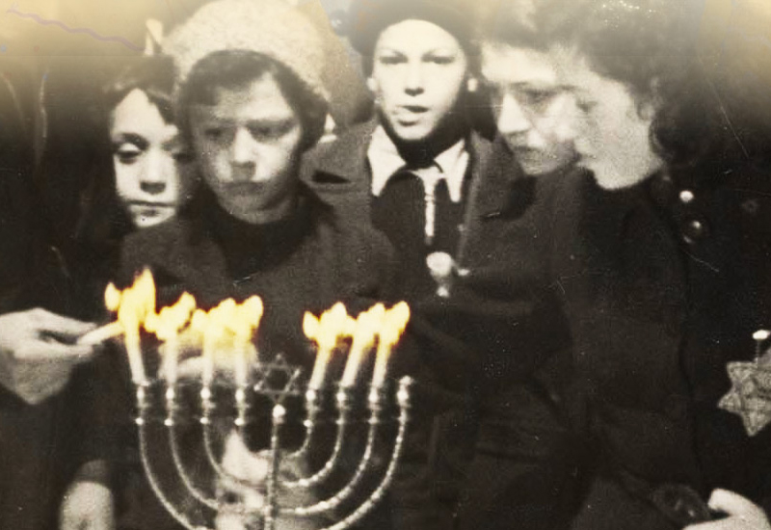

The father picked it up and started to read. Suddenly, he began to cry and then he passed out. When he was revived, he explained that the note was from the creator of this menorah.
“As I build this menorah,” it said, “I don’t even know if I’ll merit lighting it this year.” He asked that whoever finds it should realize how much mesirus nefesh went into building it, and should please learn some Torah as a merit for his soul. And then it was signed by the man’s own father!
Realizing the incredible hashgachah pratis (Divine Providence) that had to take place in order for his father’s note to reach him, he returned to his father’s ways and influenced his whole family to return along with him. (From Tiv Hamoadim on Chanukah, by Harav Gamliel Rabinovitch).
That family had potential, which was realized once there was a spark that ignited them to work on it.

Reprinted from December 13, 2017 edition of the Hamodia newspaper.

Celebrating the
Miracle of Chanukah
By David Bibi

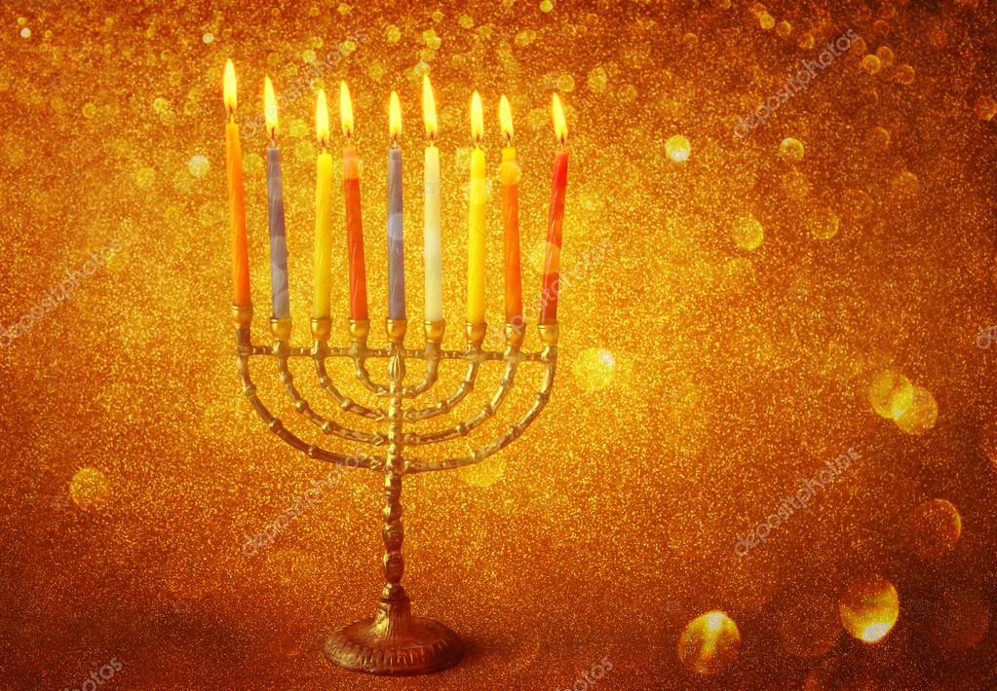

Let’s close with a final thought, one which really shows the difference between the Jewish people and the Greeks (and all mankind).
The Talmud teaches that Adam created in Late September noticed during the first three months of his life how the days slowly became shorter and shorter - He said: Woe to me, because of my sin the world is getting darker [as soon there would be no more light] and will return to a world of darkness and confusion. This must be my 'death sentence'.
Instead of accepting this imminent fate, Adam overcame his depression and took upon himself to fast, pray and repent. After eight days, Adam noticed that the days indeed had begun to lengthen. Realizing that this is 'minhago shel olam' [the way of the world or nature], he made a celebration for eight days giving thanksgiving to the Almighty. The next year, he made these days holidays.
The Rabbis explain that Adam had good intentions when making these holidays; however his offspring turned them into holidays of idol worship or better yet, nature worship. The Talmud tells us that this is the origin of Saturna and Kalanda which we explained eventually became Christmas and New Year’s Day.
The pagans celebrated this holiday as one of rebirth, of darkness into light and of the way of the world, of nature. This is the way of the world and this is reason to rejoice.
We too celebrate a holiday of light, where the flame can pierce and break the darkness, but in our holiday it is man who contributes, it is man who lights the flame and celebrates not nature but the miracle.
The world celebrates nature where the strong defeat the weak and the many oppress the few. They celebrate a world created and abandoned to the laws of the stars and of nature. The Jew celebrates a world where G-d is not only the creator, but He is intrinsically involved in our world. The Jew celebrates a world in which he is given a task and plays a role in perfecting it. The Jew celebrates his role in rising above the stars and the laws of fate.
We must remember that the hidden light, the Ohr HaGanuz hidden in the candles we light is also hidden within us and it’s our responsibility to shine for all the world to see.

Reprinted from the Parashat Mikess 5778 email of Shabbat Shalom from Cyberspace.
Candles Behind Bars
By Eli & Malka Touger

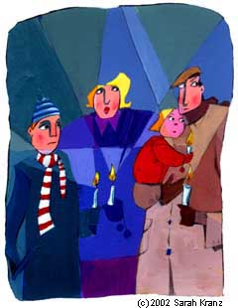

Rabbi Shabsi Katz, the Rabbi of Pretoria, the administrative capital of South Africa, and the Jewish Chaplain for the Department of Prisons in that country, maintained a relationship with the Lubavitcher Rebbefor many years.
In December of 1978, he came to visit the Rebbe for the third time. At a private audience with the Rebbe a few days before Chanukah, the Rebbe asked Rabbi Katz what was being done for Jewish prisoners in South Africa. Rabbi Katz explained that conditions in South African prisons were much harsher than in New York, but that Jewish prisoners were not obligated to work on Rosh Hashanah, Yom Kippuror Passover, and on Passover, they were given food certified kosher for the holiday by Pretoria's rabbinate.
The Rebbe asked: "And what about Chanukah? Can the inmates light Chanukah candles?" One must appreciate, the Rebbe said, how important it is for a person sitting alone in a cell to light a Chanukah menorah. One cannot fathom the warmth and hope this brings, and how this will uplift his spirits in such a dark environment.
Rabbi Katz promised that when he returned to South Africa he would begin working on the project, so that next year the inmates could light Chanukah candles. The Rebbe, however, was not satisfied, and inquired: What about this Chanukah?
Rabbi Katz pointed out that Chanukah was only a few days off. Since he was in New York, he doubted it would be possible to do anything. The Rebbe replied that as soon as their meeting ended, Rabbi Katz should use the telephones in the outside office to make any calls that were necessary.
Rabbi Katz then reminded the Rebbe that in South Africa it was four o'clock in the morning; at that hour, he dared not wake the general in charge of correctional facilities.
The Rebbe did not accept Rabbi Katz's reply, saying that, on the contrary, when the general saw that the matter was so important that he was called from overseas in the middle of the night, he would be impressed, and would appreciate the need for Jewish prisoners to light candles this year.
As soon as Rabbi Katz left the Rebbe's office, one of the secretaries led him to the small side office across the hall from the Rebbe's. He showed him the phones and told him to make himself at home.
Rabbi Katz first called his secretary in Pretoria to find the home number of General Sephton, who was a Dominee of the Dutch Reformed Church and Religious Director of Prisons. At the same time, he asked his secretary to call the general and tell him he would soon be receiving a call from overseas. And so, when he called General Sephton a few minutes later, the general was not upset, but instead, inquired how he could help.
Rabbi Katz explained that he had just completed a private meeting with one of the leaders of world Jewry, who had expressed concern about the Jewish inmates in South African prisons. The leader had explained how important it was for the prisoners to light Chanukah menorahs, and how this would bring them warmth, light and hope.
General Sephton was moved. In spite of the fact that his office was due to close that day — it was December 24 — he said that if Rabbi Katz was calling at that time of night from overseas, he could understand how urgent the matter was, and that as soon as he got to his office in the morning he would send a telex to all the prison facilities in South Africa telling them to make it possible for all Jewish prisoners in South Africa to light candles this Chanukah.
Next morning, when the Rebbe came to Lubavitch headquarters at 770 Easterm Parkway, Rabbi Katz was in the foyer. "Nu?" motioned the Rebbe. When he heard that the mission had been accomplished, the Rebbe gave him a broad smile and told Rabbi Katz that he wanted to see him after the morning prayers.
When Rabbi Katz entered the Rebbe's room, the Rebbe told him that there are 50 states in the US, and all but one allowed Jewish inmates to light Chanukah candles. "Would you believe it," said the Rebbe, "it is only here — in New York State — that prisoners cannot light menorahs for Chanukah!"
The Rebbe asked that Rabbi Katz see to it that the inmates of New York State prisons lit Chanukah candles that year. "Tell them what you did, that they should learn from South Africa, and do the same here," he advised.
Rabbi Katz did not know where to start; he told the Rebbe that he did not know whom to contact first.
"Rabbi J. J. Hecht has been working hard on this project, and will know whom to turn to," the Rebbe answered him.
When Rabbi Katz sought out Rabbi Hecht, it was Rabbi Hecht's turn to be astonished. He pointed out that it was December 24, and already past noon; nobody would be at their desks at that time. Could officials be reached at their office parties?
But after Rabbi Katz told him about his audience with the Rebbe, and his personal call to General Sephton in South Africa, Rabbi Hecht relaxed. Past experience had told him, he said, that if the Rebbe asked someone to do something right away, things worked out well even if the timing seemed bad.
After a few calls, Rabbi Hecht was able to locate the director of the New York State Correctional System, and found him in a jovial mood. Rabbi Hecht then introduced Rabbi Katz, who informed the director that Jewish prisoners in South Africa would be lighting Chanukah candles that year, and suggested that if this could happen in South Africa, surely it should happen in New York. The director agreed, remarking that if in South Africa, where Jews are such a minority, the prisons gave them permission to light candles, there was no reason why it shouldn't happen in New York. He promised to attend to the matter in time for Chanukah.
Rabbi Katz looked at his watch. It was several minutes before three, and the Rebbe would come out for the afternoon minchah prayers at 3:15. He hurried back to 770 and positioned himself outside the Rebbe's room. When the Rebbe came out for the afternoon prayers, he saw Rabbi Katz and motioned "Nu?" Rabbi Katz indicated that the mission had been accomplished. "I want to see you after minchah!" the Rebbe smiled.
Rabbi Katz was surprised. What mission would be waiting for him after minchah? When he entered the Rebbe's room, however, the Rebbe did not have another project for him. Instead, the Rebbe said that as he had done him a personal favor, he would like to do something in return.
Rabbi Katz was bewildered. He told the Rebbe that it had been a privilege and an honor to do what he had done. He had received so much in blessings and guidance from the Rebbe throughout the years that he certainly did not expect anything more.
The Rebbe did not accept this answer. So Rabbi Katz thought quickly, and asked the Rebbe for a Tanya (the book authored by the founder of Chabad, Rabbi Schneur Zalman of Liadi, and regarded as the "bible of Chassidism") for his son, who would certainly appreciate it. The Rebbe told him that one would be in the outer office shortly. When Rabbi Katz returned to pick it up, he found a Hebrew Tanya waiting for Rabbi Katz himself, a leather-bound, deluxe Hebrew/English Tanya for his son, "Challenge" (a book on Chabad) for General Sephton in South Africa, and "Woman of Valor" (an anthology of Chassidic teachings on women) for the general's wife.
When Rabbi Katz returned to South Africa, he called General Sephton. Before he could say anything, the general reassured him that he had sent the telexes the day he had received the call from America, and that the Jewish prisoners had indeed kindled Chanukah candles that year. When Rabbi Katz told the general that the Rebbe had sent gifts for him, the general said he would be right over to pick them up.
Indeed, within an hour, the general was sitting in Rabbi Katz's living room. Asked why he had hurried so, he replied that when a person sitting in New York thinks about somebody living on the other side of the globe — especially somebody imprisoned for wrongdoing — and seeks out someone to bring him light and warmth, he is a genuine leader.
"And if such a leader sends something for me, I want it as soon as possible," said the general.

Reprinted from the Chanukah 5778 website of Chabad.Org Magazine.

The Posner Menorah Painting: A Chanukah Story

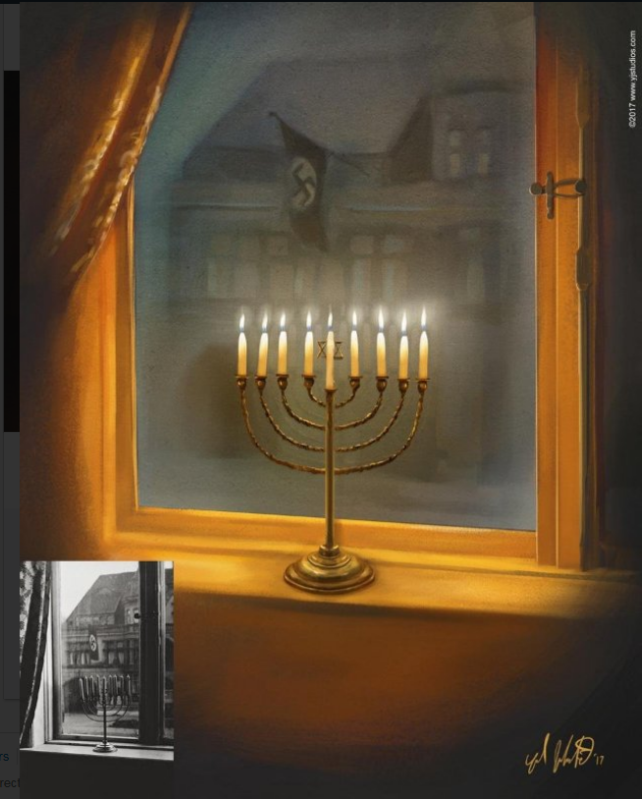

Yoel Judowitz is an artist specializing in illustration.
As Chanukah neared, he was inspired to paint a picture based on the famous photograph of Rachel Posner’s menorah, taken in Germany, 1931.
Mrs. Posner was the wife of Rabbi Dr. Akiva Posner.
She took a photo of the family Chanukah menorah from the window ledge of the family home looking out on to a building draped with Nazi flags.
She wrote on the back of the photo (in German):
“Death to Judah” So the flag says
“Judah will live forever” So the light answers.”
Mrs. Posner’s photo shows the menorah unlit.
Yoel imagined what the scene would have looked like that night with the brilliant light of the candles contrasting with the darkness and evil behind it.
He published the painting in his “Artist’s View” column in the Yated Ne’eman, and then posted it on his LinkedIn page.
The post quickly went viral.
People from all over the world reached out to express how touched they were by the dramatic scene. The Posner family contacted Yoel and sent him pictures showing how three generations of Rochel Posner’s children (all living in Israel) still light the menorah today.
Yoel explained what moved him to create the painting:
“Mrs. Posner’s photo is astonishing. The contrast takes your breath away. But I needed more. I needed to see what it looked like that fateful night, after it was lit.
I needed to witness that first moment in time, when Hashem disrupted darkness with two simple words that summarize the point of creation: “Be light.”
I needed to see the power of that light against ultimate darkness.
Baruch Hashem, the message of the painting has resonated with thousands of yidden of all levels of observance. The pintele yid is waiting to be reignited on Chanukah, you just need to add a little spark.”
High quality, affordable prints of this beautiful, inspirational painting can be purchased at:
https://society6.com/product/menorah-in-the-darkness_framed-print?sku=s6-8401417p21a12v52a13v54
LinkedIn Post here: https://www.linkedin.com/feed/update/urn:li:activity:6348068647197560832
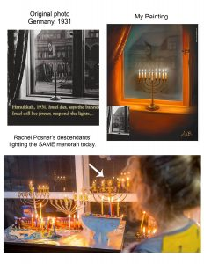 Reprinted from the December 20, 2017 website of Matzav.com
The Chanukah Spirit
By Rabbi Moshe Meir Weiss

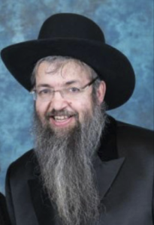

Each of our Jewish Holidays comes with a special message and has a distinct way that it impacts upon the life of every Jew. Rosh Hashanah and Yom Kippur are times of introspection and repentance; Sukkos and Pesach are seasons that strengthen our emunah, belief in Hashem, while Shavuos and Purim emphasize the supremacy of Torah in every Jew’s life.
The twelve New Moons of the year highlight our belief in the ability to always turn over a new leaf and also firm our conviction in the ultimate renewal of the world with the coming of Moshiach, speedily in our days. The Seventeenth of Tammuz with the ensuing three week period capped-off by Tisha B’Av, the saddest day of the year, train us to focus on the loss of our Temple, the sorry state of our exile, and the fact that G-d too is very unhappy with the state of affairs of His Jewish children.
But, what is the special message of the Chanukah festival? In what way should it impact upon us and our children?
The Gemora, in the second perek of Masechtas Shabbos, teaches us that when the Jews vanquished the Syrian-Greeks, we dedicated the Temple and experienced the fabulous miracle of the Menorah. Still, they did not declare Chanukah immediately. Rather, the Sages waited until the next year and only then established the beautiful holiday of Chanukah for all time.
The obvious question is why didn’t the Sages immediately declare the festival the very same year that the miracles occurred? The Kedushas Levi and the Sfas Emes both answer that the Chachomim, of blessed memory, wanted to experience for themselves the days of Chanukah when it came around the next year. Only in that way would they be able to divine what special powers lay lurking in the days of Chanukah.
When they experienced Chanukah in the next year, they found that the treasure that Hashem planted in the days of Chanukah was the special power and ability to praise and thank Hashem, and therefore the Gemora concludes that they established eight days of Chanukah for Hallel and Hoda-ah, praise and thanksgiving to Hashem.
Thus the special power of Chanukah is to aid us in excelling at the art of prayer. This makes Chanukah one of our most important national holidays since the posuk teaches us that the very reason that the Jewish People was created was to praise the Lord, as it states, “Amzu yatzarti li tíhilasi yísapeiru/I have created this nation to relate My praise.”
Indeed, Chanukah’s lesson is so fundamental that it was already planned from the beginning of Creation. This is why the twenty-fifth word in the Torah is the word ohr, light, to hint to the fact that there will come a time when, on the twenty-fifth day of Kislev, there will be the great miracle of light.
The month Kislev is spelled chof-samech-lamed-vov. These letters can be rearranged to spell the two Hebrew words, soch lo, which means a total of thirty-six.
This is very fitting since the sum total of candles that we light on Chanukah is thirty-six. But the words soch lo also mean to gaze to Him, which is also very fitting since this is the meaning of Chanukah: to focus on praising and thanking Hashem.
Furthermore, the sign of the zodiac of the month of Kislev is the keshet, the bow. This is very appropriate since the rainbow is the sign that Hashem hearkened to the prayers and sacrifices of Noach and promised to never again destroy the world. Furthermore, the Targum Onkelos translates ubakashti, and with my bow (mentioned by Yaakov Avinu), as ubiva-usi, with my prayer, further proof that the bow is linked to prayer.
The Heroes of Chanukah also point to the message of prayer. How unlikely that the Kohanim, whose sole job was ministering to Hashem and to the spiritual needs of our people, would all of a sudden become masters of artillery and at vanquishing generals. But the Kohein is the symbol of Divine Service, ambassador of our connectivity with Hashem. Thus it was very appropriate that Hashem should use them as the agents of our miraculous delivery since He wanted to herald in this festival the special message of servicing Hashem through the medium of prayer, our alternative to the Divine Service in the Temple.
In a similar vein, Rabbeinu Ephraim explains that the term tzadikí refers specifically to one who excels at prayer. We know the Chanukah enemy was Yavon, the Syrian-Greeks. When we add the letter tzadikí to the beginning of the word Yavon, presto, we come up with the word Tzion, portraying vividly how the power of prayer led Zion (the Jews) to conquer their Greek enemies.
The Kitzur Shulchan Orech teaches us that eating on Chanukah is not a seudas mitzvah, a meritorious banquet, unless we accompany the meal with zímiros, songs to Hashem. I believe this unusual requirement is for the following reason. Eating is not really a fitting celebration for Chanukah since it was part of the ways, through sumptuous feasts and banquets of wine, which the Syrian-Greeks succeeded in Hellenizing many Jews. However, if we synthesize the eating with songs to Hashem, then it bears the appropriate message for our Chanukah festivities.
As we reach the awesome day of Zos Chanukah – which is considered to be the final seal of judgment, I would like to wish all of my wonderful readers and their families, that we all be blessed with good health, happiness, and everything wonderful.

Reprinted from the December 14, 2017 website of The VUES.
Get Through Chanukah Safely – No Miracles Needed

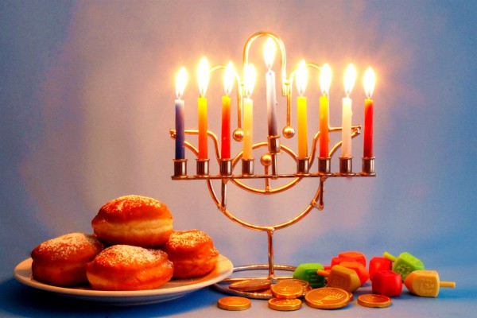
MDA Teams Are Highly Prepared to Respond to Chanukah-Related Emergencies; To Prevent Unnecessary Injuries Follow MDA’s Safety Guide and Adhere to Our Preliminary Treatment Instructions

Every year Magen David Adom EMTs and paramedics respond to a variety of Hanukkah related injuries that stem from holiday customs such as eating sufganiyot (jelly donuts), cooking with boiling oil, burns from Chanukah candles, accidently inhaling various objects, and more. Adhering to MDA’s safety instructions could prevent the next emergency. Below is our full safety guide including treatment.
Below are Safety Guidelines and Preliminary Treatment Instructions

Burns:
– Do not use an unstable Menorah, a makeshift Menorah, or one made out of flammable materials (Menorahs made during arts and crafts at kindergartens and school are usually made out of flammable materials).
– Place the Menorah on a stable, nonflammable surface. Avoid placing it on table cloths, papers, newspapers, near curtains, etc.
– Do not walk around carrying a lit Menorah.
– Make sure the Menorah isn’t exposed to wind as it could knock it over and cause a fire, or blow flammable objects at it.
– Keep the Menorah, lighters and matches out of children’s reach.
– It is prohibited to leave lit candles without adult supervision.
– Children under the age of 14 must only light candles under adult supervision.
– In order to prevent face burns, make sure to keep children with long hair away from the Menorah at all times.

Treatment:
In case somebody’s clothes catch fire, keep them away from the source of heat and roll them on the ground, you can also use a blanket to suffocate the fire. Simultaneously, call MDA at the 101-emergency line or through the “My MDA” mobile app. Take the patient’s burning clothes off, rinse them with running water, hold the burned area under the water (do not use cold water, ice or ointments).

Fried Food:
– While cooking with boiling oil, use the back of the stove and watch the pot while you cook.
– Turn the pot handle backwards so that children can’t grab it or bump into it.
– Do not spill water on boiling oil, if needed, cover the pot or the stove with a wet towel.
– It is recommended not to heat sufganiyot in the microwave as the jelly inside them may become very hot quickly and cause burns. If you do, pay attention to the temperature. Make sure to avoid touching sufganiyot and levivot with bear hands as the oil inside them may cause burns.

Treatment:
In case of a topical burn, rinse it with running water, do not apply any sort of materials to the spot as it may worsen or infect it. Avoid popping blisters for the same reason. Call MDA via the 101-emergency line or through the “My MDA” mobile app.

Prevent Asphyxiation:
– Sufganiyah dough could be dangerous for little kids, the elderly and others suffering from swallowing disabilities – cut them to small pieces and watch the person as they eat
– Keep small dreidels away from infants before the age of five, the same applies for chocolate coins commonly handed out on Chanukah

Treatment:
If the injured individual is able to speak or cough, encourage them to cough only (and not speak), and simultaneously, call MDA’s emergency line by dialing 101, or through the “My MDA” mobile app, and request an ambulance. In case the patient isn’t able to speak, cough or breathe:
– Conscious: call MDA at 101 and request an ambulance, check their mouth and apply compressions to their stomach
– Unconscious: call MDA at 101 and request an ambulance, adhere to the security instructions of the EMTs and paramedics at the dispatch venter until the arrival of MDA teams to the scene
When it comes to children and infants, if possible, turn the child over and pat their shoulders in addition to the aforementioned instructions.
One may use the accompanying scan to access the Google app page for the My MDA App.
(Editor’s Note: In America instead of calling MDA, call Hatzolah or 911.)

Reprinted from the December12, 2017 website of Yeshiva World News.

Lighting the Menorah in the Synagogue in the Morning
By Rabbi Eli J. Mansour

Description: Chanukah- Lighting in the Morning in the Synagogue
There is a Minhag (custom) to light the Menorah every evening in the Bet Knesset, without a Beracha, to commemorate the miracle of the Menorah in the Bet HaMikdash. Many people are not aware that the custom also mandates lighting the Menorah again in the morning. This parallels the lighting of the Menorah in the Bet HaMikdash which would remain lit until the morning. This is especially appropriate according to Rambam who holds that the Menorah was relit each morning.
This custom is recorded by the Peri Megadim (670:1), Nahar Misrayim, Ohr Lesion (4:42:9). This custom applies only to a Bet Knesset, which corresponds to the Bet HaMikdash, not to a private house.
Just as with the regular Hanukah light, it is prohibited to derive personal benefit from the candles in the Bet Knesset. The Mishna Berura (Rav Yisrael Meir Kagan of Radin, 1839-1933), in Siman 674, holds that even the Shamush candle of the Bet Knesset is holy and may not be used for non-holy uses. He also brings down that the candles in the Bet Knesset should not be removed from their place for the first half hour.
SUMMARY: The custom is to also light the Menorah in the Bet Knesset every morning of Hanukah.

Reprinted from the December 12, 2017 email of the Rabbi Jacob S. Kassin Memorial Halacha Series.

Let Your Kids
Enjoy Chanukah

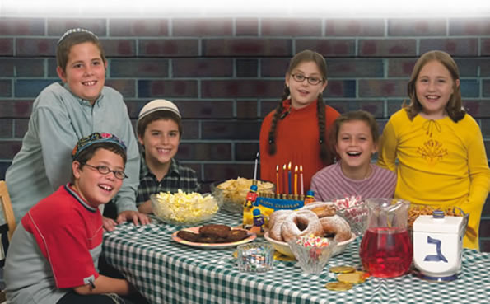

Photo reprinted from the Chabad.Org Chanukah Guide.
The Australian Version
Of the Broken Bottle
Of Chanukah Oil

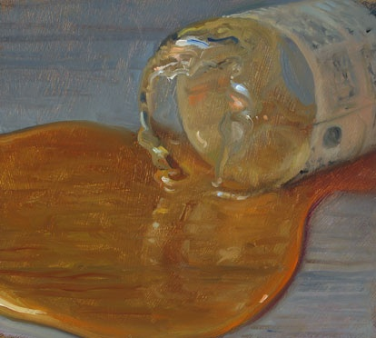

Fifty years ago, a Yid from Eretz Yisrael arrived in Australia, but he didn’t know anyone, and he didn’t know where he could go for Shabbos. He came upon a plan to go to a fish store on Friday morning, and if he sees someone buying a large fish, he would assume that this is probably a Yid, and he would ask him ifhe could go to his home for Shabbos.
The planned worked. He approached a customer who was buying a large fish, and discovered that he was indeed a Yid. He asked him whether he can stay with him for Shabbos. The man said that he would be glad to do the mitzvah of hachnasas orchim, and he brought him to his home.
And what a home it was! The Yid from Eretz Yisrael never saw a house like that before. It was enormous and beautifully designed. It was obvious that his host was very wealthy. They spent a very pleasant Shabbos together, singing zemiros and speaking divrei Torah.
On Motzei Shabbos, he thanked his host, and said that he has one question. “Go ahead,” the man replied.
The guest said, “Why do you keep a broken oil bottle in your china closet?” The guest had noticed that the china closet, which was filled with silver items, fine china and crystal, also had a broken oil bottle, which appeared totally out of place. He wanted to know its significance.
The man replied, “This oil bottle is the story of my life. My father died when I was young, and I had to support my mother. I tried my hand in business and baruch Hashem I was very successful. But together with my financial success came my spiritual decline.
“The first thing that went was my kappel (yarmulke) and gradually I dropped all the other mitzvos. “One day, I saw a young child crying. Since I was an orphan, I knew what it means to cry. I asked the child what was bothering him. “He said, ‘My father gave me money to buy olive oil for Chanukah and he warned me to be careful not to break the bottle since he doesn’t have money to buy another one. As I was walking home with the olive oil, a cat ran towards me. I ran away from the cat, I fell, and the bottle broke. That’s the reason I’m crying. How can I face my father without the bottle of olive oil’?
“The child’s words went straight into my heart, because I realized that I should be asking myself the very same question, ‘How can I go to my father without olive oil, and without the mitzvah of Chanukah licht?’ I saw my father light Chanukah licht each year. The mitzvah of Chanukah isn’t foreign to me. How could I stop?'
“I gave the child some money and said, ‘Buy two bottles; one for your father and one for me,’ and I took the broken bottle for myself. That year, I lit Chanukah licht. Immediately after Chanukah, I began keeping Shabbos. Then I started wearing tefillin. And now I am Torah observant Jew, with a beautiful family, all of us following in the ways of my father.”
This is an example of the power of teshuvah which is readily available for us on Chanukah.

Reprinted from the Parshas Mekeitz-Chanukah 5778 email of Torah Wellsprings: Collected Thoughts from Rabbi Elimelech Biderman. (Editor’s Note: There are many versions of the above broken bottle of Chanukah oil story, some going back to the 17th Century and the locations have varied from Persia to many countries where Jews have lived in Europe. This is the first time I read of this teshuvah inducing incident occurring in Australia.)
Story #1044
The Patient Menorah
From the desk of Yerachmiel Tilles
editor@ascentofsafed.com

One morning during Chanukah of 5773 (12/72), a group of junior yeshiva students including Shmuel Lipsch set out to the Golan Heights to bring the light of Chanukah and other mitzvot to the residents of many of the small scattered communities there. After a long afternoon and evening of hard work and bright success, when they finally departed for home it was nearly ten o'clock at night.
As they approached the highway exit to the town of Hatzor - 15 minutes before Tsfat - they decided to detour to the large shopping center near the exit, to spread the light of Chanukah there too. As they went from one shop to another, they came upon a store where positioned on a shelf near the plate-glass window was a Chanukah menorah, set up with the proper number of candles for that night, but as yet unlit, as if it were waiting just for them.
The students entered together. Immediately the shopkeeper approached them and welcomed them with great joy. "I was praying you would come. I know that the Chanukah lights bring blessing to my business. I would never let the menorah go unlit, not even one night" she added enthusiastically.
The teenage boys were puzzled. "It's already quite late at night. Why did you wait for so long for someone to come? Why did you not just light the candles yourself?"
"Because," she smiled, "I am not Jewish.
"I am a Druise woman," she continued. "I live in the Druise village of Tuba az-Zanghariyya."*
Not only were the boys surprised by her answer, they were more confused than before. "Why are the Chanukah lights of such significance to you if you are not Jewish?"
She related to them at length and with great sincerity why the lighting of the Chanukah menorah was so important for her. From the content of her words the yeshiva students grasped instantly that the lights were not just an "aid" for her business; it was clear that she was well aware that the fulfillment of a commandment brought an increased relationship to the Commander, to the Creator of All.
Indeed, the spiritual sensitivity revealed in her reply led the boys to suspect that perhaps she had a connection to Judaism beyond the mitzvah of Chanukah. They began to question her about her background.
It did not take more than a minute to verify their hunch, as in answer to their first question, about her family, she innocently revealed that her mother was Jewish! (In the Muslim world, religious status follows the father, so she never had a clue that she herself is Jewish according to Torah law.)
The young boys explained that through her mother she too possesses inside her the unique G-dly soul of a Jew, and therefore she is 100% Jewish. It must be, they added, that her strong commitment to having a lit menorah on the eight nights of Chanukah each year was caused by her divine Jewish neshama-soul burning within her, seeking to express itself.
Her reaction was pure happiness. She asked to clarify whether her sisters and brothers are Jewish too. With great emotion she proclaimed that she would tell all her siblings that she is Jewish and that they are also. She thanked the boys profusely.
That night the menorah of the store was lit and the blessings were said by a proud Jewess, newly ready to take her part among the Jewish people.**
Source: Translated and adapted by Yerachmiel Tilles from an article by Rabbi Yitzchak Lipsch (the father of Shmuel in the story) published in "Lubavich": the weekly newsletter of the Chabad community in Tsfat (Dec. 12, 2012).
** R. Lipsch's note: The boys too were proud (including my son Shmulik); they had been instrumental in bringing one more lost soul back to its roots, their mission as young chasidim of the Lubavitcher Rebbe.
* Translator's note: Tuba az-Zanghariyya is less than a half-hour's drive from Tsfat, and even closer to Hatzor. It is located close to Kfar Nassi.

Reprinted from the Chanukah 5778 email of KabbalaOnline.com, a project of Ascent of Safed.
Corsica Just Had its
First Public Hanukkah Celebration, Focal Rabbi Says

(JTA) — Corsica saw its first public celebration of Hanukkah in its recorded history, according to the French Mediterranean island’s only rabbi.
The event took place in the central Foch Square of the capital Ajaccio on Tuesday, the last of the Jewish holiday’s eight days, on which Jews light menorahs with candles, the Corse-Matin daily reported.

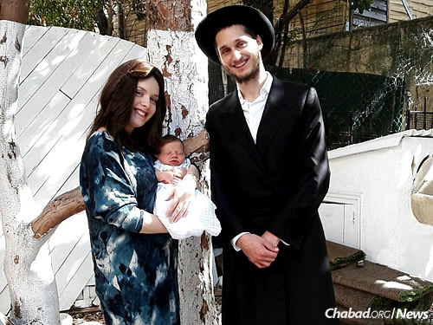
Rabbi Levi and Mushky Pinson Chabad emissaries and only Orthodox Jewish Rabbi on the island of Corsica.

“This has been the first time in the history of the Island of Beauty that the Hanukkah menorah was lit in public,” Rabbi Levi Pinson told the daily, adding it is “a historic moment.” Pinson, 27, and his wife, Mushky, opened the country’s first permanent Beit Chabad – that Hasidic movement’s term for a Jewish community center and synagogue – last year.
Ajaccio Mayor Laurent Marcangeli said he was “proud to be the first mayor of any city in Corsica to permit the lighting of candles in public,” as he put it. He said it was “an important message of tolerance.”
Several hundred people attended the candle lightings, including Jews who traveled there especially for the ceremonies from the southern mainland city of Nice, located 120 miles north of Ajaccio. “I have to say I sort of expected to see only 20 people here this evening,” Nice resident Alain Schraub told Corse-Matain. The local Jewish community of a few dozen people is “small but dynamic,” he said.
Yvonne Malka Cohen, whose parents settled in Corsica in 1919 said that for her, the candle lighting was “the biggest celebration” she’s ever seen at Fosch Square.
Roni Barkats, a local barber and member of the Jewish community, attended Tuesday’s ceremony while wearing a kippah and singing Hanukkah songs. He told the Corse-Matain daily it was a “moving experience.”
Whereas on mainland France anti-Semitic attacks have become routine, with hundreds of incidents reported annually, “you never experience anything like that here,” Barkats said. “Jews here live in security.”
Corsica was the only region in France whose authorities, operating under the Nazi puppet Vichy Government, refused to comply with orders to round up and deport Jews to be murdered. Thousands were saved thanks to authorities turning a blind eye to the presence of refugees and local Jews, and then falsely reporting to headquarters that Corsica had no or very few Jews.

Reprinted from the December 21, 2017 dispatch of the JTA (Jewish Telegraphic Agency).

A Lost Midrash, Antiochus IV, and the Historical
Context of Chanukah
By Rabbi Yair Hofman

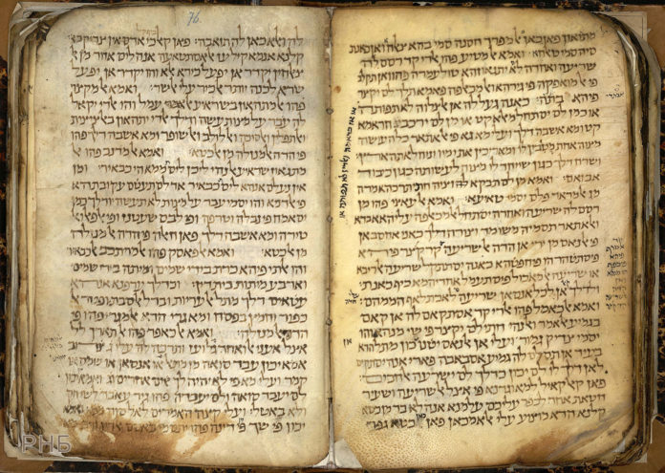

It is a sad fact that over 90% of our Midrashim have been lost. This is due primarily to the seizure of manuscripts and seforim by the Catholic Church in Europe. How do we know that this is the percentage that was lost? The answer is that it can be culled from a statistical analysis of the sheer numbers of Midrashim quoted in the Drashos of the Rishonim that are simply not there. Nine out of ten times that a Rishon cites a Midrash – it is not to be found.
Below we find a Midrash cited by the Bach that can only be found in in Eisenstadt’s Otzar HaMidrashim (p. 93). Boruch Hashem, this one was not lost entirely, but others, unfortunately were.
The Bach writes (Orech Chaim 670:4):
“That evil one [Antiochus] decreed to abolish the Korban Tamid and he further said to them: They have one particular practice in their hands – if you abolish it from their hands, then they will already be lost. Which practice is it? The lighting of the Menorah – as it states, “l’haalos bah ner tamid – to light in it a constant lamp – there is a drasha the entire time that they will light it, they shall be constant – they shall always endure.
They then went and made impure all of the oils. When Klal Yisroel returned and did Teshuvah risking their lives for the Avodah – then Hashem saved them. This happened through the Kohanim – those that served Hashem. And then a miracle happened also with the lamps.”
This author would like to suggest that the Midrash fits quite nicely into some of the historical background of Chanukah. Antiochus’s brother was the Seleucid Greek ruler who had reigned before him. His name was Seleucus the IV Philopater. It seems that Seleucus the IV, actually had much respect for the Beis HaMikdash. He gave gifts to the Beis HaMikdash and initially allowed an exemption of his tax revenue – any Korban brought to the Beis HaMikdash. The sources indicate that it was not just him who esteemed and gave gifts to the Beis HaMikdash – his predecessors did as well.
Eventually, Seleucus IV fell under extraordinary pressure. He had lost a war with Rome and had to pay them war debt. He sent his minister Heliodorus to the Beis HaMikdash to collect money out of its treasury. In the years before the rise of Antiochus Epiphanes IV – the villain of Chanukah, Heliodorus succeeded in getting that money out of the Beis HaMikdash treasury. When he returned from Yerushalayim back to Seleucus IV – Heliodorus assassinated him!
Heliodorus then took the throne for himself. Seleucus’ son should have been the true heir, but he was being held back as a hostage in Rome. Eventually, Seleucus’s brother, Antiochus Epiphanes, pushed out Heliodorus and took over the Seleucid Greek Empire himself. He implemented the Hellenization process ever further.
By the way, Antiochus’ original name was Mithridites. He ruled from 175 BCE to 164 BCE – a total of eleven years.
The point is that, initially, his family had some respect for the traditions of the Jewish people – to the point where they themselves gifted items to the Beis HaMikdash and exempted the Korbanos from taxes. The Midrash that tells us how Antiochus was aware of the efficacy of the Korban Tamid as well as the lighting of the Menorah – now further sheds light on the historical context behind the pre-history of Chanukah. We can also see why he may have been especially concerned with Rosh Chodesh, Bris Milah and Shabbos.
The war itself encompassed many miracles of the nature of gibborim b’yad chalashim. When we recite the Al HaNissim let us keep this in mind. Imagine, for example, a group of Green Berets (or perhaps even better, the New England Patriots) playing tackle football with a group of Kollel yungeleit who are masmidim – and that the Kollel yungeleit wipe the floor with them. This is the level of the miracle.
The Chashmonayim first embarked upon a series of guerilla warfare attacks on the Greeks. They then embarked upon a series of seven battles. These battles were: the Battle of Wadi Haramia (167 BC), the Battle of Beth Horon (166 BCE), the Battle of Emmaus (166 BCE), the Battle of Beth Zur (164 BCE), the Battle of Beth Zechariah (162 BCE), the Battle of Adasa (161 BCE), and the Battle of Elasa (160 BCE).
In the Battle of Adasa, General Nicanor was defeated and killed. This day, the 13th of Adar, was declared a special day by Yehudah Maccabee (See Megilas Taanis). Later it was rescinded after the destruction of the Beis HaMikdash.
The Nesivos Shalom explains that the Gemorah (Shabbos 21b) cites the passage in Megilas Taanis that the Greeks entered the Haichal and made all the oil impure. When the Chashmonayim became strong and defeated the Greeks, they searched and could only find one flask of oil with the seal of the Kohain Gadol. The next year they established it as days of Hallel and thanks.

THREE QUESTIONS
1. This Gemorah requires explanation, because it indicates that the essence of the holiday was on account of the miracle of the flask of oil – and not on the miracle of the military victory – where the mighty were delivered to the hands of the weak. Why is this so?
2. The Maharal’s question in his Sefer entitled “Ner Mitzvah” also needs to be addressed. Just because a Mitzvah was miraculously not neglected – we make an entire holiday of Chanukah with Hallel and thanksgiving for it? Hallel and thanks are only said for a miracle where we were saved – not over a fulfillment of a Mitzvah!
3. We must also understand why the Mitzvah of the Chanukah lights is specifically when the sun sets, as opposed to other Mitzvos where the Mitzvah is primarily in the day.
THE ANSWER
One can answer all this with the following idea: The main war of the Greeks in their attempt to destroy us through the fact that they darkened the eyes of Israel. They knew that it was not through military victories that they can succeed in ruling over the nation of Israel. Rather, it was through their darkening of our eyes.
AS IF THEY ARE DEAD
Just as a blind person is considered as if he is dead in matters of gashmius – physicality – even if he has all of his limbs intact, so too in matters of the spiritual. Even though he is involved in Torah and in Avodah, if he is considered among those who are “a nation walking in darkness – not seeing light” (See Yishayahu 9:1) – he is considered as if he is dead.
THE LIGHT
The purpose of creation is so that people will see the Divine Light of Hashem that shines as a bright light throughout the creation. As we find in the very beginning of creation itself, “And the world was null and void and darkness was upon the void. And Hashem said, “Let there be light.. And Hashem saw the light – that it was good.” This light was not a physical light, rather it was a Divine Light. With this light, man can see from one end of the universe to the other.
The response to Tohu vavohu is this – “Let there be light” – that a person can see with this light that the entire world is Hashem’s G-dliness – Ain Od Milvado – there is nothing else beside Him. The entire Creation is solely of His Power -as it says (Nechemia 9:6), “V’Atta mechayeh es kulam – And You give life to them all.
A UNIFIED WORLD
From this perspective, where he sees the power of the Creator throughout the entire world – he does not see a separate and divided world where all things are separate. Rather, everything is one – held together by a supernal power that sustains everyone and everything. There is, thus, no place for Tohu vavohu and darkness.
This was the essential battle of the Greeks – they darkened the eyes of Israel. They knew that the nation of Israel has no continuity through this Divine light and perspective. If this light is not present – any nation or people could have dominion over them. Their tactic was thus to darken the eyes of Israel.
This is what the Midrash (Bereishis Rabbah 2:4) has to say on the pasuk “V’ha’aretz haisa Tohu vavohu –
• Haisa Tohu – this refers to the Babylonian Empire
•Va’Vohu – this refers to the Persian Empire
• v’Choshech – this refers to the Greek Empire which darkened the eyes of Israel with their decrees.
• Al P’nai Tehom – this refers to the Evil Empire (Rome) whose depth of evil cannot be fathomed just like Tehom – the abyss
• V’ruach elokim merachefes al pnai hamayim – this is the spirit of Moshiach.
It further states in the Midrash (Bereishis Rabbah 44:17) regarding when Hashem revealed himself to Avram in Parshas Lech Lecha (Bereishis 15:12), “And it was when the sun was going down, a deep sleep fell upon Abram; and, lo, a dread, a great darkness, fell upon him.” This great darkness was Yavan – the Greeks who darkened the eyes of Israel with their decrees.
From these statements of Chazal, we see that this was the essential nature of Yavan – to darken the eyes of Israel, that they should know that through that darkening of their eyes they will be able to defeat them.
The light of the Menorah is a Divine light that shines forth from the Menorah to light up the hearts of Bnei Yisroel when they see it. The Greeks, therefore, abolished the light of the Menorah of the Beis HaMikdash and they specifically made all of the oils impure– in order to destroy them. It is as the Bach writes (Orech Chaim 670:4) citing the Braisah [See Otzer HaMidrashim Eisenstadt p. 93]:
“That evil one [Antiochus] decreed to abolish the Korban Tamid and he further said to them: They have one particular Mitzvah in their hands – if you abolish it from their hands, then they will already be lost. Which one is it? The lighting of the Menorah – as it states, “l’haalos bah ner tamid – to light in it a constant lamp – there is a drasha the entire time that they will light it, they shall be constant – they shall always endure.
They then went and made impure all of the oils. When Klal Yisroel returned and did Teshuvah risking their lives for the Divine Service – then Hashem saved them. This happened through the Kohanim – those that served Hashem. And then a miracle happened also with the lamps.”
Thus, the matter of the Menorah was not simply the observance of a Mitzvah – rather it is the very life force of the nation of Israel!
This answers the question of the Maharal as to why Chazal established a day of thanks and Hallel on the miracle of the performance of a Mitzvah and not on the actual miracle of the salvation. It is because the miracle pertained to the very essence of the continuity of the nation of Israel – [the light]. For they have no merit of continuity without that light – the entire time that they kindle the Menorah – they will continue to exist and endure.
A happy Chanukah!

Reprinted from the December 14, 2017 website of Yeshiva World News. Originally published in the Chanukah 5778 edition of the 5 Towns Jewish Times.

L’Maaseh
The Satmar Rebbe’s Chanukah Wick

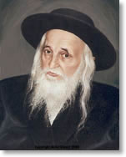

Rabbi Yechiel Spero relates a story. It was almost Chanukah, 1944, when the Satmar Rebbe, zt”l, was freed and released from BergenBelsen. Together with a small group of Jews, he was taken to the city of Caux in Switzerland to be checked for any illness.
The excitement was felt by every member of the group, as they prepared for their first festival in five years to be celebrated out of their captivity. After a group of influential Jews intervened on their behalf, the Rebbe and his entourage were permitted to go to Montreaux, to the home of a respected individual to light the first Chanukah candle.
When the Rebbe arrived, he was immediately offered something to eat and drink, but he refused. He was interested in only one thing, and that was lighting the Menorah. He headed straight over to the Menorah that had been prepared for him, and with trembling hands, he carefully reached into his pocket and took out a crude, hand-made wick.
He took out the wick that was in the Menorah and replaced it with his own, and he explained, “Several weeks ago, when I was in the concentration camp, I had no idea where I would be for Chanukah, or if I would even have the opportunity to light a Menorah. So, I began saving threads to make a wick, on the outside chance that an opportunity would arise for me to celebrate the Yom Tov of Chanukah. I have been carrying this wick with me, saving it for this purpose.”
Those assembled watched silently as the Rebbe began to sway, with his mind immersed in deep Kavanah. Tears began to flow down his face as he recited the first two Brachos in an emotional and heartbroken voice. As he began the third Brachah of Shehechiyanu, and said the words ‘that He has kept us alive’, his tears began to flow even more. He had tears of gratitude for having survived, and tears of pain for those who did not.
Finally, the Rebbe concluded the Brachah, and lit the Menorah. With immense Simchah he looked at the bright flame of the Chanukah light, and reflected that it is a symbol of hope, strength, and pride in the Jewish nation!

Reprinted from the Parshas Mikeitz and Chanukah 5778 email of Torah U’Tefilah as compiled by Rabbi Yehuda Winzelberg.
Sing the Song

It is customary to sing “Haneirot Halalu,” and/or “Maoz Tzur” after lighting the Menorah. Here is another Chanukah song we sing:

“I Have a Little Dreidel”

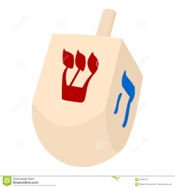
I have a little Dreidel,
I made it out of clay.
And when it’s dry and ready;
Oh Dreidel I shall play.

Oh Dreidel, Dreidel, Dreidel,
I made you out of clay;
And when you’re dry and ready;
Then Dreidel I shall play.

Reprinted from the Chabad.Org Chanukah Guide
Shabbos Stories for
Chanukah festival 5778
Volume 9, Issue ??? 25 Kislev 5778/ December 13-20, 2017
Printed L’illuy nishmas Nechama bas R’ Noach, a”h

For a free subscription, please forward your request to keren18@juno.com

Story #995
A Deserved
Chanukah Miracle
From the desk of Yerachmiel Tilles
editor@ascentofsafed.com

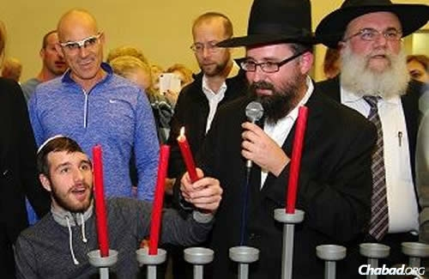

The first time Rabbi Menachem Kutner and Rabbi Yossi Swerdlov of the Chabad Terror Victims Project met Sgt. Ohad Benyishai of the Israel Defense Forces, he was lying unconscious in a hospital bed. He had been critically injured in mid-July of 2014 during "Operation Protective Edge" in Gaza, where he was deployed with his Golani Brigade's elite Egoz commando unit.
He and his unit's comrades were involved in a brutal battle in Gaza's Shuja'iyya neighborhood, which later became known as the bloodiest battle with Hamas during the entire operation. Thirteen soldiers lost their lives during the battle and many were injured. Ohad suffered a serious shrapnel wound of his head and was identified as the most seriously injured soldier during the operation.
He was quickly airlifted to the Soroka Medical Center, where on his arrival, his condition was so serious that the hospital doctors did not think he would make it through the night, but they refused to give up. After an unrelenting battle to stabilize Ohad that lasted a few weeks, Ohad rewarded their efforts when he regained consciousness.
In the months that followed, Benyishai slowly, with great determination and effort, and with devoted family support, began relearning how to function. He also mastered the Hebrew alphabet, and had even managed to say two words, ima (mom) and abba (dad), but no more.
On the second night of Chanukah, the rabbis visited the Sheba Medical Center in Ramat Gan, where he was recovering and had just celebrated his 20th birthday. There, around 70 wounded soldiers, their families and Chabad volunteers gathered for a special celebration and menorah-lighting.
Benyishai was invited to light the menorah together with Kutner. The rabbi said the blessings, and Benyishai held the shamash (helper candle) with his functional left hand. With the rabbi's assistance, he lit the two candles.
Then suddenly, the room went quiet as Benyishai slowly began to mouth the words to "Haneirot Halalu" and "Maoz Tzur" along with Kutner. The familiar traditional Chanukah tunes that he had learned during his childhood had brought back his ability to speak. He was talking!
His parents ran to him, and showered him with hugs and kisses with tears streaming down their cheeks. They had their Chanukah miracle.
Ohad was released from Sheba Hospital after an 18-month long recovery period on Monday, February 8, 2016, and returned home, but he will need to continue to undergo rehabilitation procedures in order to regain his full capacity.
Please continue to pray for the ongoing recovery of Ohad ben Erica, and the brave men and women of the IDF who have sacrificed so much to protect our precious homeland.
Source: Adapted and supplemented by Yerachmiel Tilles from an article on //Chabad.org. (The 2nd paragraph is adapted from //IsraelToday.co.il; the 2nd-to-last paragraph is from //IsraelNationalNews.com (Arutz Sheva). The photo is also from Chabad.org.)
Connection: Seasonal: Chanukah miracle.

Reprinted from the December 26, 2016 email of KabbalaOnline.org, a project of Ascent of Safed. www.ascentofsafed.com ascent@ascentofsafed.com

Chanukah: If You're Assimilated, It's a
Season of Confusion
By Miriam Karp/AMI

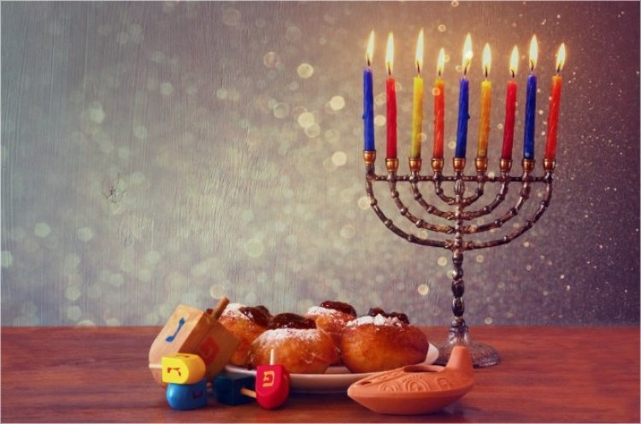

December is the season of utter confusion for a Jewish kid from an assimilated family wading through the American melting pot. Unless you have a very clear, strong Jewish identity, you feel the tension. What do you answer the cashier who extends a certain holiday greeting? What about the school play and the company party? It’s the time of year for clarification.
As the month progresses, the mall parking lots fill up, and the green and red decorations become ubiquitous, the unaffiliated Jew is pushed to reexamine and redefine the “Jewish thing.” Where does he draw the line and assert his differentness? Such questions are usually lost in the anesthetizing din of the media and the pressures of daily life. But come December, they’re hard to ignore. Growing up in the suburbs during the 1960s, I was torn. A second-generation American, my childhood was saturated with Yiddish culture, Bubby’s knishes, Jewish jokes and Fiddler on the Roof, but little in the way of real Jewish beliefs or day-to-day practice. I was jealous of my non-Jewish friends’ tree, candy canes and mountains of presents. I wanted to fit in. Badly.
Our little menorah and greasy latkes couldn’t compete with all that glitz. So I did sit on you-know -who’s lap, especially since our family friend Rube Weiss was the most famous one in town. I begged my parents for a Chanukah bush, but they weren’t willing to go that far.
Then one year Grandma Ida said yes! Grandma had been raised in an Orthodox home. On her wall, her parents looked out sternly from a turn-of-the-century photo, her father clad in a long black coat and hat, her mother peering out from under a boxy sheitel. Unfortunately, uneducated in Jewish matters and married to a socialist, Grandma kept her superstitions to herself.
We modern, rational Jews had no need for “kenahoras” and all that nonsense. Keeping kosher was a quaint relic of ancient times; nowadays we had sanitation and refrigeration. Grandma Ida sighed and accepted the new order. She smiled and bought us a Chanukah bush and stockings for the fireplace, and in the spring she bought us marshmallow bunnies and chocolate chick baskets. Why should her grandchildren be deprived?
I wish I’d learned something authentically Jewish from someone who was knowledgeable when I was young and far adrift. Maybe it would have saved me from roaming so many dead-end streets in my search for something deeper. Baruch Hashem, after light-years of searching, intensive change and discovery, I knew exactly what to do in December: get out that menorah, start frying latkes, invite the neighbors—the works.
Chanukah was celebrated with all of its genuine warmth, light and holiness; the kids were suffused with joy and excitement. I knew they were in quite a different place than I had been at their age when we happened to drive past a display of lights one year.
“Close your eyes!” my son Mendy, the little zealot, yelled to his siblings. “It’s avodah zarah!”Indeed, December is the season of sadness and confusion for so many well-meaning Jews. For several years I taught in a Reform Hebrew school. I was able to make my own curriculum and viewed the job as outreach.
Every year before Chanukah we’d have a discussion about what we were doing for the holidays. It was usually the smartest, most Jewish-looking kid in the class who would inevitably tell me, “We’re spending Chanukah with one grandmother and the other holiday with the other grandmother.”
“Oh,” I’d say with a sinking heart. “Which grandparents are Jewish?” David Cohen or Sarah Friedman or Josh Rubinstein, another nice kid, would invariably reply, “My dad’s parents.”
We are taught that only a small fraction of the Jews who were enslaved went out of Mitzrayim. I am often amazed and bewildered; how on earth did I start out way over there, wondering why my parents kept making that ridiculous racist demand that I marry a Jew—and end up all the way over here? How did I manage to jump over that vast cultural divide?
I don’t know; it must be zechus avos. How did I give up my university-conditioned cynicism? How did I accept covering my hair, so much cooking, cleaning for Pesach, kapparos—all the myriad details?
As I look back over my shoulder at those who are still on that distant multicultural shore, I realize how difficult it is for them to relate to all the stuff we do over here. They don’t even have the language to ask the right questions, to know how hungry they are.
Finding a way to show them how beautiful it is seems daunting. Some people might say, “It’s over. You can’t worry about them. Don’t look back; just hang on tight and build new generations. It’s sad, but that’s how it is. They’re gone.”
I don’t like that. It hurts. It’s wrong. I know how sweet and good those confused, earnest, assimilated and seemingly lost neshamos really are. I’d much rather sing “No Jew Will Be Left Behind” with Avraham Fried. But such a vision seems impossible. My father recently met his best friend from kindergarten, a friendship that has lasted over 80 years.
This dear man and his wife just moved into a non-Jewish assisted-living facility, complete with poinsettias and figurines and all of the other December trappings. Having long ago made peace with his intermarried sons and non-Jewish daughters-in-law and grandchildren, he is no longer bothered by the lack of kosher food or other Jewish staples. My heart aches thinking of them spending their twilight years in such a place.
Bridging the gap seems impossible. Like Chanukah. Like Eretz Yisrael. Like the Jewish people. How does such a ragtag band of persecuted wanderers continue to exist? How did the few beat the many? How did one tiny cruse of oil last eight days? How did I make that transition to the world of Torah, becoming the matriarch of a tribe of children and grandchildren with proud Jewish names and identities, bli ayin hara, whose lichtige pictures grace my dining room wall? Visitors gaze. It’s not an earthly thing. It’s not even logical to have raised all those kids, paid tuition, and bought shmurah matzah on a chinuch salary. It doesn’t make any sense at all. It’s a heavenly thing, like Chanukah, like the pintele Yid, the pilot light of the soul that continues to burn in even the most distant, most assimilated Jew.
Nowadays I travel a lot to speaking engagements. Invariably, in every audience, she is there—the one I was meant to meet. We recognize each other. A psychiatrist. An artist. A mom. A grandma. These neshamelach come in many forms and span the spectrum of socioeconomic and educational back grounds.
All their status and busyness just didn’t satisfy them. They’re all hungry neshamos, alive, the flame reaching upward, almost jumping off the wick with excitement. They’ve finally found a name for the driving force that’s been making them crazy all these years. They’ve found out where to get their neshamos some wholesome food.
I’m usually more inspired than they are. I’m revived. It’s really true—the Jewish neshamah cannot be extinguished. Each one has its own journey, its moment, when the dormant cinders blaze anew. And Hashem will lead each one lovingly home. Each one.
Take that, Pew Report, with your grim statistics! Where do we light the menorah? In the window, in the doorway. We’ve got to let that delicious light shine out into the darkness, burning until each soul is brought in from a cold, dark, empty street.
Inside. Around a warm table. And our light— Hashem’s light—is enough, enough to outshine the tinsel and the thousand million shtussim (foolish things) out there. And though it’s sometimes hard to see just how it will happen, it’s enough to bring them all home.

Reprinted from the Chanukah website of Hidabroot.

L’Maaseh

The Broken Flask

Rav Shabsi Yudelevitz, zt”l, one of the famous Magiddim of Yerushalayim, relates a beautiful and inspirational story. A poor Rabbi, who over a hundred years ago, had to go to Milan, Italy, to collect money for his family. When he got off the boat he met a wealthy, Jewish man, and he invited the Rabbi to spend Shabbos with him.
At the Seudah that night in the wealthy man’s mansion, the Rabbi saw a beautiful closet filled with exquisite silverware and crystal. He also saw something that seemed to be out of place amongst the luxurious items— a broken glass flask, with sharp points of jagged glass jutting out.
The wealthy man noticed the Rabbi’s look and asked him if everything was all right.
The Rabbi asked about the broken flask, and the wealthy man was more than happy to tell him the story.
The man was born in Amsterdam and came to Italy when he was eighteen years old, to help his grandfather run the family business. Eventually, his grandfather passed away, and his parents wanted him to sell the business and return to Amsterdam. The man, however, was very successful in the business and decided to remain in Italy, where the business kept him very busy.
One day, he was so involved with work that he forgot to Daven Minchah. A few days later he got busy early in the morning and he realized that he had forgotten to Daven Shacharis, and one by one, he stopped doing Mitzvos. Eventually he got married and had children, but he was leading a secular life. He remembered that he was Jewish, but he barely practiced any of the Mitzvos.
One afternoon he was taking a walk and saw some children playing. They all seemed to be very happy, but then he heard one of them start screaming and crying, and he kept saying, “What will I tell my father? What will I tell my father?” No one could console him.
The wealthy man went to see what the problem was. He found out that the boy came from a poor family and that his father had saved a few precious coins throughout the winter to buy a flask of oil for Chanukah, and sent this boy to buy it. His father warned him to come straight home with it and not to stop and play with his friends, as the flask may break. The boy didn’t listen, though, and sure enough, while he was playing, the flask broke and the oil spilled out.
The man asked the boy to come back to the store with him, and he would buy new oil for him to bring home. The man bought a larger flask of oil than the boy had originally gotten, and sent the now happy boy straight home with the precious oil, as well as some money for his family.
As the wealthy man was walking home that evening, the little boy’s words rang in his ears. “What will I tell my father? What will I tell my father?” And then he thought to himself, indeed, what will I tell my Father? My Father in Shamayim, Hashem, after my time here on this world? He had drifted so far from Yiddishkeit that he had forgotten that is was almost the first night of Chanukah! What excuse would he have when he stood before his Father in Heaven on that final Judgement Day?
The man walked back to where the children were playing and picked up the broken pieces of glass from the flask and took it home with him. That night, to the surprise of his wife and children, he lit a Chanukah candle. The next night, he lit two, and with each passing night, he increased the amount of candles for eight nights. He stared at the candles as they flickered and sparkled, and he remembered his parent’s home back in Amsterdam. He had realized that he had gone too far away.
The wealthy man concluded his story, “That Chanukah was the beginning of my return to the observance of Mitzvos. Eventually, with the understanding and help of my wife, we began training our children the way we were brought up. Our road back had started with that broken flask and the words of that boy, ‘What will I tell my father?’ And that is why I keep the broken pieces of that flask, as a treasured reminder of what changed my life!”

Reprinted from the Chanukah 5777 email of Torah U’Tefilah: A Collection of Inspirational Thoughts compiled by Rabbi Yehuda Winzelberg.

Behind World's
Largest Menorah
By Moshe Ben Chaim

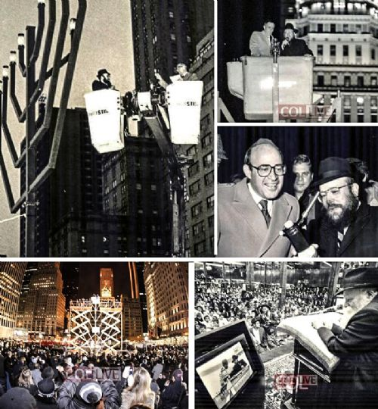
How did the world's largest Menorah end up on Fifth Avenue and how did Mayor Ed Koch shut down Chabad's critics.

As we store away our Menorahs until next Chanukah, we wanted to focus the emphasis on one of the most unique public lightings -- on Fifth Avenue in Manhattan.
There, as every year, proudly stands a gigantic Menorah, the largest in the world, according to Guinness World Records, that brings a phenomenal amount of publicizing of the miracle of Chanukah, as every day hundreds of thousands of people are exposed to it.
The Kfar Chabad magazine recently revealed interesting details about how this Menorah came about, in an interview with prominent officer of the Israel Defense Ministry and the Israel Foreign Ministry Yossi Ciechanover. His wife, Mrs. Atara Ciechanover, initiated the concept of this menorah.
The Chossid who took upon himself, at the time, the expenses of the Menorah and who actually organizes all the public lightings of the Menorah is Rabbi Shmuel Butman, the director of the Lubavitch Youth Organization.
It was difficult to reach Rabbi Butman during Chanukah as he was busy with daily arrangements for the public lighting with the participation of public figures and guests.
Now that Chanukah is over, we asked to speak to him and to hear about the "behind the scenes" story and it seems that many details were not yet revealed.

How did it all start?
In the 1970's the Rebbe spoke about public Chanukah Menorahs to publicize the Miracle of Chanukah. "We wanted to do that in the best way that befits the Big City," Rabbi Butman told us in the talks that we had with him this week.
"This is how in 5738 (1977) this Menorah was built. The size of the Menorah was 30 feet. We called the Menorah the "World's Largest Menorah" and that is how it was recorded by the world media who covered extensively the lightings each day. World media used the Menorah as the symbol of Chanukah."

Who designed the Menorah? Who built it? And what was the cost?
We used a classic design. It was not yet the custom to use the Rambam design. After considerable efforts we found, with G-d's help, a company who specialized in designing and building objects of metal and steel.
The company wanted $5000 for the design and construction. Not a small sum in those days. I contacted a supporter, Mr. William Goldberg OBM, president of the Diamond Dealers Association. Mr. Goldberg was so excited with the idea that he personally came to our office and paid for the Menorah.
Although he is no longer with us, his wife comes to the Menorah each year and feels like a partner.
For nine years, this Menorah captured the attention of the world media, due to the unprecedented Pirsumei Nisso publicizing of the miracle of Chanukah. Every year the media flocked to cover the Menorah. Even the New York Times, that isn't always enthusiastic about Jewish matters, wrote about this Menorah."

When was the famous Agam Menorah built?
In 5747, Yaacov Agam designed the Menorah. A model of the Menorah in miniature stood on the Rebbe's desk for 3 days. The entire project was arranged by Mrs. Ciechanover.
According to the words of Yaacov Agam, the Rebbe wanted the Menorah to be built to the maximum height permitted by halacha, 20 Cubits, which is 32 feet. The price for constructing this Menorah was $25,000, paid by the Lubavitch Youth Organization.

And what exactly did you do with the first Menorah?
That Menorah, till this day illuminates the surroundings at "Park Circle," the gateway to Crown Heights, Boro Park and Flatbush, where tens of thousands of vehicles pass by daily."

Which directives were from the Rebbe concerning this Menorah?
Rabbi Mordechai Hodakov, the head of the Mazkirus (secretariat) of the Rebbe showed an interest in all the details. Who is lighting today? etc. According to his directives we invited the then Mayor Abraham Beame to light.
I remember that Rabbi Hodakov very much wanted that United States Senator Jacob K. Javits should light the Menorah. Javits at the time was old and in poor health. It did not seem possible that he would come. But when Rabbi Hodakov said that he wants him to light, I went to work on it. With Rabbi Hodakov one never knew 'where the directive comes from.' Thank G-d it was with success. Senator Javits came, got into the lift and lit the Menorah.
I once got a call from Rabbi Yehuda Krinsky, the Rebbe's secretary. It was the night that the eighth candle was lit. The Rebbe told him that night to call me and ask me to light the Menorah again the next morning. We do this till this very day.

These directives came straight from the Rebbe?
This is part of what it says ‘to what is beyond you don't reach.' I will give you a case in point. Rabbi Hodakov told me to invite Robert Abrams to light. He was at the time Bronx Boro President. I answered that I don't know if there are enough open nights. Rabbi Chodakov just repeated what he said, that Robert Abrams should be invited. He was invited and he came.
A few years later Robert Abrams was elected as Attorney General of the State of New York. He came every year to light the Menorah. When an individual complained to the Rebbe about the separation of Church and State the Rebbe responded that how can there a problem of Church and State when the man in charge of that in the State of New York came himself to light the Menorah. One then understood that the suggestion of Rabbi Hodakov came ‘from above.'"

One cannot help but admire the spot that the Menorah was given...
Indeed. This is a case of S'yato Dishmayo, (heavenly intervention). Within the laws of nature, we had a good relationship with Mayor Abe Beame and he gave the order. The permit officially was issued by the Parks Department but the permission came from the Mayor's office."

Many stories have accompanied the Menorah. Can you share one of them with us?
Every New York Mayor lit the Menorah, including Ed Koch. Ed Koch was once invited to St. Louis as the Guest Speaker for the United Jewish Appeal. After his formal speech, a woman who was at the time the head of the opposition to the lightings of public Menorahs [in St. Louis], asked him for his opinion. She was certain that he would oppose it. Ed Koch answered in his characteristic blunt manner: "In my city, we have the largest Menorah - and I myself lit it." Supporters of the public lightings applauded at length and the Menorah [in St. Louis] went up.

In conclusion, Rabbi Butman, what is your message?
That the lights that all Jews and the Rebbe's Shluchim light, the world over, should usher in the eternal light of the great redemption imminently.

Reprinted from the January 5, 2017 website of COLLIVE.com
What You Should Know About “Sufganiot”
Jelly Doughnuts
By Leon Samuels

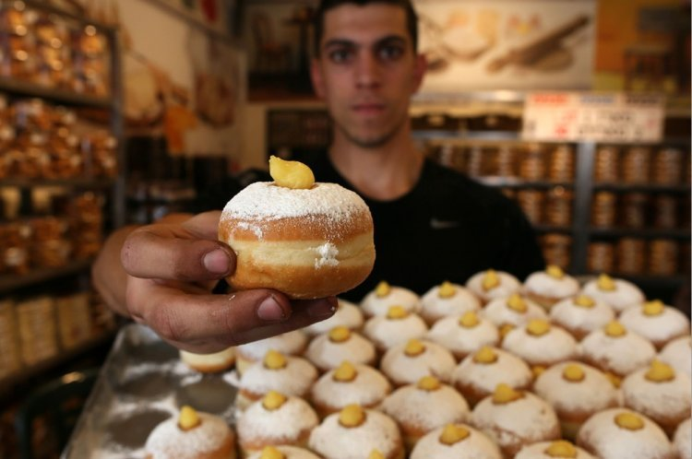

Why Kashrut Supervision is Important
When You Buy a Sufgania.

Chanukah is around the corner. One of the Chanukah customs is to eat foods fried in oil to remind us of the miracle of oil. Jelly doughnuts rate high on the Chanukah menu along with potato latkes. In Israel most of us already had a sneak preview tasting of the jelly doughnuts (which could be filled with caramel, custard or other fillings other than jelly).Rabbi Pinchas Adiria, Supervisor of the Kashrut Division of the Israel Rabbinate, want people to know what to look in Kashrut for when buying these doughnuts. This first part is general advice but more applicable to Kashrut supervisors or those making the doughnuts at home.
1) Make sure the deep fryers were kashered making sure they are not meaty and have not absorbed non-kosher substances.
2) A Jew must turn on or light up the deep fryers.
3) If the dough is large, 2 kg. or more of flour, Challah must be separated before using dough.
4) Make sure flour was properly sifted to remove small bugs common in flour.
5) When using a dairy filling like caramel some filling should be obviously visible on top so people will know it is dairy and not accidently eat it with a meaty meal. A merchant must place a “dairy” sign next to these doughnuts.
6) Merchants must have separate areas for dairy doughnuts and parave doughnuts. They should also refrain from making dairy dough so as not to get confused and make a parave doughnut with this dough.
7) Packaged doughnuts should be appropriately labeled “Parave” or “Dairy”.
For doughnut buyers:
Make sure the bakery has proper kashrut supervision from the local Rabbinical Council. This prevents kashrut fraud. Because of all the aforementioned requirements proper Rabbinical supervision is imperative.
Enjoy your kosher jelly doughnuts and have a great Chanukah!

Reprinted from the December 20, 2016 website of Hidabroot.
Chanukah at Valley Forge, 1777
From the desk of Yerachmiel Tilles

It was December 1777, when the American forces under General George Washington were awaiting the famous battle at Valley Forge. The future president was deeply concerned about the welfare of his troops. The bitter cold and the poor provisions with which his soldiers of the revolutionary army had been provided did not bode well for the outcome of the critical battle that awaited them.
Wrapped in his officer's cape and clapping his three-cornered hat down hard on his head against the chilling wind, Washington went out to see at firsthand how his men were faring. As he went from tent to tent, he saw the men dressed in rags and huddling around small fires, trying to get together a meal of something hot. As he went on, he suddenly encountered a single soldier, bent over a small metal apparatus in which he had lit a few very small, tallow candles.
Intrigued, Washington asked him what he was doing. Startled, the man jumped to his feet and saluted. Just at that moment, he had little expected to find his commander so near. But again Washington repeated his request: to understand why he had lit those little candles here, in the middle of nowhere.
The soldier, who of course was Jewish, began to unfold the age-old tale: of foreign Greeks who, upon conquering the holy land of Israel, had entered the Temple and had placed their idols in the most sacred place of worship. And he told how the valiant Maccabees, no longer able to bear the evil degrees forbidding the performance of Jewish ritual and the learning of Torah, rose up against their lords even though they greatly outnumbered them and were better armed - "Just like here, only more so, he interspersed."
Nevertheless, through the grace of Heaven, they succeeded in removing them from their land. And last of all, the soldier explained how they purified the sanctuary and, finding only one container of oil which remained undefiled, they used it to light the Menorah. Yet miraculously that one container of oil, which should have been enough for only one day, instead lasted for eight -- until new oil could be made. And this, he told the general, is why he was lighting those little lights.
General Washington stood enthralled. He looked at the little flames, and at the face of the Jew. Then, he laid a firm hand on the man's shoulder. "You are a Jew," he exclaimed," "from the nation of prophets! I treat what you just said as a message from the Al-mighty Himself! With your little lights and your inspiring story, you have struck new courage in my troubled heart."
The General shook the young soldier's hand, saluted, then turned to continue on his rounds. What happened the next day is history: Washington's forces scored a victory over the British, and this proved to be the beginning of their total success. Eventually it led to the independence of the United States of America from England.
But what is less known is the following. That Jewish soldier survived the war and returned to his home in Boston. [another version: New York City, on Broome Street -ed.] One evening, some few years later, he was sitting with his family around the dinner table when there was a knock at the door. He was astonished to see two very official-looking men standing there, but after a moment he recovered his poise and invited them in.
After introductions, one of the men stepped forward and took out a small box covered in velvet, from his inside coat pocket. With a cheerful smile, he handed it to the Jewish host, saying, "Here, take this. It is for you."
The veteran soldier looked from one face to the other for some sign of what was going on. Slowly he opened the box. It was plushly lined, setting off a brilliant gold medallion. On it was engraved a picture of a Menorah with the words inscribed: "With admiration, from George Washington."
One of the visitors then handed him a letter from the first president himself. "This will explain everything," he said. "My dear friend," was the salutation. "You don't know what you accomplished that night at Valley Forge. I couldn't sleep that night because I was sure that we had no chance of winning. We lacked ammunition. We were outnumbered ten to one. We didn't even have food or bedding for the soldiers. When I saw those boys lying asleep in the freezing cold under those thin blankets it took away my resolve. I made up my mind then and there… to surrender.
“But your lights and your words changed all that. If it wasn't for you and your Menorah, I don't know if we would be standing here today as free men. So we decided to present this medallion to you as a testimonial to that night, which was a turning point in our struggle for freedom."
Adapted by Yerachmiel Tilles from several Jewish and non-Jewish sources on the World Wide Web. Yerachmiel Tilles is the director of the AscentOfSafed.com and KabbalaOnline.org websites. His mailing list of 900+ weekly stories (editor@ascentofsafed.com) is now in its 20th year. “Festivals of the Full Moon,” the second of a 3- volume series of his best stories, is now available in Tzefat at Ascent and KabbalaOnline-shop.com.

Reprinted from the Parashat Mikeitz 5777 email of Jewish Living from Chabad of the Cardo [in Yerushalayim.]
It’s Always Hanukkah in This Picture-Perfect Italian Town
By Ruth Ellen Gruber

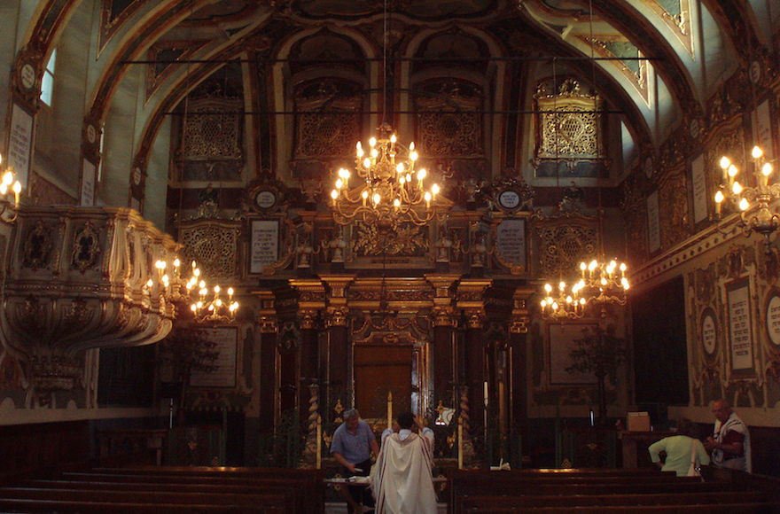
An inside view of the synagogue in Casale Monferrato, Italy, which dates to the 16th century. (Wikimedia Commons)

CASALE MONFERRATO, Italy (JTA) – It’s always Hanukkah in this picturesque town in northern Italy’s Piedmont region.
Jews have lived in Casale Monferrato for more than 500 years, with the community reaching its peak of 850 members at about the time Jews here were granted civil rights in 1848. The town still boasts one of Italy’s most ornate synagogues, a rococo gem that dates to the 16th century.
These days, only two Jewish families live in Casale. The synagogue, which is part of a larger museum complex, is now a major tourist attraction – and not only because of its opulent sanctuary with huge chandeliers, colorfully painted walls and lots of gilding. The former women’s section has been transformed into a Judaica and Jewish history museum. And the synagogue’s basement, formerly a matzah bakery, is now home to the Museum of Lights.
Hanukkah here is commemorated nonstop with a year-round exhibit featuring dozens of menorahs, or hanukkiyot, created by international contemporary artists. The collection has some 185 menorahs, according to Adriana Ottolenghi, whose husband, Giorgio, has been president of Casale’s Jewish community since the 1950s. There is no other museum in the world quite like it.
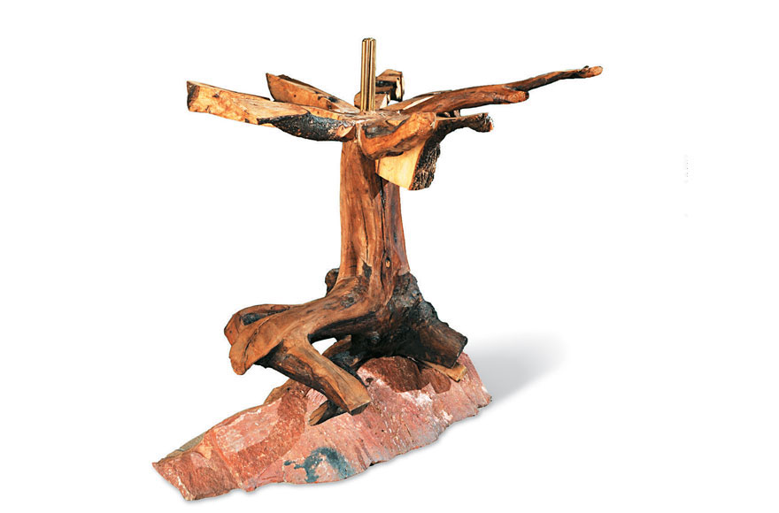
This is one of the nearly 200 menorahs at the Museum of Lights in Casale Monferrato (Foundation for Jewish Art, History, and Culture at Casale Monferrato and in Eastern Piedmont – Onlus)
“We receive more every year, and each year at Hanukkah there is a public ceremony, where we light menorahs and welcome the new pieces,” she said.
Only 30 to 40 can be displayed at a time in the vaulted underground chambers. The only time the collection was shown in its entirety was at Casale’s centuries-old castle, part of an event connected to the 2015 Milan Expo.
The Museum of Lights’ hanukkiyot come in an amazing variety of shapes, sizes, colors and media. Many resemble traditional menorahs: a straight line of candles or a candelabra with eight branches, with a ninth branch for the “shamash” candle used to kindle them. Some of the menorahs can be lighted and used on the holiday.
But other menorahs on display are more fanciful sculptural works created from the likes of metal, ceramic, plexiglass and wood.
“Artists were given a completely free rein to create a functional object or a purely evocative one,” curator Maria Luisa Caffarelli wrote in the collection’s catalog.
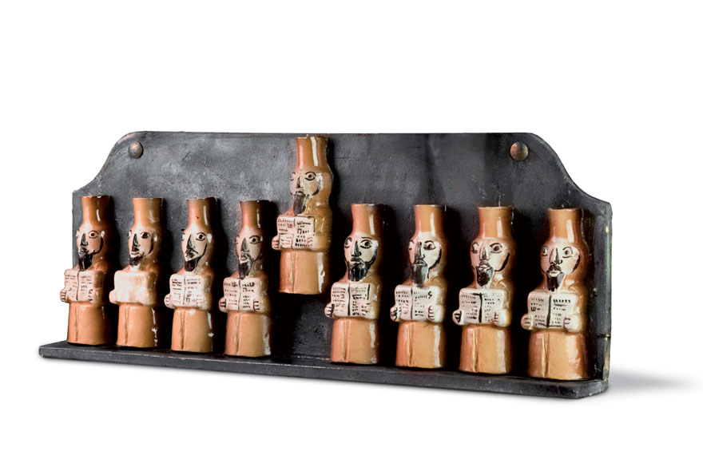
This menorah is part of the year-round display at the Museum of Lights. (Foundation for Jewish Art, History, and Culture at Casale Monferrato and in Eastern Piedmont – Onlus)

Each menorah is what designer Elio Carmi, who co-founded the collection in the mid-1990s with the non-Jewish artist Antonio Recalcati and other artist friends, describes as an “homage to the story of Hanukkah” and its message of the triumph of light over darkness.
They conceived the project as a way to highlight Jewish culture as a source of artistic inspiration, promote creativity based in Jewish tradition and underscore the vitality of Jews in contemporary society.
“The idea was born to show that Jews, though small in number, are determined,” said Carmi, who is the vice president of the Casale Jewish community, “and to use interpretations of the Hanukkah menorah to demonstrate, symbolically, the continuity of the community.”
At Hanukkah, Jews light menorahs for eight days to recall the defeat by the Maccabees of Syrian tyrants in the second century BCE. According to legend, when the Maccabees reclaimed the Temple, the eternal light miraculously burned for eight days rather than the expected one, symbolizing the survival of the Jewish people.
Each menorah in the museum is a personal interpretation of the Festival of Lights and its symbolism. The Italian artist Stefano Della Porta, for example, used ceramics and steel to create a menorah that appears to be made from giant burnt matches. American-born artist Robert Carroll created his menorah from olive wood, red Verona granite and brass. It has a sinuous, trunk-like base that supports eight branches that open out like a flower, each supporting a candle.
Carmi and his friends provided the first hanukkiyot for the project — Carmi’s was a silver-plated metal bar with small cups for the eight candles and the shamash — and then reached out to others for contributions.
Other artists — Jews and non-Jews, mainly from Italy but also from other countries — soon began making their own menorahs and presenting them to the growing collection. All of the works are donated, most of them by the artists themselves.
“It was like a chain of artists,” Carmi said. “And well-known artists began to be attracted.”
Among those is Arnaldo Pomodoro, one of Italy’s leading sculptors. His menorah, presented in 2013, is a horizontal metal girder that supports the nine candles and is decorated with abstract symbols.
“I tried to bring out a series of abstract, imaginary signs to create a story that would connect, on a general level, with the idea of thought, experience and memory; without, however, wanting to enter into the multi-faceted complexities of the symbology of the Jewish world,” Pomodoro describes in the catalog.
Ultimately, Carmi said, the Museum of Lights is about “Judaism, art and identity.”

Reprinted from the November 15, 2017 website of the JTA (Jewish Telegraphic Agency)
News Brief
Canada Issues First
Hanukkah Postage Stamp
November 21, 2017
MONTREAL (JTA) — Canada issued its first Hanukkah stamp in its official mail carrier’s 150-year-history.
Described as part of an initiative to highlight the nation’s cultural diversity, the stamps from Canada Post feature two colorful geometric designs: of dreidels and the menorah. Each pattern also has an online explanation of their relevance to the holiday.
They are arriving three weeks before the first candle is lit.
“In offering the great products, Canada Post is enabling our community to share the beauty and inspiration of Hanukkah with all Canadians,” said Shimon Fogel, CEO of the Centre for Israel and Jewish Affairs.
Canada Post made an initial issue of 3 million Hanukkah stamps and has indicated that if trial-run sales go well, it will make more over the next few years and eventually add new designs.
As part of the diversity initiative, Canada Post also issued stamps for the Muslim festival of Eid and the Hindu holiday of Dawali. Since 1964 and until this year, it had issued only Christmas stamps.
(Editor’s Note: The first Canadian Hanukkah stamp was designed by Angela Brown Carter of Entro Communications, that has offices in Toronto and Calagary as well as in Switzerland.

What One Menorah
Lighting Can Do
By Chana Sara Einseiger

There was always something about lighting a menorah. Even when I was in foster homes as an adolescent, it was something I wanted to do. Maybe it was knowing that my ancestors did the exact same thing, or that millions of people all over the world were staring at the candles too. Or maybe it was just that candlelight is so warming when the ground outside is covered in snow. I’m not sure, but I certainly never expected that lighting a menorah would have any impact on my day-to-day existence.
Nearly three years ago I decided to drop Judaism entirely. I was fed up with the entire venture. The temple I attended was costly and uninviting, not at all what I had expected. There would be no community to raise my daughter with, no traditions to pass on to her. Needless I decided to drop Judaism entirelyto say, I was a little bitter about the whole thing.
But, of course, every year I lit a menorah. When my daughter was old enough to appreciate it, I decorated the house with Chanukah flags and garlands, window stickers and crafts. Maybe at some point in her life she too would enjoy the feeling of comfort and safety that I got from the flickering candles.
The temple with which I dropped membership proceedings still sent me a newsletter occasionally, and that year I saw that various synagogues were holding public menorah lightings around the county. A giant menorah! Perfect! I dressed up my little girl in a pretty blue dress and built her anticipation to see a menorah as tall as a tree.

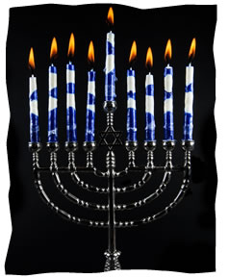

It turned out to be less dramatic than I had hoped—just a few people had gathered to see the lighting. Some homeless men were milling around. There was talk of free latkes and hot drinks in a nearby building afterwards, but as soon as the lighting was over I scooped up my daughter and made a dash for the car. My exoduswas interrupted the rabbi. He introduced himself and gave my daughter a little menorah necklace.
“Do you belong to a synagogue?” he asked.
“No,” I replied. The memory of the other temples I had been to, their high fees and constant focus on what my occupation is, rather than who my daughter and I are, made me suspicious of this rabbi. Does this one want twice the cost of my medical insurance for my daughter to play around his children?
The rabbi told me the address of his synagogue. I narrowed my eyes. ”And how much does it cost?”
His face lit up. “This is why I do this,” he said. He told me there were no membership fees. I was astounded.
So I went to the local Chabad Lubavitch. Yes, it was awkward. There was a definite language barrier, and I often had trouble following the service. But the people were friendly, and I didn’t have to sign There were no membership fees. I was astoundeda contract to be there. So I went back again, even though going to a Chabad synagogue if you weren’t raised in the world of Judaism is like diving before you learn to swim.
After some coaxing, the rabbi’s wife, Devorah, convinced me to sign up my daughter for Sunday Hebrew school. On the first day, they were having a shofar factory. The smell of power drills running into animal bones and shellac was awful, but my daughter loved it. She looked around wide-eyed at the other kids, made a friend, and was fascinated with the shofar she shellacked. I was sold.
On my way out, the rabbi said to me, “Look what one menorah lighting can do.” I smiled, but didn’t think much of it.
Time has gone by, and now I can’t forget the rabbi’s words. Yes, when I attend a service I still prefer to hide in the kids’ room, where I have some idea what I’m doing (mostly staring at the fish tank), and most of my agnostic-style views haven’t changed, but plenty has. My daughter finished a year in Hebrew school and is learning a new language. She is so proud of all her projects, and so happy with the friends she has made.
Because she enjoyed Hebrew school so much, I enrolled her in the Chabad preschool. She loves her teachers, and I’m glad that she’s in such capable hands. She has developed socially and gained a bit more confidence. After more coaxing from Devorah, she even attended summer camp. So much has changed in our routine, changes that will be there for years to come. She is making memories that she can treasure for life. That is what one menorah lighting can do.

Chana Sara lives in Whitehall, Pennsylvania, with her husband, daughter, and too many pets. She is the office manager at Chabad of the Lehigh Valley where she helps produce the Wellsprings Magazine which is published 5 times a year. What she enjoys most about working at a Chabad House is having the constant opportunity to learn something new.

Reprinted from the website of Chabad.Org

Brooklyn torah gazette
For chanukah 5778
Volume 2, Issue 14 (Whole Number 57) 25 Kislev 5778/ December 16, 2017
Printed L’illuy nishmas Nechama bas R’ Noach, a”h

For a free subscription, please forward your request to keren18@juno.com

In Budapest, Hanukkah Comes Out of the Shadows And Onto the Ice Rink
By Cnaan Liphshiz

BUDAPEST (JTA) — The outdoor ice skating rink — the largest in Central Europe — in Budapest’s city center has been part and parcel of Hungary’s Christmas tradition for nearly 150 years.
Stretching across 3.5 acres between Heroes’ Square and Vajdahunyad Castle, the Budapest City Park Ice Rink draws hundreds of thousands of visitors from across the country each winter. They come for the Christmas market, the winter festival, and the promise of smooth ice and affordable skate rentals.
It’s an enormous and enormously popular attraction, so City Park Ice Rink is busy nearly every day with the Christmas revelers. Except, however, on the first night of Hanukkah.
On that evening, the rink is populated with hundreds of Jews. They gather to sing Hanukkah songs as they watch rabbis on skates light a large menorah built by EMIH, the local branch of the Chabad Hasidic movement. With help from a donor in Budapest, they rent the rink for $12,000, and distribute sufganiyot and tea to holiday revelers who have pre-purchased tickets.
The City Park Hanukkah celebration started just over a decade ago, and it is unusual in that it’s one of just a few places in Europe where the North American “Hanukkah on ice” tradition has taken root. In the U.S., Chabad rabbis organize dozens of Hanukkah on ice events each year featuring the ceremonial candle lighting, munching on the deep-fried Hanukkah delicacies and ice skating, with games for children and training for the inexperienced.

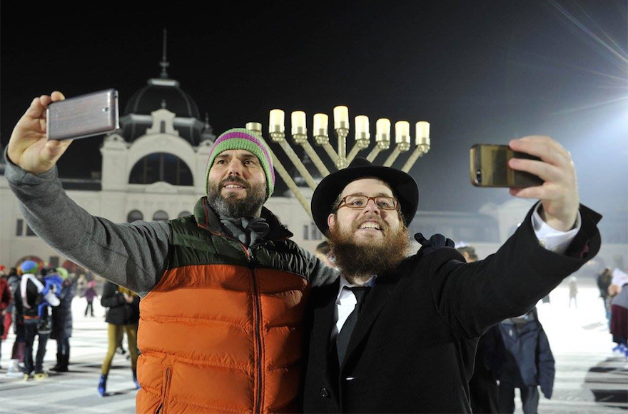
Rabbi Slomo Koves, right, and a participant at Chabad Hungary’s 2015 Hanukkah on Ice event take selfies at Budapest’s City Park Ice Rink, Dec. 6, 2015. (Courtesy of EMIH)

But in Budapest, the event is part of a broader “coming out” of Jewish communities in the former communist bloc, where after years of practicing their religion underground, Jews are now celebrating Hanukkah in very public ways.
“Hanukkah used to be low key in Budapest, as was everything else
connected to Judaism during socialism,” said Rabbi Boruch Oberlander, one of the early organizers of Budapest’s Hanukkah on ice tradition. Back then, Jews feared that practicing any religion — and Judaism especially — invited persecution.
“But it’s not good for Judaism when things are low key,” he added, because it made people leave the tradition. Throughout the Soviet sphere of influence, decades of religious persecution compounded the Nazi-caused devastation. Unaware or ashamed of their Jewish identity, countless Jews in that part of the world assimilated, distanced themselves from Judaism and produced children that no longer regarded themselves as Jewish.
Against this background, Hanukkah has a special significance in the post-communist world, said Oberlander, a Brooklyn-born rabbi who settled in Budapest 28 years ago as an emissary of Chabad.
Oberlander isn’t just referring to public events at ice skating rinks — there’s also the longstanding practice of placing Hanukkah menorahs on the windowsill, specifically for all to see.
“Meaning, don’t be low key!” he told JTA.
Oberlander, 53, does not skate himself, he said, explaining he’s “not very good at it.” But in his community, the event is one of the most popular because of how it combines seasonal amenities, sports and religious ceremony in a fun, family-friendly setting.
His interpretation of how Jews should celebrate Hanukkah is shared by many rabbis all over the world — Chabad rabbis, in particular — who stage large, public menorah lightings in central squares of major cities. New York, for example, boasts two such massive events: The Grand Army Plazas in both Manhattan and Brooklyn have been in competition over which holds the title of World’s Largest Menorah.
Such displays inspired Jews to think big in Western Europe, ending decades in which communities traumatized by the Holocaust had shunned initiatives that advertise Judaism.
Since 2013 in the Netherlands, for example, the chief rabbi has been lifted in a crane (along with the Israeli ambassador) to light the first candle of a 36-foot menorah built for the Jewish community by Christian Zionists who say it is Europe’s largest. In Berlin, a giant menorah is lit at the Brandenburg Gate monument.
Like the massive menorah lightings, Europe’s growing Hanukkah on ice trend — which this year can be observed in Budapest, Moscow and London — also started in the United States, where it is occurring this year in locations from Wollman Rink in New York’s Central Park, to Houston to San Mateo, California.
In Moscow, the popular Hanukkah on ice event, which began in 2012, is eclipsed by what may well be the largest celebration of Hanukkah in Europe: the annual gathering of 6,000 Jews at the State Kremlin Palace for an evening of dance and performances, as well as the bestowing of awards to communal VIPs. Organizers saythe venue is important to them for symbolic reasons because it produced some of the world’s worst anti-Semitic policies after the fall of Nazi Germany.

In Budapest, the city’s summertime Jewish cultural festival is also an example of Jews reclaiming their place in society. Judafest, which was held for the 10th consecutive year, draws thousands of Jews and non-Jews to the historically Jewish 7th district for sessions, activities and exhibitions connected to Jewish cooking, dancing and Yiddish.

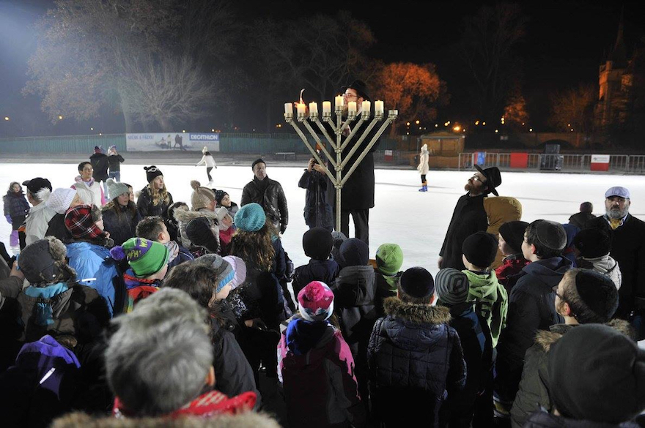
Rabbi Koves lights a menorah at the Hanukkah on Ice event, Dec. 6, 2015. (Courtesy of EMIH)

But there’s something special about the Hanukkah on ice event, which is held at an iconic location with strong ties to the holiday period for all Hungarians.
“I think it indicates a generational difference in which young people our age don’t think twice about participating in an event that celebrates, publicly, our Jewish identity,” Eszter Fabriczki, 30, a regular at the event, told JTA. “Holocaust survivors passed the fear element to their children, but not to their grandchildren.”
Against this background, Fabriczki said her father “is freaking out over my wanting to give my son a circumcision, if I have a son, because then he could be identified as Jewish.” She has no children, adding: “I have no thoughts of this kind, living a pretty comfortable Jewish life.”
Despite the generational gap it exposes, Fabriczki said she and her mother have bonded over the City Park Ice Rink Hanukkah event.
“I’m quite religious but my mother is not, so the Hanukkah on ice event is something we can share because she likes to ice skate and it’s important for me to observe all the Jewish holidays,” Fabriczki said.
But for 16-year-old Sara Szalai, Budapest’s Hanukkah on ice means quality time with her dad, Kalman, who is the managing director of the Jewish community’s Action and Protection Foundation — the local equivalent of the Anti-Defamation League, which monitors anti-Semitic incidents.
Neither are particularly concerned, she said, about self-identifying as Jews at the event.
“Maybe there are people who think this way, but for us it’s not a big issue,” said Szalai, who added that she’s a “pretty good” skater.
“It’s usually pretty crowded there, so it’s a rare opportunity to really skate properly on Hanukkah without worrying about bumping into people,” she said.
The event typically unites Jews across the religious-secular divide. Hanukkah has fewer restrictions than other Jewish observances such as Shabbat or Yom Kippur, when observant Jews are not allowed to operate machines, travel or perform any action classified as work.
In Hungary’s fractious Jewish community — where interdenominational tensions are rising amid polarizing policies undertaken by the nationalist government — the Hanukkah on ice event offers a rare armistice in which the secular, religious, local and Israeli Jews put aside their differences for a night of fun.
It’s also, Fabriczki noted, “a chance to see rabbis on skates.”

Reprinted from the December 5, 2017 website of the JTA (Jewish Telegraphic Agency).
POLITICS
Congressional Democrats
Left Out of White House Hanukkah Party
By Julie Hirschfeld Davis and Katie Rogers

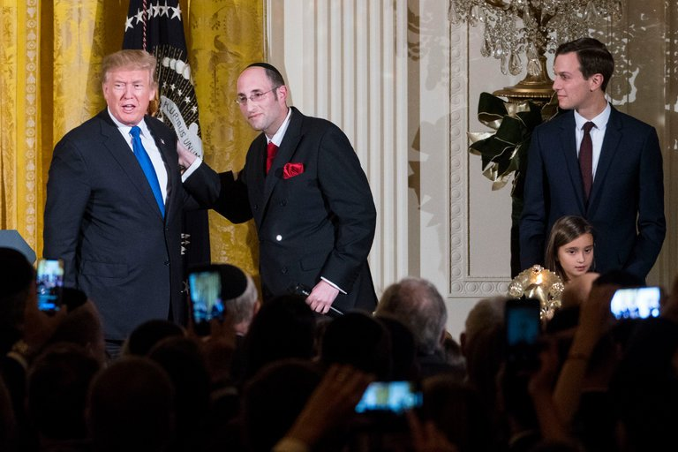
President Trump with Rabbi Meir Yaakov Soloveichik, and Jared Kushner during a Hanukkah Reception on the State Floor of the White House, on Thursday. Photo Credit - Doug Mills/The New York Times

WASHINGTON — The latkes were fried and the kosher lamb chops were prepared on Thursday, just as in past years, for the first White House Hanukkah party of the Trump era. But there was one prominent break with tradition: President Trump did not invite Democratic lawmakers.
Mr. Trump, who prizes loyalty and seldom forgets a slight, left Democratic members of Congress off his Hanukkah list this year, according to congressional aides tracking the invites. He also did not invite Reform Jewish leaders who have been critical of him or progressive Jewish activists who have differed with him publicly on policy issues.

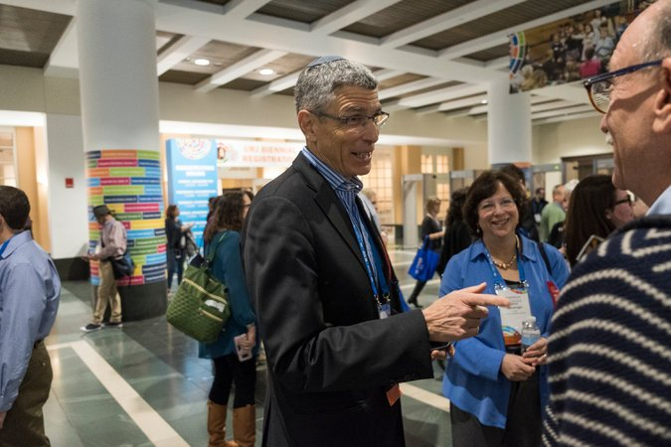
Rabbi Rick Jacobs, left, at a meeting for Reform Jews this week in Boston. Photo Credit - M. Scott Brauer for The New York Times

The move injected a partisan tinge into a normally bipartisan celebration at the White House, where on Thursday Mr. Trump spoke to a crowd standing amid Christmas trees.
“I know for a fact there are a lot of happy people in this room,” Mr. Trump said to raucous whoops and applause, adding simply, “Jerusalem.”
He wished those assembled a Happy Hanukkah, then said, “I think this one will go down as especially special.”
Mr. Trump’s young grandchildren, who are Jewish, lit a menorah to mark the occasion.
This year’s Hanukkah party was all the more joyous for attendees because it came the day after Mr. Trump delighted many Jews, particularly those politically allied with him, by declaring Jerusalem the capital of Israel and recommitting himself to moving the American Embassy there.
“People are in a celebratory mood and just kvelling over this incredible, historic moment,” said Morton Klein, the president of the Zionist Organization of America, who attended the reception as well as a “Hanukkah Nightcap” party afterward at the Trump International Hotel. That affair was hosted by the Republican Jewish Coalition, the organization funded by the casino magnate and Republican super donor Sheldon Adelson, and America First Action, a political action committee staffed by Trump allies.
Representatives Lee Zeldin of New York and David Kustoff of Tennessee, the two Jewish Republicans in Congress, were attending the party, their offices said. But Jewish Democrats left off the invite list — many of whom have been harsh critics of Mr. Trump — were not in a festive mood.

Representative Nita M. Lowey, Democrat of New York, in June in Washington.CreditAndrew Harnik/Associated Press

“It’s deeply unfortunate that the White House Hanukkah Party — a bi-partisan event bringing together Jewish and non-Jewish leaders alike to celebrate the Festival of Lights since 2001 — has turned into a partisan affair under this administration,” Representative Nita M. Lowey of New York said in a statement.
This year, officials slashed the size of the annual reception, inviting around 300 guests to one soiree instead of hosting 1,700 over two parties as in the past.
Among those who did not make the cut were Rabbi Rick Jacobs, the president of the Union for Reform Judaism, who in August criticized Mr. Trump for his handling of the neo-Nazi march in Charlottesville, Va. On Wednesday, Rabbi Jacobs said the president should not have made his declaration about Jerusalem, arguing that it could undermine the chances of achieving peace between Israelis and Palestinians.
The White House chalked up the limited guest list to a new approach from the president.
“I am not aware of the political affiliation of any of the guests, but I do know that this year was meant to be more personal than political,” said Stephanie Grisham, a spokeswoman for Melania Trump, the first lady, whose office oversees White House party planning. She declined to elaborate.

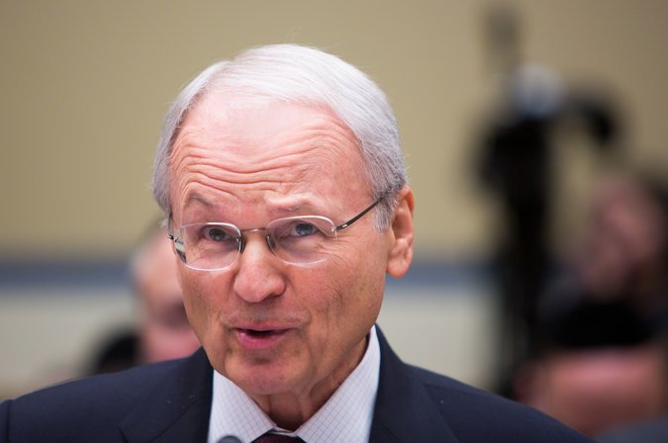
Morton Klein, of the Zionist Organization of America, speaking last month at a congressional hearing about moving the American Embassy in Israel to Jerusalem. Photo Credit - Tasos Katopodis/Getty Images
But for some invitees, the message was clear.
“He did not invite people who have been hostile to him,” Mr. Klein said in an interview. He should know. After being invited to the 2009 White House Hanukkah party during President Barack Obama’s first year in office, Mr. Klein was later cut from the guest list after condemning the former president in scathing terms. (Last year, Mr. Klein referred to Mr. Obama as a “Jew-hating anti-Semite.”)
Officials from J Street, a progressive pro-Israel group that strongly backed Mr. Obama and the nuclear deal he forged with Iran — which was detested by many conservative Jews — were excluded.
Malcolm Hoenlein, the executive vice chairman of the Conference of Presidents of Major American Jewish Organizations, said Mr. Trump’s proclamation on Jerusalem was a “consensus issue in the Jewish community.” He said it would add to an ebullient mood at the Hanukkah party, which is to mark an eight-night festival beginning Tuesday night that celebrates the Jews liberating their temple from oppressors.
Vice President Mike Pence and his wife, Karen, mingled at length with guests, attendees said, and both he and Mr. Trump were showered with compliments about the Jerusalem speech.
“It was very festive and appropriate,” said Nathan J. Diament, the policy director of the Union of Orthodox Jewish Congregations of America, who brought his 12-year-old son, Josh. “People were telling them, ‘Thank you,’ and, ‘Congratulations.’
The attendance of a Supreme Court justice, Stephen G. Breyer, nominated in 1994 by President Bill Clinton, a Democrat, was the only hint of bipartisanship at the gathering, Mr. Diament said.
At the party at the Trump International Hotel, in a small room adjoining the presidential ballroom, guests gathered to eat fish roe, latkes, egg salad and salmon. Attendees mingled with an assorted band of Republican representatives, including Mike Gallagher of Wisconsin, Lee Zeldin of New York and Don Bacon of Nebraska.
Other boldfaced names in the Trump orbit, including David A. Clarke Jr., a former sheriff of Milwaukee County, and Jill Kelley, the Tampa socialite, mingled near the bar. Several guests clutched copies of the book “Let Trump Be Trump,” by Corey Lewandowski, the president’s first campaign manager, which he had been signing earlier in the lobby.
Duvi Honig, the founder of the Orthodox Jewish Chamber of Commerce, a group that works to encourage business opportunities and shape public policy, was also in attendance. Of the earlier reception, he said he believed the White House had focused on inviting allies and “new kids on the block” versus people who had been invited every year in the past.
“The president’s making a nice statement recognizing how he’s judging success,” said Mr. Honig, who recently returned from a trip to Israel with the former White House communications director Anthony Scaramucci. “He’s an investor. He sees where the return is.”
Mr. Honig, who took photographs with Mr. Pence and Mr. Adelson, said he was impressed with Mr. Trump’s “calm, confident” demeanor at the White House.
“He wasn’t bragging about Jerusalem,” Mr. Honig said. “He said it was the right thing to do. He showed America that we can lead and make a controversial decision.”

Reprinted from the December 7, 2017 website of The New York Times. A version of this article appears in print on December 8, 2017, on Page A22 of the New York edition with the headline: Joyous Hanukkah Party, Just Not for Everybody.

This Moroccan Doughnut is Israel’s Hottest Hanukkah Treat
By Andrew Tobin

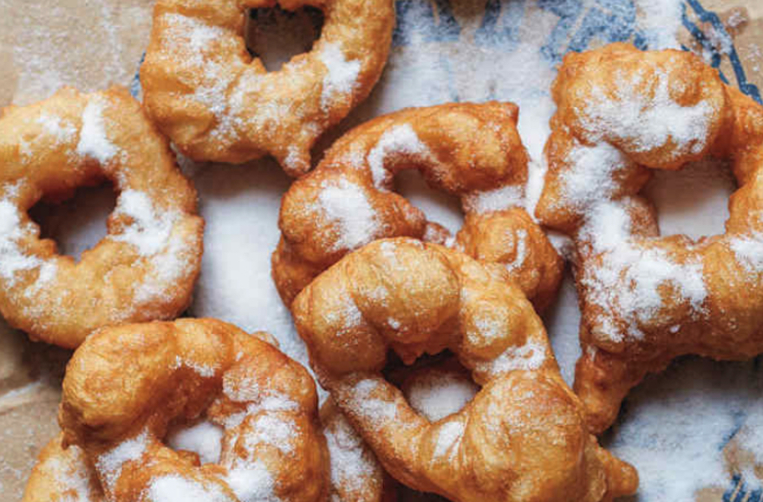
The sfinj hails from North Africa. (Con Paulos for “Breaking Breads by Uri Scheft/Artisan Books)

TEL AVIV (JTA) – The sufganiyah is the plump, shining star of Hanukkah in Israel.
During the holiday season, the famed jelly doughnut poses in the windows of cafés and bakeries across the country. It sparkles with oil and sugar, and shows just enough filling to keep fans interested.
Every year, top chefs compete to give the sufganiyah an edgy new twist, whether its cheesecake filling, mascarpone topping or a chocolate-filled squeeze tube accessory. Israeli TV channels, newspapers and social media are filled with close-up shots and reviews of the most enticing innovations.

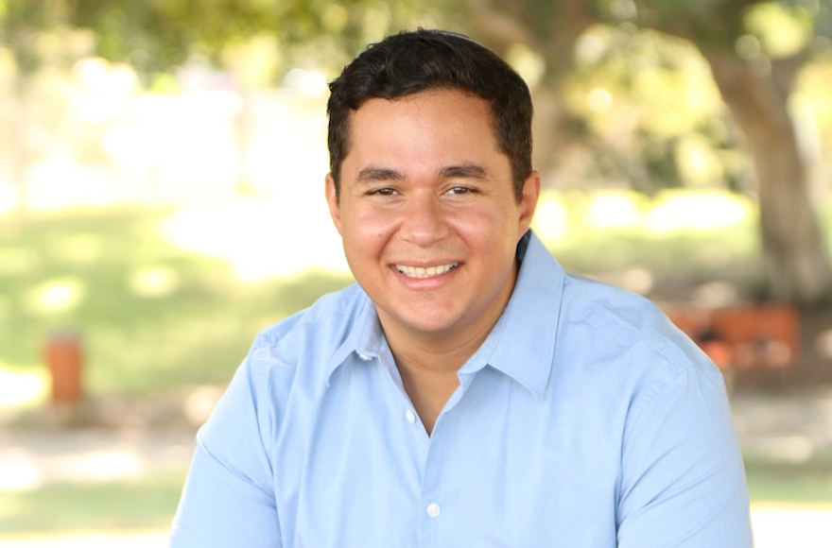
Dan Illouz hosts an annual sfinj party in Jerusalem. (Courtesy of Illouz)

Meanwhile, in homes across the country, Israelis quietly fry up a humbler Hanukkah doughnut called the sfinj. The confection hails from North Africa, and is a favorite of Jews whose families came to Israel from the region. But even European Jews have adopted the sfinj and helped push it toward the limelight.
Part of the appeal of sfinjim, the plural for sfinj, is that they are easy to make. Simply take a dollop of dough, poke a hole in the middle and deep fry in vegetable oil. The doughnuts can then be dipped in honey and coated in sugar, usually of the powdered variety.
Israelis of North African descent prepare sfinjim for holidays and special occasions. Dan Illouz grew up in Montreal, where his family ate the doughnuts during the eight nights of Hanukkah. When he immigrated to Israel eight years ago, he was dismayed that he could only find sufganiyot, so he began making sfinjim in his kitchen to celebrate the holiday.
During Hanukkah in 2010, Illouz, a 31-year-old public relations manager in Jerusalem, invited a handful of friends over to enjoy the doughnuts with him. Word spread quickly: Last year, about 400 people showed up at his three-bedroom apartment for what has become an annual sfinj party. Illouz expects at least as large a crowd for the third night of this Hanukkah, Dec. 14.
To feed the masses that show up throughout the night and spill into the street, Illouz begins preparing at around 7 a.m., 12 hours ahead of time. He estimated that he fries up about 150 of the doughnuts. It’s first come, first serve.
Sfinjim are of course at the center of the event, but Illouz also serves sweet couscous and store-bought Moroccan cookies and beverages. He puts on Moroccan music to set the mood, and when the sun sets, he and his guests light the menorah candles. Needless to say, sufganiyot, plural for sufganiyah, are not on the menu.
“I’m not ideologically opposed to sufganiyot,” he explained, “but I do prefer sfinjim. They’re just simpler, and they’re not quite as unhealthy.”
Illouz said his sfinj party is an expression of both Moroccan and Israeli pride, a duality that has become easier to reconcile in recent years. While Mizrahi Jews, or those with roots in North Africa and the Middle East, were long a socioeconomic underclass that faced systemic discrimination in Israel, their culture has lately experienced something of a renaissance.
Illouz said the new hipness of Moroccan traditions is probably part of what draws so many people to his sfinj parties.
“There’s definitely an element of that in the fact that people get excited about the party. People want to have a taste of this culture,” he said. “What I think is really beautiful is that all Israelis are able to enjoy it.”
About half of Israelis are now of Mizrahi descent, though the numbers are becoming blurred by marriage with Asheknazi, or European Jews, and others. Mizrahi music dominates the Israeli airwaves, with some musicians even singing in Arabic. Mizrahi cuisine, from falafel to shakshuka, is not only popular street food, but is also big at high-end restaurants and on popular cooking TV shows. And Mizrahi celebrations, like the post-Passover Mimouna feast and the henna pre-wedding bridal shower, have been embraced by the mainstream.
Of course, Mizrahi Jews have been contributing to Israeli culture for decades, whether or not it was always appreciated. Some credit them with bringing the tradition of Hanukkah doughnuts to the Jews of Palestine in the first place. According to this theory, sfinjim were then largely superseded by deep-fried Eastern European jelly doughnuts similar to today’s sufganiyot. (The oil is a nod to the Hanukkah legend in which the ancient Temple’s menorah stayed lit for eight days on a one-day supply of lamp oil.) The Arabic word “sfinj,” meaning sponge, was replaced by “sufganiyah,” a Hebrew word sharing the same root.
Some Ashkenazi Jews have also started making sfinjim at home, often inspired by Mizrahi friends and family.
Uri Scheft, a co-owner and chef at the high-end bakery chain Lehamim, learned to make the doughnuts from his wife, whose mother immigrated to Israel from Morocco. He included a sfinj recipe in his 2016 cookbook “Breaking Breads: A New World of Israeli Baking,” which celebrates the cuisines produced by the “melting pot” of Israeli society.
Scheft said he has planned for many years to serve sfinjim at his bakeries. But he would first want to set up a prep area so he could serve them fresh to customers.
“The character and the structure of sfinjim is very light, which make them very tasty, but only if they are eaten right away,” he said. “I think this is why bakeries shy away from serving them.”
While it is hard to find a hot sfinj for sale in Israel, it is not impossible.
Keren Kadosh, a pastry chef with a Moroccan background, occasionally serves them at her bustling downtown Jerusalem bakery, Café Kadosh — often in response to requests. At the same time, her lifetime of eating the doughnuts has shaped the way her bakery prepares sufganiyot, which it serves at a rate of a 1,000 day during Hanukkah.
“When the the sufganiyot come out of the fryer, we role it in sugar, and we get that exact same crunch, sweetness and texture,” she explained. “So in a way, we’re participating in the Moroccan culture of blessing each other, which has also become Israeli culture.”

Reprinted from the December 5, 2017 website of the JTA (Jewish Telegraphic Agency)
Jerusalem and Chanukah
By Rabbi Berel Wein

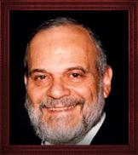

The decision by Pres. Trump to recognize Jerusalem as the capital of the state of Israel has been received in dismay and anger by portions of the Arab and Moslem world. This is pretty much what could have been expected since portions of that society have never given up on the idea of the destruction of the Jewish state.
However, what is more troubling and disappointing, to me at least, is the reaction of the left wing, peace-loving, progressive minded, noise making, arrogant section of the Israeli media and public. To think that the leading Israeli newspaper and a Zionist political party would object to what Pres. Trump has done is really mind-boggling.
The founders of the state, many of who were as left wing as they come, defended Jerusalem as part of the Jewish state both physically and politically. No effort was spared to make Jerusalem a Jewish city and to make it the capital of the Jewish state. The government offices were moved from Tel Aviv to Jerusalem, the Knesset building was erected in Jerusalem and the governmental quarter housing the ministries of the government has steadily expanded in Jerusalem.
The world may not have been willing to grant us Jerusalem but the Jewish people knew in heart and mind that Jerusalem was ours and that it was the capital and the heart of any Jewish state. For a section of the Jewish society to turn its back now on Jerusalem indicates how far removed these Jews are from their heritage and history.
The holiday of Chanukah, which marks the triumph of the ancient Maccabees over the Syrian Greeks, the restoration of Jerusalem as the holy capital of Israel and the purification of the Temple, also records for us that a different and just as significant battle was fought at that time. That battle was against the Hellenistic Jews, who denied Jerusalem, profaned the Temple and attempted to assimilate Judaism completely into Greek paganism and culture.
This struggle continued long after the military victory against the Syrian Greeks. It raged throughout Second Temple times and continued in various forms throughout Jewish history till our day. Within Jewish society there is always an anti-Jewish ideal on the agenda. It is always cloaked in piety and righteousness and represents itself as being progressive and tolerant when in reality it is neither.
Many times in Jewish history this insidious element has gained ascendancy in power and influence. But its accomplishments and triumphs never lasted. They were proven wrong by outside events as well as by the internal wisdom of Jewish society, which eventually rejected these ideas and plans.
The small lights of Chanukah have certainly outlasted the blazing temporary glory of Greek culture and Hellenistic Jewish imitators. But the struggle always continues and apparently is an eternal one. Perhaps that is why one of the blessings over the candles of Hanukkah refers to those days but also to our time. And we are witness to this by the events and reactions at this time regarding the recognition of Jerusalem as the capital of Israel by the President of the United States.
The Balfour Declaration, with all of its ambiguity and unfulfilled promise, opened the door for the eventual creation of the Jewish state in the land of Israel. The recognition by the United States of Jerusalem as the capital of the state of Israel may or may not be followed by other countries doing so. But that is only a short-term and immediate view of the matter.
Just as the Balfour Declaration had a long-term positive effect and revitalized the Jewish people in their attempt to gain independence and stature in the world, so to this declaration of Jerusalem as being the capital of the state of Israel has the potential for long-term positive change of attitude towards the Jewish state in world society.
The Talmud teaches us regarding personal probity and holy intentions that "if you will open your heart to me only as wide as the head of a pin, I will eventually open it as wide as the grand entrance to the Temple.” What we are witnessing is only a pin prick in the anti-Israel movement that has pervaded the American State Department for so many decades.
The previous president broke long-standing American policy by allowing America to facilitate the resolution in the United Nations against Israel. This new president has also broken long-standing American policy by recognizing Jerusalem as the capital of the state of Israel. We should appreciate the moment even though the future consequences are still not known.

Reprinted from the Parashat Miketz – Chanukah 5778 website of Rabbiwein.com

Shabbos Stories for
chanukah 5777
Volume 8, Issue 15 25 Kislev 5777/ December 25, 2016
Printed L’illuy nishmas Nechama bas R’ Noach, a”h

For a free subscription, please forward your request to keren18@juno.com

The Miracle of
Bubbie's Menorah
By Eli Hecht

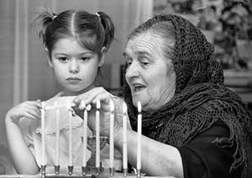

My sweet grandmother is a small woman, barely five feet tall. Her two feet tall candelabra was more than just a candle-holder. It was a family symbol, a magnet that brought us all together.
On Shabbat evenings Bubbie would don a special Shabbat kerchief. With great fanfare she would light each candle. When she finished lighting the last candle, she stood in front of the candelabra and closed her eyes. Tears ran down her cheeks. She prayed for her husband, her married children and her grandchildren. She spoke in Yiddish, "Her mein tier tata, hiet oif mein man, kinder un di eyniklach...." (Dearest Father in Heaven, watch and protect my husband, children and grandchildren. May it be your will that they grow up to be good people who are loyal to our religion. Please grant my dear husband a livelihood and patience. Watch over us all.)
We all stood by the Shabbat table in awe. Bubbie looked like a queen speaking to the King of Kings, the Almighty G-d. When she finished her prayer, we began our Shabbat.
As our family grew, Bubbie spent more time with her candles. By the time she reached her 94th birthday, she had many married grandchildren, who also had children of their own. There were five generations in Bubbie's family. When lighting the candles, Bubbie prayed for each family member.
Her candelabra was made of solid silver with a heavy silver base. All year-round it had three branches of two candlesticks. In the middle was a stem for another candle. The traditional custom for Shabbat eve is to light one candle each for the father, mother and children. As each child is born, another candle is added to the Shabbat lighting. Throughout the year Bubbie's candelabra was fitted for five candles.
During the week of Chanukah, she added another branch of two candlesticks each, making a total of nine candles. The candelabra was built in such a way that the candle holders could be removed and oil cups could be inserted for the special lighting on Chanukah. Our Shabbat candelabra became a Menorah.
During the week of Chanukah she gave her prized candelabra to my grandfather to light candles for the holiday. Chanukah was our happiest time. All the children, grandchildren and great-grandchildren came to Bubbie and Zaydie to receive Chanukah gelt and join in the Menorah lighting.
Imagine the two-foot menorah with nine candles shining in all its glory. Zaydie stood proudly like a Kohain, the high priest in the temple, when he lit the menorah.
When Zaydie died, Bubbie would spend her winters in Miami Beach. She took her candelabra with her. Every Shabbats Bubbie would shine the silver candelabra and pray, "May my mazel (luck) always shine!"
All this came to an end when someone stole her menorah. Bubbie was livid. Her small body shook like a willow in the storm as she spoke about her most prized possession, her candelabra. How could anyone steal it? Her only concern was how she would light her candles.
She believed the menorah would return. "I have prayed that the menorah would protect us, and I'm sure that the menorah has done just that. Now I pray that the menorah protect itself and be returned to me."
With silent determination she prayed and prayed. The family did not know what to do. Unexpectedly a childhood friend from Austria, Bubbie's birthplace, once visited us and announced, "I never saw another menorah like yours until today. Surprisingly I saw a replica of your menorah, in the window of a gift store."
We were dumbfounded. Could it be that our guest had seen the stolen menorah? Bubbie jumped back and said, "Let's get my menorah back! It soon will be Chanukah and I need the menorah back."
Bubbie, my parents, Bubbie's girlfriend, and a policeman made their way to the gift shop. With a gleam in her eyes and a shout of joy Bubbie pointed to her menorah and said to it, "Yes, you have done well. You have protected us and now you have protected yourself. Come back home with me."
Before anyone could say anything, Bubbie grabbed the menorah off the shelf and held it close to her heart. Nobody could stop her. Neighbors, Jewish and non-Jewish, joined Bubbie in her triumphant walk home. The closer she neared home, more and more people joined her. Bubbie, dressed in the European manner, with her slight frame carrying a menorah almost as big as her, followed by a procession of excited family and friends, was a sight to see. It truly was a grand Chanukah parade.
The menorah was given a special cleaning, and that Chanukah was the brightest in Bubbie's home. Who says that miracles don't happen anymore?

Reprinted from the Chanukah website of Chabad.Org

MODI’IN — FORTRESS OF THE HASMONEANS

The modern city of Modi’in founded in 1994, and the religious community of Modi’in Ilit (Kiryat Sefer) nearby, recall one of the miracles of Chanuka now being celebrated by Jews throughout the world. As we say in the special prayer of that day, “It was in the days of Matityahu, son of Yochanan the Kohen Gadol, the Hasmonean, and his sons” that the miracle of “the mighty and numerous Greek forces” bent on forcing assimilation were overcome by “the weak and few”. Mount Modi’in was the place where the Hasmoneans rallied their outnumbered forces and with the help of Heaven achieved victory over their oppressors. (OHRNET)
Chanukah – Lighting Left
By Rabbi Yirmiyahu Ullman

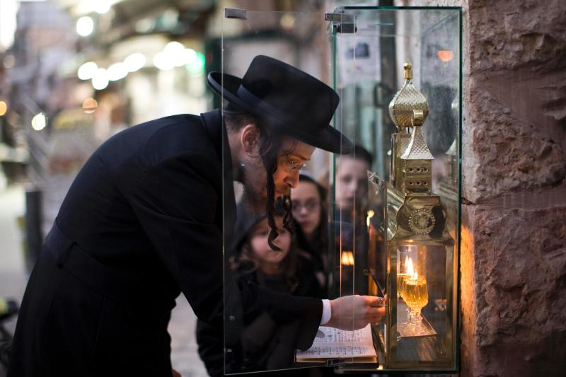
A man lighting a Chanukah Menorah in Yerushalayim

From: Chava

Dear Rabbi, It seems to me that the right side is usually given precedence in performing mitzvot. Why is the Chanukah menorah lit on the left side of the doorway?

Dear Chava, Many people nowadays light inside the house either on a table or near the window. But it is correct that according to the original halacha, and as still practiced by many today, the ideal location to light the Chanukah menorah is on the left side of the main, outer doorway into the house.
One reason that’s given in the sources is in order that a person will be encompassed by mitzvot — by the mezuzah, whose place is fixed on the right, and the menorah, which is therefore placed on the left. In this way, a person’s goings out and comings in are illuminated by the spiritual and physical light of the mezuzah and the menorah.
In addition, the verse states, “There is length of days in its right hand; in its left there are wealth and honor.” “Length of days” refers to the World-to-Come, which was given to Israel. “Wealth and honor” belonged to Yavan (ancient Greece), the descendent of Yefet. But when the Greeks tuned to evil, Israel merited their portion as well. Hence we have the mezuzah, which mentions length of days, on the right; and we light the menorah to symbolize our victory over Greece on the left, expressing our hope to receive their wealth and honor for the purpose of serving G-d.
Another idea is that since the doorway serves for entry as well as departure, while the menorah is on the left of the doorway going in, it illuminates the right side going out. That is to say, this lamp sheds light upon us even when we are “outside”, in exile among the nations of the world. And even now, while the Temple is not built, the light of the Chanukah menorah illuminates our path in exile.
In a similar light, the original altar was consecrated on the 25th of Kislev, the same day on which Chanukah was later instituted. The mitzvah of making a sanctuary for G-d in which He may dwell in our midst is thereby timeless, and every Jew is obliged to yearn daily for the rebuilding of the Temple.
One way we do this is by lighting the Chanukah menorah in memory of the miracle that occurred during that rededication of the Temple. And we place it facing outward on the right — like a person on vigil waiting at the door in anticipation of a long-expected wayfarer’s return. May we merit the arrival of Mashiach and the restoration of the Final Temple speedily in our days, Amen!

Reprinted from the 5776 Chanukah email of OHRNET, the Ohr Somayach Torah Magazine of the Internet.
Chanukah, 1942
By Carola Schiff

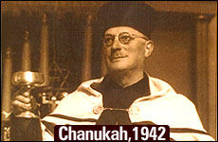

Spreading the light in Nazi-occupied France.

My father, Reb Meir Shlomo Sommer, Monsieur Sommer as he was called in France, was a man of uncompromising faith, conviction and courage. He was the principal of a Jewish Day school in Hamburg/Altona, Germany until Kristallnacht, when the Nazis closed the school. In July 1939, my father and mother were able to flee to France on a two week tourist visa to escape the Nazi reign of terror. In France both my parents were interned, separately, in various detention and labor camps. By Divine miracle, they were both released and reunited in October 1940.
Since they were Jewish refugees from Germany, they were considered a threat to France and were forced to go into hiding in the outskirts of Perigueux, a small town in southwestern France.
In 1942, at the height of the Nazi reign of terror, there were constant "Raffles" – Jews would be summarily rounded up and sent to horrible detention camps and from there to the infamous death camps of Eastern Europe. Curfew times were enforced and no one was allowed on the streets at night. It was a constant struggle to find hiding places to evade the Nazis and their French collaborators.
"From a population of about 330,000 at the end of 1940, nearly 80,000 Jews had been deported or murdered in France. They represented more than 24 percent of the Jewish community." (The Holocaust, The French, and the Jews, Susan Zuccoti p.207).
During their internment and in hiding, my parents clung to their faith with tenacity. Against all odds, my father maintained his strong Torah principles, never compromising on Kashrus, Shabbos or Jewish holidays. He was a man of strength and kindness. He was filled with love for his fellow Jew, and always tried to help others in need. He would regularly ignore the war-imposed curfew, and at the risk of his life, braved the terror of the Nazis in order to teach Torah to Jewish children in hiding.
After the war, my father was the spiritual leader in Vichy, France. Shortly after his untimely death in 1956, we received the following condolence card highlighting how my father managed to spread the light of Chanukah during the darkest time in Nazi-occupied France:

Chanukah 1942
1942 in Perigueux, France, a few men hurried into a rundown wooden barrack. Each opened the door carefully looking around to make sure they weren’t being followed. They then went into a hidden backroom. This room served as the makeshift Shul for those brave enough to venture out. The "shul" barely scraped together a minyan of men to pray.
They davened Maariv quickly, their hearts rapidly beating with the knowledge that at any moment the Nazis could storm in and arrest everyone. One man lit the menorah as the others ran to grab their coats and get home as fast as possible.
Suddenly, a man in the back of the room stood up and in a deep, warm voice started to sing “Maoz Tzur.” The men were frightened and aghast. Someone might hear; it was too dangerous! Soon another man joined in singing, then another and another, until everyone was tearfully and courageously singing with joy. For the moment, gone were the fears of the Nazis. For a few moments, Chanukah was there in all its glory, as in days of Judah the Maccabbe, a few brave men stood proud, their faith prevailing over the evil surrounding them.
The man who stood to sing was my father, Reb Meir Shlomo Sommer known to all as Monsieur Sommer, of blessed memory. My father had never told anyone of us his Chanukah victory during those dark time, yet even after his death, this story continues to inspire light.

Reprinted from the Chanukah website of Aish.com
Sufganiyah – To Eat or Not to Eat, That is the Question!

Why Jelly Doughnuts Are
Eaten During Hanukkah
By Emelyn Rude

It's not just a matter of celebrating with foods cooked in oil

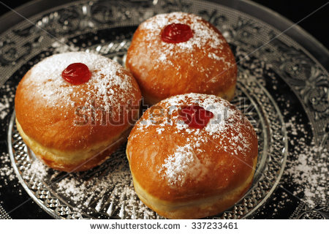

The Israeli version is the sufganiyah—the singular of sufganiyot—and it’s not only the L-rd’s consolation prize, but also a staple of annual Hanukkah celebrations. It’s said that the fried treats are a good fit for a holiday focused on oil, commemorating the miracle of one night of oillasting for eight. The most stereotypical sufganiyot, after all, are fried balls of yeast dough filled with strawberry jelly and dusted heavily with powdered sugar.
But jelly doughnuts weren’t a part of a typical diet at the time the Hanukkah story would have taken place, and the miraculous oil isn’t the whole story behind why they’re eaten on the holiday.
The word sufganiyot can be traced back to the Greek word sufan, meaning “spongy” or “fried,” as can the Arabic word for a smaller, deep-fried doughnut named sfenj. This could perhaps be where these treats got their name; similar fried balls of dough have been eaten to commemorate Hanukkah for centuries by Jews in North Africa.
But these Moroccan and Algerian treats didn’t have the modern sufganiyot’s characteristic jelly filling, which is where migrants from Central Europe came in. The first fried pastries in European history typically contained savory fillings, like meat or mushrooms. But the establishment of colonies in the Caribbean in the 16th century brought cheap, slave-produced sugar to the continent and led to a renaissance in fruit preserves and from that a renaissance in sweet stuffed pastries.
The first known recipe for a jelly doughnut, according to historian Gil Marks, can be found in the 1532 German cookbook Kuchenmeisterei, which translates to “Mastery of the Kitchen” and is remembered by history for being one of the first cookbooks run off of Gutenberg’s famed printing press. The treat was made by packing jam between two round slices of bread and deep-frying the whole thing in lard.
From its Germanic origins, the dessert quickly conquered most of Europe. It became krapfen to the Austrians, the famous Berliners to the Germans and paczki to the Polish. Substituting schmaltz or goose fat for the decidedly un-Kosher lard in their fryers, the Jewish peoples of these regions also enjoyed the dessert, particularly Polish Jews, who called them ponchiks and began eating them regularly on Hanukkah. When these groups migrated to Israel in the early twentieth century, fleeing the harsh anti-Semitism of Europe, they brought their delicious jelly-filled doughnuts with them, where they mingled with the North African fried-dough tradition.
But it would take more than just the mingling of Jewish cultures to make the sufganiyot the powerful symbol of Israeli Hannukah it is today. Credit must be given to the Israeli Histradut. Founded in 1920 in what was then British-mandated Palestine, the national labor group’s aim was to organize the economic activities of the Jewish workers in the region. Founded on Russian socialist principles, full employment was amongst its aims, as was the integration of the new Jewish immigrants making their ways to the country’s shores.
The latke, the classic fried potato pancake that was already associated with Hanukkah celebrations, is a dish that can easily be made at home. A perfectly filled and fried sufganiyot is much more difficult. Even some of the most talented at-home cooks will agree that the treat tastes better when left up to the professionals. Which is exactly what the Histadrut wanted: a Hanukkah treat that involved professionals. As many important Jewish holidays are concentrated in autumn, the end of that season often brought a lull in work in Jewish quarters.
By pushing the sufganiyot as a symbol of the Festival of Lights, as opposed to the DIY-friendly latke, the Histradut could encourage the creation of more jobs for Jewish workers.
By all accounts, the Histadrut’s efforts to promote the jelly doughnut worked. In modern Israel, over 18 million sufganiyot are consumed in the weeks around the holiday, which averages out to over three doughnuts per citizen. More people enjoy the fried treat than fast on Yom Kippur, the holiest day in the Jewish calendar, and the Israeli Defense Forces purchase more than 50,000 of the doughnuts each day of the eight-day holiday to boost the morale of its troops.
Sufganiyot can now be found throughout the United States as well during Hanukkah, produced by Jewish and non-Jewish bakeries alike. After all, as people all over the world have been discovering for centuries, no one can say no to a truly delicious jelly doughnut.
Emelyn Rude is a food historian and the author of Tastes Like Chicken.

Reprinted from the December 7, 2015 edition of TIME Magazine

Israeli Health Minister Declares ‘Donuts – Out!’
By Times of Israel Staff

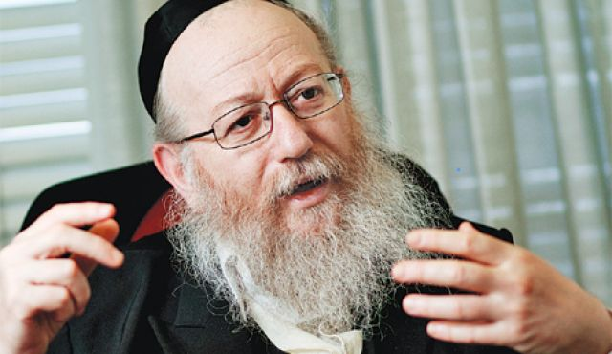
Health Minister Yaakov Litzman at a press conference at the Health Ministry in Jerusalem, on November 21, 2016. (Photo by Hadas Parush/Flash90)

[Rabbi] Yaakov Litzman says Israel must find alternative to sugary, oily Hanukkah treat, educate children to eat better. Health Minister Yaakov Litzman has urged Israelis to eat fewer sufganiyot, the oily jelly donuts traditionally eaten during Hanukkah — and in recent years in Israel, for weeks beforehand — as part of his crackdown on unhealthy food.
Litzman, of the ultra-Orthodox United Torah Judaism party, who in the past criticized the amounts of junk food eaten in Israel, and specifically called out fast-food giant McDonald’s, has now found another target, the Kikar Hashabat news site reported Sunday.
“When I said that we should cut down on McDonald’s, they thought I’d gone crazy,” Litzman told a healthy lifestyle forum. “If I would have said it today, I would have said, ‘Sufganiyot – out!'”
Litzman said that there are many healthy, alternative ways of celebrating the festival which should be encouraged.
“We can find alternatives and we don’t have to feed our children donuts which do not match health values and proper nutrition,” he said. “Obviously we can eat them, since they are part of our tradition, but there are better substitutes. I call on the public to avoid eating donuts which are full of oil.”
Litzman was speaking at a conference led by Professor Itamar Raz, head of the National Council for Diabetes.
In March, Litzman controversially attacked McDonald’s, saying that “there is no need to eat junk food, not in our country.”

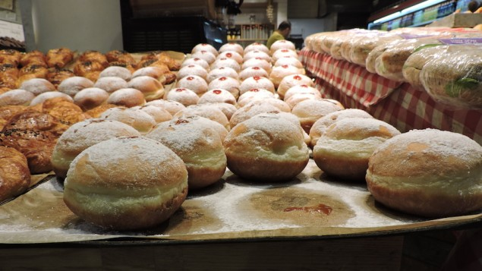
He urged parents and educators to teach children not to eat junk food and sweets and stressed that the Health Ministry would focus on “preventative” medicine this year to curb disease.
Now the minister may have bitten off more than he can chew in attacking these winter treats. Jelly donuts are very popular in Israel, where an array of flavors is featured at bakeries, supermarkets, coffee shops and restaurants beginning as early as October.
The Festival of Lights, which commemorates the Maccabean revolt against the Greeks, has long featured oily foods such as latkes and donuts in remembrance of the miracle of the temple oil, which lasted eight days instead of the expected one.
Jelly-filled donuts typically have around 375 calories per 100 grams. However, just days ago Burger King announced that, this Hanukkah, it will be offering a version of its Whopper burgers served on the traditional sufganiya.
The American fast food chain said the “Sufganiking” will be on sale at all Burger King chains in Israel starting on December 25, the first night of Hanukkah, until January 1st, and will cost NIS 14.90 ($4.00).

Reprinted from the December 12, 2016 edition of the Times of Israel.
The Story of Chanukah in Brief

REMEMBERING LIGHT
During the time of the 2nd Temple, the Holy Land was ruled by cruel Greeks. They robbed the Jews of their property, and set up idols in the Beit HaMikdash. No one could stand up against them, till Mattityahu and his sons rose up and drove them from the land. The Chanukah lights remind us of the great miracle that a small band of Jews defeated the mighty Greek armies.

FIGHTING FOR LIGHT
The Greeks were philosophers. They accepted the Torah as a book of wisdom, but not as something holy that connects us to Hashem. In the end, they made Torah learning illegal, and outlawed Mitzvot like Shabbat, Rosh Chodesh, Brit Milah, and the holiness of Jewish marriage. The Maccabeesrisked their lives to keep Torah alive! That’s why they won!

THE MIRACLE OF LIGHT
An even greater miracle than defeating the Greek armies was the miracle of the oil. The Greeks had made all the oil in the Beit HaMikdash impure. Miraculously, the Maccabees found one jar that had been overlooked. But it only had enough oil for one day. So great was their love of G-d, that they lit it anyway! Hashem made another miracle, and the oil burned for eight days! Everyone could see that the Shechinah dwelt with the Jews.

JOYOUS LIGHT!
With tremendous joy, the Jews cleansed the Beit HaMikdash and began to serve Hashem once again! Nowadays, we have to draw on that joy, because the darkness has grown very great! That's why we make Chanukah parties, with dreidels, latkes, and Chanukah gelt. Joy has the power to overcome any negative thing, and break any evil decree!

ADDING LIGHT!
Every day of Chanukah we add another candle till all eight candles of the Menorah are ablaze. By adding a candle every night for 8 days, we charge ourselves up with light, so that we will constantly be adding in Torah and Mitzvot (which are compared to light), throughout all the days of the year to come.

HOLY LIGHT!
The light of the Chanukah candles is holy, like the light of the Menorah in the Beit HaMikdash. We are careful not to use it for any purpose — our Mitzvah is just to look at the candles and listen to the story that they tell.

FILLING THE WORLD WITH LIGHT!
The miracle of Chanukah occurred in a dark time when there were wicked decrees against the Jews. But the Maccabees had courage and never lost hope. Their mesirut nefesh (self sacrifice) turned the darkness into light! Today too, our mesirut nefesh for Torah and Mitzvot will light up the world and bring Moshiach Now!

Reprinted from the website of JewishKids.org

Shabbos Stories for
Chanukah 5777 – Part 2
Volume 8, Issue 17 2 Teveth 5777/ December 31, 2016
Printed L’illuy nishmas Nechama bas R’ Noach, a”h

For a free subscription, please forward your request to keren18@juno.com

A Slice of Life
"Hizzoner" and
Two Menoras
By Rabbi Yosef Landa

I was listening to the radio the day Ed Koch passed away, when I heard a recording of the former New York City Mayor answering a reporter's question about how he would like his epitaph to read.

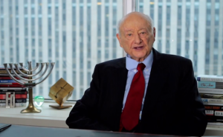
The late Mayor Ed Koch of New York City
with a Menorah in the background.

In his inimitable style Koch responded without missing a beat. "He was fiercely proud of his Jewish faith and he fiercely loved the City of New York," he said. I was totally impressed. Here was a wonderful manifestation of the "pintele yid," that inexhaustible Jewish essence which is at the core of every Jew. It was noteworthy, I thought, how Koch had mentioned his pride in his Jewish identity first, ahead even of his love for New York.
I recalled how over 30 years ago while serving as Mayor, Koch helped some of my fellow Jews in St. Louis - may G-d bless them and keep them - to learn an important lesson. Koch probably never knew what he accomplished that day, and I never had the opportunity to thank him for it. So I'll share the story here as my belated expression of gratitude to "Hizzoner" the Mayor.
Young, idealistic and inexperienced, my wife, Shiffy, and I had just moved to St. Louis a few months earlier to establish Chabad in this mid-size Midwestern Jewish community of about 50,000. One of our earliest community-wide projects was to erect a fifteen-foot Chanuka menora on the plaza of the St. Louis County Government Center. The county executive happily approved the menora display and even joined us for the beautiful lighting ceremony. The TV and news reporters were present and provided ample media coverage. We received many wonderfully supportive comments from the public, Jews and non-Jews alike, telling us how the menorah was a tasteful and fitting expression of Jewish celebration and pride, and of the religious diversity which is this country's blessed hallmark.
Much to our surprise and dismay, the menora display also encountered fierce opposition, which emanated largely from the professional leadership - well meaning, I am sure -- of an array of local Jewish establishment organizations. Their argument was ostensibly that they considered the placement of the menora on public property to be in violation of the constitutional separation of church and state. It was evident, however, that there also was an underlying unease with the forthright, unabashed public display of Jewishness which the menorah represented, and which many Jews in this conservative city, in the middle of America, were unaccustomed to at the time.
These were well-intentioned people who were firmly attached to what they perceived to be the Jewish community's sacred opposition to such displays. Some saw us as foreigners, "imports from Brooklyn" (that's how one writer referred to us in an op-ed), who had come to town to overturn long-standing, hallowed community norms. The county executive, to his great credit, remained firm in his support of the menorah display, and the entire community was abuzz over this controversy. The local Anglo-Jewish newspaper made it front-page news and editorialized against us, and word of the discord within the Jewish community even reached the general media. It was not a pleasant situation, to say the least.
A lot has changed since then. We have become good friends with many of the people who initially opposed us, and Chabad now enjoys deep and fruitful relationships with individuals and organizations from throughout the community. The public Menora has become a commonplace and accepted feature in many cities across the country. Moreover, in a couple of landmark rulings the U. S. Supreme Court gave its nod to this sort of "holiday display" on public property. Eventually American Jewish organizations came around to recognize that there exists a constitutional argument in support of such displays as well, namely the protection of our religious freedom and of free speech. But our story happened well before that.
It was the last day of Chanuka that year, and the iconic, big city Mayor Ed Koch happened to be in St. Louis to address the annual meeting of the local Jewish Federation which was held over a Sunday brunch at an upscale St. Louis hotel. Several hundred supporters were in attendance, including many of the professional and lay leaders who were heading the opposition to the menorah. Koch gave his speech, which of course had nothing to do with the menorah, and then proceeded to take questions from the audience.
That's when one questioner took to the floor and asked Koch to explain how, as a Jewish mayor, he dealt with the issue of religious symbols on public property and, specifically, would the mayor be kind enough to share his own view about the placement of menorahs on public property.

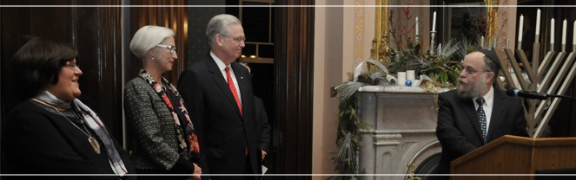
From right to left: Rabbi Yosef Landa, Missouri Governor Jay Nixon, First Lady Mrs. Georganne Nixon and Rebbetzin Shiffy Landa at the 2013 Festival of Lights (5th Night of Chanukah) that was celebrated with a lighting of the Menorah and a Chanukah Party at the Governor’s Mansion in Jefferson City, Missouri.

An audible gasp went up from the audience. Someone had dared to bring up the embarrassing, unmentionable topic of the menorah display in the presence of this important guest. Then there was utter silence as the straight-shooting Koch responded in his typical direct and outspoken manner. "I have no problem whatsoever with having a privately-funded menorah on public property", he said. "I think it's absolutely wonderful. I'm proud to say that we have one in New York City at Fifth Avenue and Central Park" he continued.
As if he hadn't said enough on the subject, the Mayor continued further. "Let me tell you what else we do in New York," he said. "The menorah is in Manhattan. The people who light the menorah are the Lubavitchers. They live in Brooklyn. So when they light the menorah in Manhattan late on Friday afternoon when it's getting close to Shabbos, we provide them with a helicopter and we fly them back to Brooklyn, so they can get home in time for Shabbos!"
Nothing more needed to be said. That was the end of the problem. While I'm sure most people in the audience didn't change their minds about the menorah display and the First Amendment just because of what Koch had said, he nonetheless succeeded to make everyone understand that good and decent people within the Jewish community can hold differing views on such matters.
While doing so, he not only quieted a controversy regarding church-state separation, but more importantly, he let my fellow Jews in St. Louis see a wonderful first-hand example of real, unapologetic Jewish pride. He reminded them that there's no reason in this great country for anyone to hide their Jewishness as if it were contrary or inimical to American life and culture. And for that I am most grateful. Thank you, Mayor Koch.

Reprinted from last year’s Miketz 5775 edition of “L’Chaim,” a publication of the Lubavitch Youth Organization in Brooklyn, NY. ,Rabbi Landa is the director of Chabad of Greater St. Louis, in Missouri

When Levi Yitzchak of Berditchov Wished His Kehillah Blessings for
The New Year on December 31st

It was late at night one New Year’s Eve, December 31, and the beis medrash of Rav Levi Yitzchak of Berditchov was still filled with his chasidim who were sitting and learning. Close to midnight, the door to the private office of the Rav, which was adjacent to the beis medrash, opened, and the Rav shouted out to his Chasidim: תכתבו טובה לשנה ותחתמו, ‘May you be inscribed and sealed for a good year!’ He then returned to his office and closed the door behind him.
The chasidim were mystified. Didn’t the Rav know that this was the secular New Year and not the Jewish New Year? A short time later the same thing happened and the Berditchover Rebbe came out to bless them. And then this happened again for a third time.
The chasidim were totally baffled! As not just anyone could approach the Rav, the men asked an elderly chasid to approach him and ask for an explanation. The Rav told the elderly man the following: The previous Rosh Hashanah, the tefilos and shofar blowing of the city of Berditchov were especially beautiful and heartfelt and went directly to Heaven. Hashem was so taken by these tefilos that He immediately inscribed the entire city in the Book of Life and bestowed on each and every one of them a year of health and wealth.
When Yom Kippur came, Hashem was so taken by their fasting and crying. The people poured out their hearts into their prayers. Hashem was about to seal the inscription that He had written on Rosh Hashanah, when suddenly the Satan spoke up.
“True, the people have been praying fervently, but, this is only one day! How can You inscribe them favorably for an entire year based on their actions of only one day?"
Hashem therefore held back and the inscription was not sealed. Immediately after Yom Kippur, the people started to build their succos in preparation of the upcoming Yom Tov. The defending angel spoke up, “Hashem, see how Your people are involved in doing the mitzvah? Even the poor people are building their succah to the best of their abilities!”
The Satan was not to be deterred. “Again, I object! True, they are building succos for You. But, look at the houses they live in, permanent structures of brick, stone and glass. But for You, Hashem, they merely build temporary shacks that can barely last the week!”
Again, Hashem held back from sealing the inscription. Simchas Torah came and the shuls were filled with dancing and joyful happiness. Again, the defending angel came to Hashem and spoke up. “Hashem, don’t You see how your children are rejoicing for Your Torah? Shouldn’t the inscription be sealed?”
Hashem was about to seal the inscription when again the Satan spoke up. “I object yet again! True, they are rejoicing with the Torah tonight. But, how can You inscribe them favorably based on their actions of one night? When Yom Tov is over, they will go back to their old ways! They are undeserving!”
Hashem once again held back from sealing the inscription. So it was that the inscription that was written on Rosh Hashanah remained unsealed through Yom Kippur, Succos, Hoshanah Rabbah, Shmini Atzeres and Simchas Torah.
Tonight, on New Year’s Eve, however, the defending angel spoke up. “Hashem, King of the Universe! Do You see how non-Jews celebrate the New Year? Shouting and drinking in the streets, and all manner of carrying on! Do you remember how your children celebrated their New Year? They did it with prayer, atonement and holiness.”
“This time the Satan had no response. Rav Levi Yitzchak concluded, “Therefore, after all this time the inscription was finally sealed! I felt it appropriate to bless everyone with a Shanah Tovah!”
Reprinted from the Parshas Vayechi 5775 email from Torah U’Tefillah: A Collection of Inspiring Insights compiled by Rabbi Yehuda Winzelberg.

Celebrating New Year’s
Day or Not
By David Bibi

This year (2014), January 1st coincides with the Tenth of Tevet, a day of fasting, mourning and introspection. On the 10th day of the Jewish month of Tevet, in the year 3336 from Creation, the armies of the Babylonian emperor Nebuchadnezzar laid siege to Jerusalem. Thirty months later—on 9 Tammuz 3338—the city walls were breached, and on 9 Av of that year the Holy Temple was destroyed.
This morning in Synagogue, I mentioned that the Shulchan Aruch and the Tur suggest that if possible, a person should really fast three days, the 8th, 9th and
10th of Tevet. This fast is so strict that when it falls on Friday, while every other fast is pushed off, we must fast on Friday.
Some even suggest that if the Tenth of Tevet fell on Shabbat (it’s not possible using our current calendar) we would be required to fast on Shabbat. Given that this day falls on the day when our neighbors are out celebrating we decided to replace our class this morning with a discussion of New Year’s day and how a Jew should treat that day.
The class was based on a class given by my wife Chantelle’s rabbi, Lawrence Kelemen. He is, aside from my wife’s rabbi, a professor of education at Neve Yerushalayim College of Jewish Studies for Women in Jerusalem, where he also lectures in modern and medieval philosophy.
R’ Kelemen was awarded his undergraduate degree at U.C.L.A. and did graduate studies at Harvard. My daughter Aryana had the pleasure of having him as a teacher while she studied in Israel. He has many classes available on line to listen to at SimpleToRemember.com, including The Real Story of Christmas, We Are Never Alone: The Unbelievable Story of a Child’s Birth and A Rational Approach To The Divine Origin of Judaism. I published a version of this article more than a decade ago, but after the class, everyone wanted me to put the class into writing so they could share it with others so here we go. And on the one hand, I’m sorry if you cancel your New Year’s plans but on the other hand, when you finish reading this, how can you not?
In 46 B.C.E. the Roman emperor Julius Caesar first established January 1 as New Year's Day. Janus was the Roman god of doors and gates, and had two faces, one looking forward and one back. Caesar felt that the month named after this god ("January") would be the appropriate "door" to the year. Caesar celebrated the first January 1 New Year by ordering the violent routing of revolutionary Jewish forces in the Galilee.
Eyewitnesses say blood flowed in the streets. In later years, Roman pagans observed the New Year by engaging in drunken orgies -- a ritual they believed constituted a personal re-enacting of the chaotic world that existed before the cosmos was ordered by the gods. Do we really want to celebrate a pagan holiday?
Early Catholics did not accept this pagan date as the New Year at first. When the calendar system of Anno Domini was first introduced by Dionysius Exiguus in 525 of the common era, he assigned the beginning of the new year to March 25. This date is called Annunciation day in the church because it is they
claim, the day of the announcement by the angel Gabriel to Mary that she would conceive and become the mother of Yeshu.
So while the pagans celebrated January 1 as the beginning of the year, Christians celebrated March 25 as their beginning of the year. After William the
Conqueror was crowned at Westminster Abbey on December 25th in 1066, he announced that the New Year would take place on January 1st after the Roman custom and to forever commemorate his monarchy. The Christians weren’t very pleased and about a century later, the year 1154 ended on the 31st of December, but the start of 1155 was delayed to 25-March. And things continued this way for the next 500 years.
The Julian calendar as set up by Julius Caesar counted 365 ¼ days per year and the rule was to add one extra day every four years to allow for that extra quarter. But the year is actually 365 days, 5 hours 48 minutes and 46 seconds as the Rabbis knew more than a thousand years prior. And those missing 12 minutes year after year add up.
In 1582, Pope Gregory XIII ( one of the greatest anti-Semites of all time) abandoned the traditional Julian calendar and established the Gregorian calendar which differs from the Julian in three ways: (1) No century year is a leap year unless it is exactly divisible by 400 (e.g., 1600, 2000, etc.); (2) Years divisible by 4000 are common (not leap) years; and (3) once again the New Year would begin with the date set by the early pagans, the first day of the month of Janus - January
1. The Pagan New Year would become the Christian New Year.
And how should one celebrate a Christian New Year? On New Year’s Day, Pope Gregory XIII decreed that all Roman Jews, under pain of death, must listen
attentively to the compulsory Catholic conversion sermon given in Roman synagogues after Friday night services. On Year Year’s Day 1578 Gregory signed into law a tax forcing Jews to pay for the support of a "House of Conversion" to convert Jews to Christianity. On New Year’s 1581 Gregory ordered his troops to confiscate all sacred literature from the Roman Jewish community. This included copies of the Talmud, Jewish law books and Torah scrolls.
Thousands of Jews were murdered in the campaign. New Year’s sounds more like a day of mourning as it is this year than a day of celebration. Throughout the medieval and post-medieval periods,
January 1 - supposedly the day on which Jesus' circumcision initiated the reign of Christianity and the death of Judaism - was reserved for anti-Jewish activities: synagogue and book burnings, public tortures, and simple murder.
As such Israelis felt they shouldn’t celebrate New Year’s day, but still needed an excuse to party on New Year’s eve. So in Israel, these celebrations are
called “Sylvester.”
Tis was the name of the “Saint” and Roman Pope who reigned during the Council of Nicaea (325 C.E.). The year before the Council of Nicaea convened, Sylvester convinced Constantine to prohibit Jews from living in Jerusalem. At the
Council of Nicaea, Sylvester arranged for the passage of a host of viciously anti-Semitic legislation.
All Catholic “Saints” are awarded a day on which Christians celebrate and pay tribute to that Saint’s memory. December 31 is Saint Sylvester Day – hence celebrations on the night of December 31 are dedicated to Sylvester’s memory. Amazing, Israeli’s celebrating the day of an Anti-Semite and the one who prohibited Jews from Jerusalem.
For Jews, The day is more an anniversary of mourning then one where we could possibly engage in reckless and drunken merriment. Paraphrasing Rabbi Kelemen, many who are excitedly preparing for their New Year celebrations would prefer not knowing about the holiday’s real significance (and most never even heard of the Tenth of Tevet.) If they do know the history, they often object that their celebration has nothing to do with the holiday’s monstrous history and meaning. “We are just having fun.”
He [Rabbi Kelemen] tells us to imagine that between 1933-45, the Nazi
regime celebrated Adolf Hitler’s birthday – April 20 – as a holiday. Imagine that they named the day, “Hitlerday,” and observed the day with feasting, drunkenness, gift-giving, and various pagan practices. Imagine that on that day, Jews were historically subject to perverse tortures and abuse, and that this continued for centuries.
Now, imagine that your great-great-greatgrandchildren were about to celebrate Hitlerday. April 20th arrived. They had long forgotten about Auschwitz and Bergen Belsen. They had never heard of gas chambers or death marches. They had purchased champagne and caviar, and were about to begin the party, when someone reminded them of the day’s real history and their ancestors’ agony.
Imagine that they initially objected, “We aren’t celebrating the Holocaust; we’re just having a little Hitlerday party.” If you could travel forward in time and meet them; if you could say a few words to them, what would you advise them to do on Hitlerday?
When I wrote this way back when I concluded ….. So now that I have completely ruined your New Year’s eve plans let me end with a thought from my club going days. (I guess all of life’s experiences have lessons). Those of us who would party in Studio and Xenon every night would know that on New Year’s
Eve, one takes the night off. New Year’s Eve was known as the night 'the regular people' came out and we considered ourselves anything but regular.
As Jews, we should remember that we are special, so this year before you run out to party, consider the origins of the day especially for us. The first Jewish
New Year’s day was the day that G-d created man. The first January 1st was the day Caesar ordered the murdering of Jews. As Jews we celebrate Rosh Hashana with family and in prayer. We have our New Year’s day! Maybe we can leave January 1st to everyone else. Why not leave it to the regular people? And remind yourself that you really are more than just regular. You are very special!

Reprint from the 2014 email from Shabbat Shalom from Cyberspace.

Story #941
A Timely Invitation
From the desk of Yerachmiel Tilles
editor@ascentofsafed.com

A Jew in Montreal submitted to L'Chaim Weekly the following report that occurred during Chanukah 5768 Dec. 2007).
Soon after his Bar Mitzva, my younger brother decided to renounce all practice of Jewish traditions. In the years that followed, he was totally disinterested and disengaged from any customs or rituals of the Jewish holidays and his identity as a Jew was utterly non-existent.
After my brother got married, he and his family moved to the St. Dorothy, Laval, neighborhood of Montreal, a couple of streets away from my parents' home.
For a number of years, Christian missionaries had been regularly visiting my brother's home. Most of us know the importance of simply closing the door on these people the very first time they appear at our homes. Wanting to be courteous, my brother innocently gave them a listening ear each time they appeared. The missionaries' visits became frequent and regular. Eventually, they invited him to join them for an evening at their house of worship, "...for you to better understand the Word, and for your daughter to interact with other children...," they told him. My brother had every intention of accepting their personal invitation.
The same evening that my brother was receiving this invitation from the missionaries, a totally different scene was taking place in my parents' home. A Chabad rabbi, Rabbi Zalman Stiefel of the Young Israel of Chomedey, Laval, had organized a Chanuka party at the home of a family with whom he had become friendly in the St. Dorothy neighborhood. Not knowing who would attend the party, one week before Chanuka Rabbi Stiefel decided to personally visit 10 homes that had a mezuza on the front door post and invite these Jewish neighbors to the Chanuka party. One of his first stops was my parents' home, as they live directly across the street from where the Chanuka party was taking place.
My parents were delighted with the invitation and happily accepted. My mother then asked the Rabbi if he would do them a favor. "Would you mind going to our son's home? There is no mezuza on his front door. Here is the address. Can you please invite him to the Chanuka party as well? He lives a few blocks away. He is estranged from Judaism, but perhaps a personal invitation...," she ended hopefully.
Now, back to my brother's house. He was having an animated discussion with his wife, his brother-in-law, and his brother-in-law's fiancé about the upcoming missionary event. "I married a Jew and you're staying a Jew!" my sister-in-law was telling my brother. "You're not going to this event!" she told him strongly.
My brother's brother-in-law picked up the phone and jokingly threatened, "I'm going to call your father and tell him to come over here to make sure that you don't go to this event." He then picked up the phone and pretended as if he was having a conversation with my father, explaining what was going on and insisting that my father come over to prevent him from going to the missionary event.
My brother was becoming more and more upset as everyone in the house seemed to be turning on him.
My brother began to shout, "The missionaries show an interest in me. They come to my door and visit me in my home. They spend time with me. They came to personally invite me to this event. When has a rabbi ever shown an interest in me? When has a rabbi ever knocked on my door and personally invited me to any kind of event?
My brother paused for a moment from his emotional outburst and at that instant, the doorbell rang.
Half-jokingly, my brother's brother-in-law said, "It's probably your father..."
The shock and disbelief on everyone's face was apparent when they opened the door and saw a young smiling rabbi standing there. Rabbi Stiefel was holding a menora and Chanuka candles in his hand.
It took a few seconds for everyone to collect themselves and think to ask the rabbi to come in out of the cold. "I'd like to invite you to a Chanuka party that is taking place a few blocks away," Rabbi Stiefel began.
Try to imagine the scene. My brother was busy trying to hold back his excited dog with one hand as he attempted to explain to the rabbi how shocked he was to have the rabbi visit his home to deliver the message of Chanuka.
This one encounter was sufficient to change my brother's thinking completely.
The next week, Rabbi Zalman and Aida Stiefel and their five children, together with the party's host and family waited to see who would turn up for the party. Low and behold in a wonderful display of Divine Providence, the only family to show up at the Chanuka party was my brother together with his daughter and our parents. Together they lit the menora, sang some Chanuka songs, enjoyed potato latkes and jelly donuts, all of which created wonderful memories for everyone.
That evening, my brother attended his first Jewish celebration as an adult. A few days later my brother attended the much larger menora lighting celebration at the synagogue.
More recently, he was invited with his family to join for a Shabbat meal at the Stiefel home, an invitation he graciously accepted and enjoyed.
I know that my brother and our whole family have been touched by this Chanuka miracle. G-d is great and omnipresent in our lives. I hope and pray that we all experience miracles "in these days at this time."
Source: Reprinted with slight variations by Yerachmiel Tilles from //lchaimweekly.org, issue #1051.
Reprinted from the Chanukah 5776 email of KabbalaOnline.org, a project of Ascent of Safed. www.ascentofsafed.com

It Once Happened

The First Night of Chanukah In the Court of the Kotzker Rebbe

It was dark outside. Nobody was out on the street. But in one building you would not have known it was night. It was the study hall of the Kotzker Chasidim in the heart of the forest. The Chasidim were sharing Torah thoughts. They sang Chasidic melodies and their faces were aglow with joy.

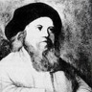
The Kotzker Rebbe
Chanuka was approaching and the next day they would kindle the first light of Chanuka. As they did every year, the Chasidim traveled to their Rebbe (Rabbi Menachem Mendel Morgensztern, zt”l, 1788-1859) to celebrate the holiday in a special atmosphere of holiness. Dawn broke and the Chasidim were still going strong, as though they had slept through the night.
"Chasidim," called out one of the elders of the group. "The sun is rising; let us go to the Rebbe." They quickly got ready for the morning prayers which were recited in an especially joyous atmosphere. After that, they set out on the way with song and dance. "G-d willing, we will arrive by this evening when the Rebbe lights the menora," rejoiced one of the Chasidim.
The wind howled. The Chasidim wrapped their coats even more tightly and continued battling the strong wind. Just a few hours remained until they would reach the Rebbe's holy court. But the sky darkened, the wind picked up strength, and snow began to fall, making walking difficult.
"Chasidim, be strong, surely this is the Satan who wants to delay us from being with the Rebbe on Chanuka. Let us muster our strength and with G-d's help we will get there safely," called out Hershel encouragingly.
They continued walking but for some reason, the road did not come to an end. According to their calculations, they should have arrived at the Rebbe's court already. A thick forest surrounded them and the Chasidim realized they were lost.
Suddenly, they heard someone shout, "Halt!"The Chasidim froze in their places. A few moments later, a band of Cossacks on horseback surrounded them.
"Ha," the evil ones chortled. "We have caught fat fish this time. Jews!" The Cossacks felt around in the Chasidim's pockets and knapsacks and took every penny they could find. They then brought them deeper into the forest to a place only the Cossacks knew about.
The Chasidim walked quietly, each one immersed in his thoughts, making a spiritual accounting, and praying for a Chanuka miracle.
The Chasidim were soon led to dark underground cells. "We will wait here until the commander comes and decides what to do with you," said a Cossacks as he whipped one of the Chasidim. Some time went by and the commander appeared. He declared that they be hung. The Chasidim began pouring out their hearts in the recital of Psalms and they rent the heavens with their tears.
At that very same time, in the court of the Rebbe, many Chasidim were waiting. The menora was ready and the first cup was filled with oil. The Chasidim waited for the Rebbe to come out of his room and light the menora.
One hour went by and then another and Reb Menachem Mendel of Kotzk was still in his room. The Chasidim there were surprised. "Every year, the Rebbe lights the menora as early as possible because the mitzva is so dear to him. Why is he waiting this year?"
The clock showed that it was close to midnight and the Chasidim were still waiting. Suddenly, the door opened and the Rebbe came out in a rush. Something looked amiss.
There was silence in the room as the Rebbe walked toward the menora. The Shamash was lit and the Rebbe said the first blessing loudly. Then the Rebbe said the next two blessings and held the Shamash to the first light, but oy, the wick did not ignite. The Rebbe tried again and again with no success. He sighed heavily and the Chasidim knew something had happened.
The Rebbe extinguished the Shamash, looked at the Chasidim, and quickly left the synagogue. The Chasidim looked at one another in shock. A commotion erupted until one of the Chasidim gave a bang and said, "It is not time for talking. Let us recite Psalms to avert the evil decree." Books of Psalms were quickly opened and the Chasidim read chapter after chapter with tears.
In the meantime, the Rebbe went to his room and changed his clothes. He put on a coarse leather jacket, big boots, a hairy coat and a leather hat that covered his face. He wrapped himself in a scarf and went out a back door into the blizzard.7
The Rebbe had a hard time walking through the deep snow, but this did not deter him from his mission. A few hours of exhausting walking passed until he reached his destination. He entered the forest and knew just where to go. He stopped at the entrance to the Cossack camp and stood there fearlessly. The Rebbe gazed at the Cossacks and they trembled. They quickly dropped their weapons and fled.
The Rebbe approached the hidden trapdoor, lifted it, and went down until he was facing the Chasidim.
"Rebbe!" they exclaimed in disbelief. "What is the Rebbe doing here? How did the Rebbe know we were in trouble?"
The Rebbe did not reply. He just motioned to them to get out and go with him to his synagogue so they could light the menora before daylight. "You did not wander far, the road to Kotzk is not long," the Rebbe said reassuringly. This time, the walk was easier and within a short time they were at the Rebbe's warm, inviting synagogue.
The Rebbe went over to the menora and lit the Shamash. This time, the first light lit immediately.

Reprinted from the Parshas Mikeitz 5777 edition of “L’Chaim Weekly,” a publication of the Lubavitch Youth Oganization in Brooklyn, NY.
Chanukah Gems

Which Menorah Should
The Father Light?

On Chanukah we celebrate by lighting the Menorah, which puts emphasis on publicizing the miracle that occurred with the oil. A question was once posed to Rav Yitzchak Zilberstein, Shlit”a.
A man told him that he had in his possession an old and ornate Chanukah Menorah made of silver. It was an inheritance that had been passed down in his family for generations. It was a work of art, and its value was many thousands of dollars. It was always an inspiration for him to light it each year, and it was also a beautiful sight to behold.
This particular year, just prior to Chanukah, the man’s young son had come home from school with a prize he had won for Hasmadah, diligence in learning Torah— it was a small brass Menorah, and the son was very proud that he had earned it.
What should the father do? Should he continue using the beautiful Menorah, or, as a sign of encouragement to his son, should he use the small brass Menorah he had come home with?
At first thought, Rav Zilberstein reasoned that since Chanukah is a time in which it is important to emphasize Hiddur Mitzvah, beautifying the Mitzvah, the father should use the silver Menorah.
On the other hand, what greater symbol of Pirsumei Nisa, publicizing the miracle, can there be than using the prize his child had won, a Menorah earned for Hasmadah in Torah study? In today’s times especially, a child who gives up his time to devote himself to Torah study perfectly demonstrates our true victory over the Greeks, who tried to get us to stop learning Torah and destroy our relationship with Hashem. This was why we fought the Greeks, and this is why we won the battle.
Rav Zilberstein told the man that we have a responsibility to publicize this fact, and he advised him to light the small Menorah that his son brought home!

Reprinted from the Chanukah 5777 email of Torah U’Tefilah: A Collection of Inspiring Stories compiled by Rabbi Yehuda Winzelberg.
The President’s
Last Chanukah Reception

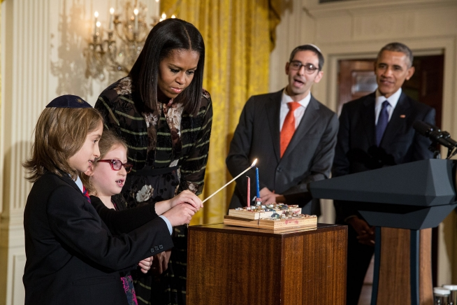
President Barack Obama, First Lady Michelle Obama and Rabbi Steven Exler watch Elijah and Shira Wiesel [grandchildren of the late Elie Wiesel] light the menorah during a Hanukkah reception in the East Room of the White House, Dec. 14, 2016. (Official White House Photo by Chuck Kennedy)

President Obama hosted his final Chanukah White House celebration, joined by community members from across the United States.
As the secular holidays coincide with the beginning of Chanukah, a time when the president is on vacation in Hawaii, the traditional White House receptions were moved up by over a week to accommodate the president’s schedule. As the president joked, “It so happens we’re a little early this year. But Michelle and I are going to be in Hawaii when Hanukkah begins, and we agreed that it’s never too soon to enjoy some latkes and jelly doughnuts.”
Following what has become a tradition in the Obama White House, there are two receptions, one in the afternoon and one in the evening, to allow for a diverse array of Jewish personalities from across the spectrum to participate. The president jokingly alluded to this in his evening remarks. “This is our second Hanukkah party today, but in the spirit of the holiday, the White House kitchen has not run out of oil.”
At the afternoon ceremony, the Obamas honored Elie Wiesel, the Holocaust survivor, author, and Nobel Peace Prize winner who passed away earlier this year.
“It’s important for our community to internalize that the White House Chanukah Reception is not merely a party to socialize but an important milestone for the Jewish community when the leader of the free world identifies with the historical aspirations of our people,” said Ezra Friedlander, CEO of The Friedlander Group. “When the president speaks, the world listens, and this year’s remarks addressing issues pertaining to highlighting the protection of religious freedom was especially significant in light of recent attempts to ban religious rituals domestically and abroad.”
President Obama’s remarks addressed this topic:
“The first chapter of the Hanukkah story was written 22 centuries ago, when rulers banned religious rituals and persecuted Jews who dared to observe their faith. Which is why today we are asked not only to light the menorah, but to proudly display it—to publicize the mitzvah.
“Everybody in America can understand the spirit of this tradition. Proudly practicing our religion, whatever it might be—and defending the rights of others to do the same—that’s our common creed. That’s what families from coast to coast confirm when they place their menorah in the window—not to share the candles’ glow with just your family, but also with your community and with your neighbors.”
The president concluded by honoring the memory of Elie Wiesel: “The story of Hanukkah, the story of the Jewish people, the story of perseverance—these are one and the same. Elie Wiesel taught us that lesson probably better than just about anybody. In one of his memories of the Holocaust, Elie watched a fellow prisoner trade his daily ration of bread for some simple materials with which to piece together a makeshift menorah. And he wrote that he couldn’t believe the sacrifices this man was making to observe the holidays. A stunned Elie asked him, ‘Hanukkah in Auschwitz?’ And the man replied, ‘Especially in Auschwitz.’”

Excerpted from the December 23, 2016 edition of the 5 Towns Jewish Times.

Shabbos Stories for
Parshas Mikeitz 5775
Volume 6, Issue 14 28 Kislev 5775/ December203, 2014
Printed L’illuy nishmas Nechama bas R’ Noach, a”h

For a free subscription, please forward your request to keren18@juno.com

It Once Happened

In the Merit of Matitiyahu, Father of the Macabbees

A huge group was gathered on the other side of the large table and looked in the direction of their rebbe, Rabbi Avraham Wienberg, the Slonimer Rebbe. He stood opposite the wicks in the Chanuka menora, meditating and contemplating, for an unknown reason not yet ready to kindle the Chanuka lights.
Hundreds of Chasidim stood in awe and with great respect, watching their Rebbe as he stood preparing for this mitzva. They waited with bated breath for the glorious moment when he would take the wax candle in his hand and begin reciting the words of the Chanuka blessings.
Minutes, which seemed like hours, passed and then the Rebbe began chanting the blessings. He infused each word with kabbalistic intentions, and each chasid there was able to hook into the holiness of the moment according to his own level.
"Help me, deliver me!"
The dreadful cry tore through the hearts of all those gathered there and awakened each person from his reverie. Everyone looked in the direction of the voice.
The Rebbe, his face aflame with the holiness of the moment, also turned his head in the direction of the voice toward the end of the synagogue. There stood a women with her hands outstretched toward the heavens, crying with a bitter heart.
It became clear that this woman was not one of the wives of the chasidim gathered there. In fact, she had no connection to the Rebbe or the Chasidic lifestyle. "Who was she?" some murmured.
The distraught woman lived with her family in this town. Her husband was a wealthy and well-respected businessman who had never in his life entered this Chasidishe synagogue. He and his friends were among those who laughed at the Chasidic lifestyle and customs.
For many years the couple had not been blessed with children. When their son was finally born they were already much older. Their happiness knew no bounds. He was always given the best of everything, though he was not especially spoiled.
On the eve of Chanuka the young boy fell ill. The doctors came to his bedside and cared for him with devotion. But they could not help him. To everyone's horror his fever rose from day to day. Tonight, his situation worsened. The boy lost consciousness and the doctors who were standing around his bed raised their hands in hopelessness.
The father of the child was pacing around the house in agony and bitterness. But his mother could not stand seeing her son's suffering any longer and left the house. Suddenly she began walking quickly. Toward what or where or whom she knew not. But her feet seemed to have a mind of their own, and before she knew it she found herself in front of the Slonimer synagogue just as the Rebbe was preparing to kindle the Chanuka lights.
"Rebbe, help me," cried the woman in a voice that echoed throughout the entire synagogue.
"Tell her not to worry," the Rebbe said quietly to someone. "She should go and return home. She should ask her husband to add to her son's name the name 'Matitiyahu' [Matithias]. And in the merit of that great tzadik--father of the Macabbees--who gave up his life for the Jewish people and the Holy One, the sick child's life will be lengthened. And another thing, when the child is fully recovered, his father should bring a 'pidyon nefesh' of chai--life--18 coins which will be given to charity in the Holy Land."
The following day, at about the time when the Chanuka candles were being lit, a new face was seen in the Slonimer synagogue. It was the father of Matitiyahu, who had brought to the Rebbe 18 rubles, a pidyon nefesh for his son who was fully recovered, to the Rebbe.

Reprinted from the Archives of L’Chaim Weekly (Issue #227 – Parshas Mikeitz – December 1992).

Shabbos Stories for
Parshas Mikeitz -Chanukah 5774
Volume 5, Issue 14 27 Kislev 5774/ November 30, 2013
For a free subscription, please forward your request to keren18@juno.com

It Once Happened

Reb Zushe and the
First Night of Chanuka

The followers of Rabbi Dov Ber, the Maggid of Mezritch, awaited his entrance into the synagogue for the lighting of the Chanuka menora on the first night of Chanuka. For the past few years, Reb Zushe, one of the Maggid's greatest disciples, had been honored with lighting the shamash candle. Reb Zushe would then hand it to the Maggid who lit his menora from it. But Reb Zushe was nowhere to be seen and the chasidim wondered if his absence was the reason the Maggid had not yet lit the menora.

The Hours Quickly Ticked Away
Minutes, then hours ticked by, as the chasidim waited for their Rebbe to emerge. Finally, at about midnight, the Maggid emerged from his room and walked towards the menora. As if to himself, the Maggid said quietly, "Reb Zushe will not be with us tonight. We will light the menora now."
The Maggid honored another of his chasidim with the privilege of kindling the shamash for him, the blessings were chanted and the one, solitary wick was lit. Then all of the holy assemblage joined together in singing the traditional Chanuka hymns.
The next morning, just as the Maggid and his chasidim were finishing the services, Reb Zushe walked in. Weary from traveling, Reb Zushe shuffled over to his customary place and dropped down on the bench. His friends came over and gave him a hearty welcome. One of them reported, "The Rebbe waited a long time for you last night. What happened?"
"After we light the Chanuka menora tonight," promised Reb Zushe, "and with the Rebbe's permission, I will tell you what happened."
All of the chasidim gathered around the Maggid's menora on the second night of Chanuka. After the Maggid lit the menora they eagerly listened to Reb Zushe's story:

Scheduled to Return to Mezritch
In Time for Chanuka
"As you all know, immediately after the High Holidays, it is my custom to travel throughout the small villages and hamlets near Mezritch. I go from town to town, speaking with the adults and teaching the children about the wonders of our heritage. I also speak to them about how G-d loves each and every single Jew and that they are all important to Him. I tell them about our Rebbe and explain some of the Rebbe's teachings.
"Each year, I plan my schedule so that I can return to Mezritch in time for Chanuka. Yesterday, I was on my way back to Mezritch when a terrible snowstorm started. I pushed on through the storm, though many times I felt I could not continue. Knowing that I would soon be back in Mezritch near the Rebbe was what kept me going.
"The storm worsened and I soon realized that I would have to stop and rest a bit before continuing, if I wanted to make it to Mezritch at all. And so, I stopped at the home of Yankel in a village not too far from Mezritch. By this time it was already quite late in the afternoon. I pounded and pounded on the door until finally, someone called out, 'Who is it?'
"'It is I, Reb Zushe,' I said loudly.

Yankel’s Wife Looked
Absolutely Terrified
"Yankel's wife opened the door. She looked absolutely terrified as she bid me inside. I noticed that the children, too, looked frightened.
"The poor woman burst out, 'Yankel left the house early this morning to gather firewood. He promised he would come back early, for even then he saw we were in for a terrible storm. It is late already and still he has not returned,' she wailed.
"For a split second I hesitated. If I went into the forest now, who knew if I would come out alive? But I knew I had no choice. I put on my coat and scarf once again and set out toward the forest.
"I passed a few rows of trees when I saw the upright form of a man covered with snow. Only his face was visible in that white blur. I saw right away that it was Yankel, and I thought for sure that he had frozen to death. But when I came very close, I noticed to my surprise, that he was still breathing. I brushed Yankel off and tried to warm him up.
"Somehow I managed to drag and carry Yankel back to his house where his wife and children greeted us with cries of joy. With my last ounce of strength I deposited Yankel on the bench near the stove and fell to the floor myself. Miraculously, Yankel's wife was able to "thaw" him out. She brought us a bottle of strong mashke which we drank eagerly to warm our insides. At about midnight we felt sufficiently strong enough to stand up and light the Chanuka menora. As we said the prayer, 'who made miracles for our ancestors, in those days at this time," we knew without a doubt that G-d had made a miracle for us now, too.

As Soon as the Sun Rose
"As soon as the sun rose in the morning I set out for Mezritch and arrived when you saw me this morning."
Reb Zushe finished his story. The Maggid looked deeply into Reb Zushe's face. "Know, Zushe, that in Heaven they waited--as it were--to light the Divine Chanuka menora until you lit the menora together with Yankel. In the merit of your saving a Jewish soul from death, the Heavens awaited you."

Reprinted from the archives (Issue #246 – Parshas Vayeshev 5753/December 18, 1992 of L’Chaim, a publication of the Lubavitch Youth Organization in Brooklyn, NY.

Who's Who

Yehuda HaMaccabi

Judah the Maccabee (Yehuda HaMaccabi) was one of the five sons of Mattathias the Priest (Mattisiyahu the Kohen) from the city of Modiin in Israel. Judah was called "Maccabee," a word composed of the initial letters of the four Hebrew words "Mi Kamocha Ba'eilim Ado-shem - Who is like You, O G-d."
On his deathbed, Mattathias enjoined his sons to follow the advice of their oldest brother, Shimon in general matters and Judah in waging war. Judah was considered one of the greatest warriors in Jewish history.

Reprinted from last week’s edition of “L’Chaim,” a publication of the Lubavitch Youth Organizationin Brooklyn, NY.
The Menorah That
Lit Up My Life
By Laura P. Schulman

Two years ago I was in Baltimore on business, and happened to pass by the public menorah [orchestrated by the Chabad shaliach] in front of Johns Hopkins University just as the first light was being lit. My eyes welled with tears. Although I was raised a secular Jew, my family has always celebrated Chanukah.

Felt Cold and Lonely
To be away from my family that first night of the holiday felt cold and lonely. Now, seeing the lights of the first night’s flames of that big menorah, my heart lit up also, and I felt the warmth of my people all around me.
The next day I was walking by the waterfront, and a young man in a black hat ran up to me and politely asked, “Excuse me, are you Jewish?” Somewhat surprised that anyone would care, I answered in the affirmative.
“Do you know that it’s the second night of Chanukah tonight?” he asked earnestly.
I nodded.
“Do you have a menorah?” he inquired, looking a bit anxious.
“No,” I replied.
“Do you want one?” he asked hopefully.

Almost Shouting with Joy
“Do you have one?” I asked, almost shouting with joy.
“Yes, I’ll get you one!” he replied, almost as excited as I.
He ran off, and returned moments later with an entire menorah kit in a box: little brass candleholder, box full of the right number of candles, and complete instructions. Also a DVD full of Chanukah stories, how-tos, even recipes. I politely declined the offer of a doughnut (fried foods are traditional on Chanukah, but I have to pace myself), and raced off to my hotel room to examine the contents of the box and watch the DVD.

Childhood Memories of Chanukah
Childhood memories of Chanukah lights, my father telling stories of the Maccabees, the miracle of how one day’s worth of oil somehow lasted for eight days . . . it all came flooding back. I knew I had been given a gift that Chanukah in Baltimore: the gift of the return of Judaism to my life, and of my life to Judaism.
All this because of a menorah on the steps of a public institution. And all because I “happened” to be passing by that day, and the flame of the menorah ignited the spark that had been sleeping in my Jewish heart for nearly 50 years.
When I returned to Seattle the following week, I called a rabbi for the first time in my life. I told him what the menorah in Baltimore had stirred in me. Over the next two years, with his wise and gentle guidance, I found my way as a fully observant Jew. The spark that was rekindled by a public menorah is now a steady burning flame.

Grateful to Live in a Country
That Offers Religious Freedoms
How grateful I am to live in a country that is founded on the right to worship as we choose, in the manner in which we choose. I thank our founding fathers who crafted the Constitution of the United States of America, which recognizes our freedom to express and practice our religion. And I thank those who have the courage, in these sometimes dark times, to defend those rights.
We never know how many hearts and lives are touched and, yes, even transformed by the sight of the miraculous Chanukah lights, shining into the darkest reaches and reminding us of miracles long ago and not so long ago.
All those selfless souls whose courage and staunch commitment fuel the kindling of light the world over deserve our heartfelt gratitude. I know they have mine.

Reprinted from Chabad.Org The article was originally printed The Jewish Press

The Inspiration of Chanuka

From: Josh in Melbourne

Dear Rabbi,
I just wanted to ask you a few questions about Chanuka. Why is Chanuka so important? What is the main feature of Chanuka? What do you think would happen if the Greeks were successful in the battle against the Maccabees? Why were the Maccabees chosen to fight the Greeks? Thank you for your time and I hope to hear from you soon.

Dear Josh,
Chanuka is so important because it means the victory of Torah over Greek philosophy. Unlike previous pagan ideas so revolting to Jews, Greek
paganism was bound up with beauty, art and philosophy.
Therefore, it captured the imagination of many Jews. Many Jews became “Greekified,” or “Hellenists.”
This may surprise you, but the Greeks did win. You see, there was a battle and there was a war. The Maccabees won the battle and were able to hold on for a while but eventually they succumbed to Pompeii’s conquest 80 years later.
But the miracle of the oil inspired us to realize that G-d is with us no matter what. Without that inspiration the Jewish People might not have been able to survive future periods of even greater persecution.
Why the Maccabees? Because their father Mattityahu possessed faith in G-d which gave him the courage to stand up against power and corruption. The name “Maccabee” comes from the Hebrew acronym “Mi Camocha B’eilim Hashem” — who amongst the mighty is like You, G-d?”
Although the Maccabee’s military victory didn’t last, the miraculous events of the war and the oil inscribed the message of faith and loyalty indelibly into the Jewish soul.

Reprinted from this week’s email of OHRNET, the Ohr Somayach Torah Magazine of the Internet.

Love of the Land
Modi’in – the City
Of the Maccabees

Modi’in is the historical name of the mountain stronghold of the Maccabeans whose victory over the vastly superior forces of the Hellenist Greek oppressors is celebrated on Chanuka.
In his historical account of that epic struggle between pagan idolatry and Hebrew faith, Josephus describes how the wicked Antiochus ordered his officers to wipe out any trace of Judaism. They did indeed slay anyone who remained faithful to Torah observance, except for those who fled to the mountain area of Modi’in together with Matitiyahu, the son of Yochanan.
It was from this Modi’in that Matitiyahu and his five sons led their small band of faithful Jews in a seemingly hopeless war of “the mighty against the weak, the many against the few, the impure against the pure, the wicked against the righteous, the sinners against those who adhered to the Torah” — a war ending in a miraculous victory, climaxed by the miracle of the oil in the Menorah which burned for eight days.
Since the Six-Day War, the Modi’in area has been intensely developed and is the home of the fast-growing city of Modi’in I’lit, a thriving Torah-observant community, midway between Jerusalem and Tel Aviv.

Reprinted from this week’s email of OHRNET, the Ohr Somayach Torah Magazine of the Internet.

Hanukkah is NOT Thanksgiving
Why Hanukkah is the Most
Anti-American Holiday of All.
By Emuna Braverman

I have to confess that I don’t understand the whole Hanukkah/Thanksgiving dilemma. Perhaps it’s because I grew up in Canada where Thanksgiving is a holiday of recent creation, added to the calendar in imitation of the Americans. It never caught on, perhaps due to its lack of historical antecedents. I led a deprived childhood, missing out on roast turkey, cranberry sauce and yams with marshmallows. So I don’t really get all the fuss, not the mention the fantastical numerical calculations about the infrequency of this occurrence.
As you may have been noticed, it is not unusual for Hanukkah to go head to head with another, more widely celebrated holiday. And, unfortunately, it often gets lost in the shuffle. It gets trivialized or downplayed or treated as a simple children’s celebration.
And that’s unfortunate because it’s a profound holiday with many important messages.
I like to think of Hanukkah as the holiday of Jewish pride – we place our menorahs in our windows to publicize the miracle, to proclaim to the world that the Almighty takes care of His people – and to express our gratitude.

The Most Anti-American Holiday of All
It is, ironically, the most anti-American holiday of all (don’t jump on me yet; I like living in this country and am very appreciative). Why? Because America is all about assimilation, about fitting in; this is a country that prides itself on being a melting pot.
Sociologists have even developed a model for the stages of assimilation – including some Malcolm X-style anger and national pride in the middle – with the ultimate goal and resolution being a seamless participation in American life, a quiet loosening of the ties to other countries, other values, other customs (unless it’s something quaint to be trotted out in a yearly festival of costumes and food but otherwise invested with no daily significance).
There is even a course like this taught in grad school. In my class, everyone had to map their personal or family’s trajectory, starting with their immigration to the United States. But the model just didn’t work for me. I didn’t assimilate. I chose to live differently, separately. My people’s laws and customs infuse my daily existence, with each holiday offering deeper meaning and significance. I couldn’t contort my belief system, my national heritage and identity, to fit the sociological paradigm. So I got a B in the course!

It Just Fueled My Jewish Pride
But that just fueled my Jewish pride. Maybe it’s the rebel in me but I was happy to be different, to make my own choices, to stand apart from the crowd. But maybe it’s not just me. The Torah mentions over and over again that we are a stiff-necked people. That’s why the Greek’s initial strategy didn’t work. They tried to forbid the learning of Torah but that just got us annoyed. Even people who weren’t learning previously wanted to participate!
Thanksgiving is a nice holiday. It’s about gratitude and family – and lots of pie! There’s nothing not to like about it (except that over-stuffed feeling).
But Hanukkah is about transcendence, about elevating our lives, about focusing on our relationship with G-d, about using the material to accomplish the spiritual. The Greeks may have been known for the Olympics but the truth is it’s no competition at all; Hanukkah wins it hands down.
I’m grateful to live in America but it’s a privilege to be a part of the Jewish people and to have a covenant with God – and to proclaim our pleasure through our blazing Hanukkah lights – the lights of hope, the lights of wisdom, the lights of intellect, the lights of Torah. No turkey-shaped menorah for me…

Reprinted from this week’s email of Aish.com

Story #835
The Light in the Window
From the desk of Yerachmiel Tilles
editor@ascentofsafed.com

During World War II there was a group of fighting partisans who had broken out of the Nazi camps in Poland. The group comprised a few Jews and some former Polish army officers. They organized a resistance force that used to harass the Germans.
On one of their missions, they found an old, starving rabbi who had been left for dead by the Nazi murderers. One of the Catholic partisans took mercy on the man and nursed him back to health. The rabbi was of no real use to the partisans, so he was given the job of cooking and praying for the safety of the fighting men. Remarkably, this group of partisans suffered no casualties for the rest of the war.

The Group Broke Up
When the War was Over
When the war was over the group broke up. Some went back to Poland; others traveled to Latvia. Others became wandering people with no homeland. As the Russian government clamped down on the people, depriving them of their freedom, those of the group that were still in Russia decided to flee together.
A plan was made to leave the Russian territories by night. An informant helping these escaping partisans told them, "You must cross the river in the winter when it is frozen. When you reach the other side of the river you'll be entering no-man's land. There you will find a hut. This hut is used by a Russian soldier who is in charge of preventing border crossings by all unauthorized people.

His Job was to Shoot Anything that Moved
His job is to shoot anything that moves. However, at one o'clock in the morning he leaves his hut and walks a few miles to the next hut, where he meets another soldier. There the soldiers exchange reports and supplies. Then he returns to his watch. The complete trip takes him approximately two hours. During that time, you can warm yourselves in his hut but you must be out of there by the time he returns."
This group of brave men consisted only of the younger people. Most of the older people had given up hope, deciding to remain behind in the Russian territories. The only old man willing to travel with them was the rabbi. A heated argument broke out: "Let's leave him," said one. "After all, he can find food in one of the towns. We really do not need to be slowed down by a frail, old man. We have done our share."
But then, a religious Christian partisan exclaimed, "If we leave him, we are all doomed. I will not leave without him." So, reluctantly, they included the rabbi.

A Cold and Miserable Night
It was a cold and miserable night. A blizzard broke out. Sure enough, the leader was correct: the old man could not keep up with the rigorous climbing and running. The blizzard increased and more than once they had to stop to carry the old rabbi. As light as he was, he was now a big burden, slowing down the entire group. More than once, they argued if they should just leave him.
It was one o'clock in the morning when they arrived at the hut which, by now, was half buried in the snow. They could smell the fire and warmth coming from the hut. They waited and waited for the soldier to leave. It seemed like forever. It wasn't a moment too soon that the soldier left. Almost frozen to death, the fleeing group fell into the hut, each one trying to get his icy hands and frostbitten feet closer and closer to the fire.
The old rabbi moved away from the group. He opened a small bag and took out an old and rusty menorah. Then he took a small piece of string, rolled it into a wick and proceeded to fill the menorah with some oil from a small tin bottle that he somehow had managed to bring with him. The act taking place put everyone into a trance. Not a word was uttered nor a sound heard. Spellbound, everyone watched the rabbi.
In a barely audible voice, the rabbi recited the blessings for the lighting of the menorah, picked up the menorah, and placed it by the window of the hut. Then he lit the menorah and began to sing an old Jewish song traditionally sung after lighting the Chanuka candles: "Maoz Tzur/ Rock of Ages," which speaks of G-d's miracles for his people through the generations.

Like an Erupting Volcano
Like an erupting volcano, the leader was jolted out of his stupor and yelled, "Put out that light!" You will bring the Russian soldier back here. We will all be caught and shot."
The rabbi tried to explain that it was the first night of Chanuka and that he had kindled the light in order to keep the commandment of remembering the miracle of Chanuka. "No," said the rabbi. He would not extinguish the flame. "It must burn for half an hour. This is according to the ancient Hebrew law."
Suddenly the door of the hut flew open. A tall soldier holding a machine gun yelled at the startled group to put their hands up into the air. The Russian soldier approached the old rabbi, looked at the menorah, and said to him in Russian, "I, too, am a Jew. I have not seen a menorah in six years." He kissed the rabbi's beard and broke into tears.
The soldier proceeded to tell the group, "After I left the hut I suddenly remembered that I had left some reports in a drawer. As I was returning I saw a light coming from the hut. I couldn't believe my eyes - a menorah in no-man's land, in the middle of a blizzard, right in my hut."

Proceeded to Offer Out Vodka
The soldier told the group that they were safe and proceeded to take out a large bottle of vodka, giving each one a drink. He said, "It's good that I was on guard. Another guard would have killed all of you! Come, I will show you how to cross the border. Remember me, Rabbi. Pray that I have a Chanuka miracle and will be able to leave the army safely and be with my family."
The very shaken but relieved little group followed the soldier out across the border. Somehow they made their way to freedom and then they all went their separate ways. The old rabbi went to Israel. He told his story to fellow survivors. One of them, in turn, told it to me as a small boy.

[Source: Adapted by Yerachmiel Tilles from an article by Rabbi Eli Hecht written for //LchaimWeekly.org, and then reprinted by Living Jewish (a Jerusalem weekly).]

Reprinted from this week’s email of KabbalOnline.org, a project of Ascent of Safed. www.ascentofsafed.com ascentofsafed.com

Shabbos Stories for
Parshas Miketz Chanukah 5773
Volume 4, Issue 13 2 Teveth 5773/December 15, 2012
For a free subscription, please forward your request to keren18@juno.com

Yehudit: The Woman
Who Saved the Day

It is not clearly known when the story which we are about to tell actually took place. The story first appeared in a very ancient book named after the heroine, Yehudit (Judith), and it was written in Hebrew. However, the original text was lost, and only a Greek translation remained, and not a very accurate one at that.
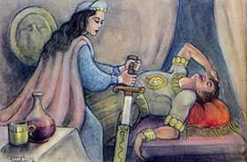
The story was retold in different versions. According to one version, it happened during the time of the Maccabean revolt against Syrian oppression, and Yehudit was a daughter of Yochanan the high priest, father of the Hasmonean family.
At any rate, the heroic deed of Yehudit has inspired faith and courage in the hearts of Jews throughout the ages.

The town of Bethulia, in the land of Judea, came under siege by Holofernes, a mighty Syrian-Greek general, at the head of a huge army.
Holofernes was notorious for his cruelty in suppressing rebellions. When he captured a rebel stronghold, he showed no mercy to the men, women and children sheltered there.
Now he was determined to crush the rebellion of the town of Bethulia, whose inhabitants refused to recognize the oppressive rule of the Syrians.
The men of the beleaguered town fought bravely and desperately to repulse the repeated assaults by the superior enemy forces. Seeing that he couldn’t take the fortified town by force, Holofernes decided to starve the inhabitants into submission. He cut off the food and water supply, and before long the town was indeed brought to the verge of surrender.
Hungry and thirsty, and in utter despair, the townspeople gathered in the marketplace and demanded that, rather than die of hunger and thirst, they should surrender to the enemy.
Uzziah, the commander of the defense forces, and the elders of the town tried to calm the populace without success. Finally they pleaded, “Give us five more days. If no salvation comes by the end of five days, we will surrender. Just five more days . . .”
Reluctantly the people agreed, and slowly they dispersed. Only one person, a woman, remained in her place, as if riveted to it, and she addressed Uzziah and the elders, who had also turned to go. Her voice was clear and firm.
“Why do you test G-d, giving Him only five days in which to send us His help? If you truly have faith in G-d, you must never give up your trust in Him. Besides, don’t you know that surrender to Holofernes is worse than death?!”
So spoke Yehudit, the noble daughter of Yochanan the high priest. She was a young widow. It was several years since she had lost her beloved husband, Menashe, and she had devoted all her time to prayer and acts of charity ever since.
Yehudit was blessed with extraordinary charm, grace and beauty, but she was particularly respected and admired for her devoutness, modesty and lovingkindness.
Yehudit’s words made a deep impression on Uzziah and the elders.
“You are quite right, daughter,” they admitted, “but what can we do? Only a downpour of rain that would fill our empty cisterns could save our people, but it is not the rainy season. We are all suffering the pangs of hunger and thirst. Pray for us, Yehudit, and maybe G-d will accept your prayers . . .”
“We must all continue to pray, and never despair of G-d’s help,” Yehudit said. “But I have also thought of a plan. I ask your permission to leave town together with my maid. I want to go to Holofernes . . .”
Uzziah and the elders were shocked and dismayed. “Do you know what you are saying, Yehudit? Would you sacrifice your life and honor on the slim chance that you might soften Holofernes’s heart? We cannot allow you to make such a sacrifice for us.”
But Yehudit persisted. “It has happened before that G-d sent His salvation through a woman. Yael, the wife of Heber, was her name, as you well know. It was into her hands that G-d delivered the cruel Sisera . . .”
Uzziah and the elders attempted to discourage Yehudit from such a dangerous mission, but she insisted that she be allowed to try. Finally, they agreed.

Yehudit passed through the gates of Bethulia, dressed in her best clothes, which she had not worn since her husband passed away. A delicate veil all but hid her beautiful face. She was accompanied by her faithful maid, who carried on her head a basket filled with rolls, cheese and several bottles of old wine.
The sun had already begun to hide behind the green mountains when Yehudit and her maid wound their way toward the enemy’s camp, their lips whispering a prayer to G-d. Presently they were stopped by sentries, who demanded to know who they were and who sent them.
“We have an important message for your commander, the brave Holofernes,” Yehudit said. “Take us to him at once.”
“Who are you, and why are you here?” Holofernes asked, his eyes feasting on his unexpected, charming visitor.
“I am but a plain widow from Bethulia. Yehudit is my name. I came to tell you how to capture the town, in the hope that you will deal mercifully with its inhabitants . . .”
Yehudit then told Holofernes that life in the beleaguered town had become unbearable for her, and that she had bribed the watchmen to let her and her maid out. She went on to say that she had heard of Holofernes’s bravery and mighty deeds in battle, and wished to make his acquaintance. Finally she told Holofernes what he already knew, that the situation in the besieged town was desperate, that the inhabitants have very little food and water left. Yet, she said, their faith in G-d remained strong, and so long as they had faith, they would not surrender.
On the other hand, she added, before long, every scrap of kosher food would be gone, and in desperation they would begin to eat the flesh of unclean animals, and then G-d’s anger would be turned against them, and the town would fall . . .
“But how will I know when the defenders of the citadel will begin to eat unkosher food, as you say, so that I can then storm the walls and capture the city?” the commander of the besieging army asked.
“I had thought of that,” Yehudit answered confidently. “I have arranged with the watchmen at the city’s gates that I would come to the gate every evening to exchange information: I will tell them what’s doing here, and they will tell me what’s doing there.”
Holofernes was completely captivated by the charming young Jewish widow who had so unexpectedly entered his life and was now offering him the key to the city. “If you are telling me the truth, and will indeed help me capture the city, you will be my wife!” Holofernes promised. Then he gave orders that Yehudit and her maid were to have complete freedom to walk through the camp, and anyone attempting to molest them in any way would be put to death immediately. A comfortable tent was prepared for the two women, next to his.
The two women, veiled and wrapped in their shawls, could now be seen walking leisurely through the armed camp at any time during the day and evening. Fearful of the commander’s strict orders, everyone gave them a wide berth. Soon, they attracted little if any attention. Yehudit could now walk up to the city’s gates after dark, where she was met by a watchman.
“Tell Uzziah that, thank G-d, everything is shaping up according to plan. With G-d’s help, we shall prevail over our enemy. Keep your trust strong in G-d; do not lose hope for a moment!”
Having delivered this message for the commander of the defense force of the city, Yehudit departed as quietly as she had appeared.
The following evening she came again to the city’s gate and repeated the same message, adding that she had won Holofernes’s complete confidence.
In the meantime, Holofernes, having nothing special to do, spent most of his time drinking, with and without his aides. When he was not completely drunk, he would send for Yehudit. She always came to his tent in the company of her maid. On the third day, he was already getting impatient.
“Well, gracious Yehudit, what intelligence do you bring me today? My men are getting impatient and demoralized doing nothing; they cannot wait to capture the city and have their fun . . .”
“I have very good news, general. There is not a scrap of kosher food left in the city now. In a day or two, famine will drive them to eat their cats and dogs and mules. Then G-d will deliver them into your hands!”
“Wonderful, wonderful! This surely calls for a celebration. Tonight we’ll have a party, just you and I. I shall expect you as my honored guest.”
“Thank you, sir,” Yehudit said.

That evening, when Yehudit entered Holofernes’s tent, the table was laden with various delicacies. The general was delighted to welcome her, and bade her partake of the feast. But Yehudit told him she had brought her own food and wine that she had prepared especially for that occasion.
“My goat cheese is famous in all of Bethulia,” Yehudit said. “I’m sure you’ll like it, General.”
He did. And he also liked the strong, undiluted wine she had brought. She fed him the cheese, chunk after chunk, and he washed it down with wine. Before long he was sprawled on the ground, dead drunk.
Yehudit propped a pillow under his head and rolled him over on his face. Then she uttered a silent prayer.
“Answer me, O L-rd, as You answered Yael, the wife of Heber the Kenite, when you delivered the wicked general Sisera into her hands. Strengthen me this once, that I may bring Your deliverance to my people whom this cruel man vowed to destroy, and let the nations know that You have not forsaken us . . .”
Now Yehudit unsheathed Holofernes’s heavy sword, and taking aim at his neck, she brought the sword down on it with all her might.
For a moment she sat down to compose herself. Then she wrapped up the general’s head in rags, concealed it under her shawl, and calmly walked out and into her own tent.
“Come quickly,” she said to her maid, “but let’s not arouse suspicion.”
The two veiled women walked leisurely, as usual, until they reached the gates of the city. “Take me to Uzziah at once,” she said to the sentry.
Uzziah could not believe his eyes as he stared at the gruesome prize Yehudit had brought him.
“There is no time to lose,” she told the commander. “Prepare your men for a surprise attack at dawn. The enemy’s camp is not prepared for it. When they run to their commander’s tent, they will find his headless body, and they will flee for their lives . . .”
This is precisely what happened.
The enemy fled in confusion and terror, leaving much booty behind. It was a wonderful victory, and it was the G-d-fearing and brave daughter of Yochanan the high priest, the father of the Hasmonean family, that saved the city of Bethulia and all its inhabitants.

Reprinted from the website of Chabad.org

How the Lights of Hanukah
Can Trump the Doctors
By Rabbi Shmuel Choueka

“There was only enough to light one day; a miracle happened and it lit eight days.” (Talmud Babli Shabbat 21:)

One may ask, why is the miracle of the Hanukah oil so great? The Gemara tells us a story of Rabbi Hanina ben Dosa . On a Friday afternoon, there was no olive oil and all they had was vinegar. The Rabbi declared , “The One who tells oil to light can tell vinegar to light!” Miraculously the vinegar lit for the entire Shabbat. Why don’t we celebrate that miracle?
Rabbi Yitzhak Hutner zt”l answers that Rabbi Hanina be Dosa was a great saddik. All of his actions were with so much self-sacrifice that he lived a life above and beyond nature. Hashem always acts measure for measure with man. Since the Rabbi lived above nature in his relationship with Hashem, so did Hashem relate to him in a miraculous way, and the vinegar lit. The most amazing part of the miracle of Hanukah was that this was a miracle for all the Jews of that time. Therefore they must have all been on the spiritual level to merit such a miracle.
One Hanukah, Rabbi Abraham Twersky visited an elderly friend, Lazer, who was quite ill in the hospital. Lazer was depressed, having received a poor prognosis from his doctors. Although the hospital forbade lighting any fire, Rabbi Twersky pleaded that Lazer be allowed to light the Hanukah candles. He assured the nurse that Lazer’s wife would remain with the candles as long as they burned. The hospital agreed, and Lazer was overjoyed.
“Listen,” Lazer said, “the oil in the Bet Hamikdash could only burn naturally for one day, yet it burned for eight days. The doctors say I have only one year to live – but that’s according to nature. Hashem can turn one year into eight, or even more!”
The doctors could not understand how Lazer actually survived another ten years without any treatments. The powerful radiance of the Hanukah candles were able to help him where the radiation therapy could not. Apparently, Lazer’s belief in Hashem was so great that he merited this great miracle. Shabbat Shalom. Rabbi Reuven Semah
The Midrash tells us that Pharaoh saw signs of kingship on Yosef, and when he interpreted the dreams correctly and suggested that Pharaoh appoint someone to lead the country Yosef was the obvious choice. What did Pharaoh see on Yosef that showed kingship?
A king is someone who is concerned about his people. To rule others doesn’t only mean control and power, it means caring and doing for others. When Yosef was in jail and saw the butler and baker depressed because they had dreamt disturbing dreams, Yosef asked them what was bothering them and whether he could help. Even though Yosef was in trouble himself, he cared about their plight and did something about it. Later on when Yosef was appointed viceroy, he was in charge of feeding everyone during the famine. The Midrash says that Yosef would not eat until everyone else was fed first. This trait was evident on Yosef when he stood before Pharaoh, and that’s why he chose him as viceroy!
We all have areas that we are in charge of, our families, or committees, or businesses. If we want to exhibit signs of leadership, it is how we can take care of those we are responsible for. The more we are concerned and devoted to others, the more we show signs of leadership!

Reprinted from this week’s email of the Jersey Shore Torah Bulletin.

A Slice of Life
A CHANUKA MIRACLE:
Lighting the Menora in the
Buenaventura Mall
By Rabbi Yitzchok Sapochkinsky

He was still clutching the receiver of the telephone, his hands trembling, when I walked into the Chabad House in Westlake.
"She was so nasty," the yeshiva student told me. "She said that if we go ahead with the menora lighting she'd burn a cross next to it!"
"What did you tell her?" I questioned the young man, who was experiencing anti-semitism for the first time.
"I said, 'Be my guest.' " But from the look on his face I could tell that he was quite shaken up.
Agoura, the site of the menora in question, is the epitome of suburbia. With a 35% Jewish population, it was understandable why local shopkeepers and malls had posted "Happy Chanuka" signs alongside other holiday greetings. Yet, the woman was blaming Chabad for that, too. "Ever since you came along," she had yelled, "there's Jewish stuff all over the place."

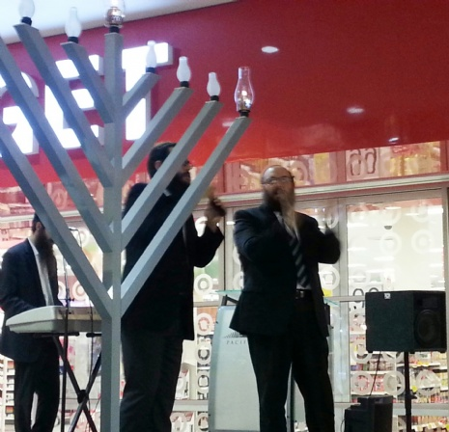
Photo from the Chabad of Ventura Chanukah Menorah Lighting of 2013

She threatened to organize a boycott of the stores that hosted "Chanuka at the Agoura Mall" and burn a 50-foot cross. We had to come up with the perfect solution, and Chanuka was less than two weeks away.
That evening our minds were on other things, though. I was working together with some of the students from the Lubavitch yeshiva in Los Angeles who were helping us out on a special project. We were busy through the night constructing floats to lead a procession of cars welcoming a new Torah scroll to our Chabad House. At 4 a.m. we finally finished and the subject of Chanuka came up and with it a repeat of the phone conversation.
"I know what," said one of the yeshiva students. "Doesn't the Rebbe encourage us to always add to our activities, especially in the face of adversity? Instead of lighting the menora only at the Agoura Mall, let's find another city and bring the message of Chanuka there, too."
His simple yet sincere words made an impact on all of us. Choosing the city was easy. Two of the students present had scouted out the entire area the previous summer when they had gone to small Jewish communities throughout the San Fernando Valley organizing Jewish classes and activities for children and adults.
"Ventura," they declared in unison, "Lots of Jews there but not much happening Jewishly."
We trusted their judgement and the only remaining question was where in Ventura.
"That mall," one of the students, Asher, recalled. "If I could only remember its name. It's the biggest mall in Ventura." Time was of the essence and I wasn't about to let this sudden burst of enthusiasm slip away.
I dialed 4-1-1. "Hello, operator. I need the number for the mall in Ventura."
"Name of business," came the familiar reply.
"I don't know, operator. But it's the biggest mall there," I added hopefully.
"Hm, the Buenaventura Plaza?" she asked.
I said the name out loud and the boys nodded in agreement. "That's it," I told her excitedly.
"Please hold for the number."
"Wait, operator," I said, realizing that a phone number wouldn't do me much good at 5 a.m. "Do you by any chance know how to get there?"
I'm not sure if all operators are especially nice at that time of the day, or if G-d was simply on my side, but she knew the exact location and gave us directions. I hopped into my car for the 30-minute trip to Ventura. Arriving on the scene, I found a one-storey indoor mall decorated from head to toe with green and red. "Ah," I swelled, "the perfect place for a menora!"
Back home, the sun was beginning to rise as we put the finishing touches to a flyer and the public relations material. Asher reminded us that in our excitement, we had forgotten to ask the mall management for permission.
"Right," I agreed. "It wouldn't sit too well with them if they read about it in the papers before we asked them," I chuckled.
Chanuka at the Agoura Mall went ahead as planned. No disturbances as had been threatened. But it was the seventh night of Chanuka that stands out as one of the most memorable experiences of my life. Close to 300 people jammed into a small area between Thom McAn Shoes and The Pretzel Factory in the Buenaventura Mall. An employee from Radio Shack came out and offered to lend us a PA system.
An old man in a wheel chair was crying while clutching his grandson's hand tightly. "Not in Ventura. I never would have believed it," he sobbed.
"This is really a miracle."
Another women joined in, "This must have taken you months to organize."
Six months later, Rabbi Yaacov and Sarah Latowicz were officially welcomed as the Chabad emissaries to the new Chabad House of Ventura. Today, some five years later, Ventura boasts a Hebrew School, minyan, classes, day camp, and a full array of Jewish programs and activities.
And all because an irate woman threatened to extinguish the light of the Chanuka menora!

Rabbi Sapochkinsky and his wife, Brocha are the Chabad emissaries in Westlake Village, California.

Reprinted from the archives of “L’Chaim,” a publication of the Lubavitch Youth Organization – Issue #247 (Parshas Mikeitz 5753/December 1992) The article originally appeared in The N'Shei Chabad Newsletter.

When Christmas and Hanukkah Crashed
By Sara Debbie Gutfreund

For the first time in my life, I was the only Jew in the group.
My winter break when I was 15 was a turning point in my life, although I had no idea it was coming. My dad took me and my brother to a ski resort in Canada where we enrolled in a week long ski school to improve our jumps and form.
The teenagers in our group were from all over the world, and most of them were far better skiers than we were. But we kept up with the grueling exercises, skiing down mogul lined slopes with one ski and preparing for the final race scheduled for the last day of ski school.
Most of the kids were friendly, but for the first time in my life, I was the only Jewish girl in the whole group. My life had been pretty sheltered. I went to a Jewish day school in New York, lived in a mostly Jewish neighborhood and went to Jewish summer camps. I wasn't used to being the odd one out.
It was also one of those years when Christmas and Hanukkah coincided, so while everyone was discussing their Christmas plans, my brother and I pretended not to hear as we adjusted our boot settings. And we avoided eye contact with the instructor who asked us whether we were coming to the party that night. I thought about the little silver menorah in the living room of our chalet, and about the blessings that we would say that night.

That afternoon in the ski lodge I warmed my hands next to the fire and stared at the enormous pine tree decorated with hundreds of lights and shiny gold ornaments. I had never really looked closely at a Christmas tree before, and I was surprised by how beautiful it was. The lights were simply mesmerizing, and when one of the girls who I had been skiing with that day sat down next to me and asked if I was coming to the party that night, I began to reconsider.
I didn't have to drink or eat anything. I could light the menorah with my family and then hang out with my ski class for a while. It seemed like it would be anti-social not to go, and there wasn't anything technically wrong with going to the party, was there?
Lighting the menorah that night with my father and brother, I looked out the window into the snowy night and saw the tiny, flickering candles reflected back at me. Suddenly they seemed so small, like sparks of light that kept eluding my grasp. I listened to the familiar, ancient words of the blessings and saw them fall like soft snowflakes through my hands. When I asked my father if he minded if I went to the Christmas party, he seemed surprised but then just nodded and told me to be back by eleven. We ate the potato latkes silently, and then my brother surprised me by announcing that he was coming too.
The hall was full of wreaths and blinking lights and songs that I knew by heart from the radio. I sat with a group of girls from my ski class, and we joked about the upcoming race the next day. I wasn't the worst skier in the group but I was close. We all knew Ethan would win anyway. Blond and blue eyed, he was here from Switzerland, and it looked like he had been skiing since he could walk.
Suddenly he was standing in front of our group with his brother. They were wearing matching green sweaters and cracking up over something. Then Ethan asked us if we wanted to hear the joke. "What did the Jew say to the..."

The room began to spin. Is this guy really telling an anti-Semitic joke to my face? How could he? Until then, I had felt fine at the party. Not exactly like I belonged, but almost. But now I felt my whole face go red, and I interrupted him loudly, "I'm Jewish."
Everything went quiet. I could hear the wind whipping through the snow outside the lodge window as everyone stared at me.
"You're Jewish? But you don't look Jewish," Ethan mumbled.
"What is that supposed to mean?"
I had always thought that anti-Semitism was a thing of the past, irrelevant to my cushioned, New York bubble where being Jewish was a badge of pride. I stormed out of the party and walked back in a blur of snowflakes that fell so hard I could hardly see. But then I saw them. The lights of the menorah in the window. They were tiny and flickering in the winter darkness, but they warmed my confused heart as I pulled the door shut behind me.
I sat in the soft shadows on the living room and looked at my face in the mirror. What did Ethan know anyway? Staring back at me was a Jew. So what if I had blond hair and green eyes? What did it mean to look like a Jew anyway? I didn't know, but suddenly I knew what it felt like to be a Jew. I wanted to stand up for who I was and where I came from. I wanted everyone to see the little, silver menorah in our window. I wanted to be part of the strength and endurance climbing through these flames before me.

The Showdown
The next morning we all stood in a very uncomfortable silence at the top of the mountain. The race course was marked by red and black flags that dotted the slope below us. I was still so angry. I skied faster than I ever had before and to my utter surprise, I had beaten every member of the class except for Ethan. But he was a far better skier than I was, and I knew there was no way that I could win.
We stood braced at the top of the course, avoiding each other’s eyes, preparing for the showdown. The starting signal rang out. Ethan raced right past me, but then something miraculous happened. For the first time that week, Ethan fell. He was fine, but by the time he had regained his balance, I was by the finish line.
He skied up to me and finally looked me in the eyes. "You know it was just a joke. Congrats on the race."
Ethan offered his hand, but I shook my head. I took off my skis and walked towards the lodge. Through the window the enormous tree still twinkled, but I was immune to its light. I was different. I had my own light. I didn’t realize it before, but it was a miraculous torch that I was holding. And I was meant to carry it and run a different race.
I turned around and headed home.

Reprinted from this week’s email of Aish.com
Story #785
Chanukah Shopping
From the desk of Yerachmiel Tilles
editor@ascentofsafed.com

It was Chanukah and I [Mrs. Nechama Berenshtein] was at the mall. I was in a hurry, though not to do last minute shopping. I had brought a group of young women students with me from Crown Heights, Brooklyn, to a shopping mall in New Jersey so that we could give out Chanukah menora kits. As Lubavitcher Chasidim we were shopping for opportunities to encourage our fellow Jews to kindle the candles for the Festival of Lights. The drive out to New Jersey had taken longer than I had anticipated and we needed to head back just 45 minutes after we arrived. I had to return to Brooklyn to give a lecture. I was preoccupied with pacing the entrance of the mall to make sure that the girls would regroup on time.
As I looked up from my watch for the umpteenth time, I noticed a circle of seats in the center of the food court of the mall. There were a number of women of all ages sitting on the seats, chatting, laughing, eating their food or drinks. "This is going to be very easy," I told myself, as I sized up the situation, noting that many of the girls and women looked Jewish.
There was one young man sitting by himself in the circle of seats, but he was obviously not Jewish. It wasn't even his purple and green hair or the earrings that pierced his ears and other body parts. He just had a decidedly non-Jewish look. Keeping in mind that the Lubavitcher Rebbe always encouraged women to approach women (and men to approach men), I was relieved that I would not seem ill-mannered if I didn't attempt to hand the young man a Chanukah kit.
I went amongst the women and girls, asking them if they were Jewish and if they would like Chanukah menora kits. The Jewish women responded positively and eagerly took the kits. Some of them even asked if I had Shabbat candle lighting brochures with me, as well.
I spoke with the last of the women and turned to leave. I looked at my watch again and noted that I was at the end of the allotted 45 minutes. I quickly began walking toward the mall entrance to meet my students.
I hadn't walked more than a few steps when I heard someone say, "Nechama, go back."
Now, to be honest, I'm not the kind of person who hears voices. But then it came again, "Nechama, go back."
"Leave me alone," I protested. But it wouldn't.
"Nechama, go back and ask him if he's Jewish."
What can it hurt? I asked myself. So I turned around and started walking toward the young man, who was in the midst of munching on some kind of McDonalds concoction and drinking a huge soda. An order of fries, liberally sprinkled with ketchup, was perched on his knee.
"Excuse me, are you Jewish?" I asked him.
The next thing I knew, I was covered in soda, ketchup and mustard. The young man had been so shocked by my question that he had dropped everything. After apologizing profusely, he asked, "Please tell me, why did you ask me if I'm Jewish?"
To this day, I don't know how or why these words popped into my mind, but I said quite confidently, "You look Jewish!"
And then I heard a sob erupt from what could only have been the depths of his heart. The young man began to cry, but stopped and said, "Say that again, please."
"You look Jewish," I said once more. A new torrent of tears was unleashed. But once again, he stopped himself and asked, "Please, say that again." And I did a third time.
After calming himself down, the young man told me the following:
"My mother was Jewish but my father was not. Though my mother didn't really care about religion -- they celebrated all of the non-Jewish holidays at home -- she was adamant that I go to a Jewish school.
"Everyday in school, the other children used to mock me. It wasn't because we didn't celebrate the Jewish holidays at home; they didn't know that. It was because I was a carbon copy of my father. I look exactly like him. The kids in school used to say, 'Why are you here? You don't look Jewish. Why are you wearing tzitzit and a kipah, you don't look Jewish.'
“And it's true. I don't look Jewish at all. Day after day the children mocked me. I would return home each day in tears. My father begged my mother to let me leave the school. 'Look how miserable he is,' he would say to my mother. After a few years of mockery and torture, my mother agreed with my father and let me leave the Jewish day school and go to public school.
"To this day, I remember the mockery," the young man said, wincing in pain. "Today, I was sitting here and I was watching you go over to all of the women and girls, asking them if they are Jewish. 'G-d,' I said, 'I'm not guilty that I'm not doing anything Jewish. Look, this girl will go over to everyone else, but she won't come over to me, to ask me if I am Jewish. I don't look like a Jew!'
“As you neared the end of the circle, I looked up to G-d and said, 'I will even prove that I am righteous. If this girl will come over and ask me if I am Jewish, then I will give You another chance.' When you left, I said, 'Aha. You see, G-d!'
"And then, you turned around and walked back toward me. Well, now I guess I have to give G-d another chance." I gave the young man a Chanukah menora kit, and the phone number of his local Chabad-Lubavitch Center and we parted.
I do not know if he ever contacted the Chabad Center. But I do know that the tiny flame in each one of us, even if it is untended or G-d forbid, it is mocked, burns eternally within every Jew.

Adapted by Yerachmiel Tilles from lchaimweekly.org (#949), with permission.

Reprinted from this week’s email of KabbalaOnline.org, a project of Ascent of Safed.
www.ascentofsafed.com ascent@ascentofsafed.com

Shabbos Stories for Parshas
Mikeitz (Chanukah) 5772
Volume 3, Issue #13 28 Kislev 5772/December 24, 2011
For a free subscription, please forward your request to keren18@juno.com

The Hidden Light
By Rabbi Mendel Weinbach

What is so special about the mitzvah of Chanuka lights? This is the question that arises when we read the words of Rambam (Laws of Chanuka 4:12): “The mitzvah of Chanuka is a very beloved mitzvah.”
This extraordinary title for a mitzvah, one not assigned to any other mitzvah, calls for an examination of the special nature of this command.
The answer lies in the mystical concept of Ohr Haganuz: When G-d created the world and said, “Let there be light”, the illumination that resulted was not what we see today. This was a light, say our Sages, which enabled one “to see from one end of the world to another.”

What Happened to the “Special” Light?
What happened to this light is explained in the gemara (Mesechta Chagigah 12b) quoted by Rashi in Parshat Bereishet (1:4):
“G-d saw that the wicked were unworthy of enjoying it and therefore set it aside for the use of the righteous in the World to Come.”
Where did the Creator store this Ohr Haganuz hidden light in the meantime? Our sacred commentaries have suggested that the Ohr Haganuz was stored in the words of the Torah. When one learns Torah he gains some of that world-spanning perspective provided by this magical light.

Tradition About the Lights of Chanuka
There is also a tradition that the Ohr Haganuz was stored in the lights kindled by Jews on Chanuka. The 36 lights of the eight days of Chanuka correspond to the 36 hours of the primeval light before it was set aside.
This explains the custom of spending some time looking at the Chanuka lights so as to gain a tiny glimpse of the hidden light which they reflect.
What can we hope to gain from such a virtual reconnection to a light which enabled one to see from one end of the world to another? Chanuka brings together thousands of miles of the universe and thousands of years of history. It celebrates the end of the Hellenist exile, the third of the four exiles our people have experienced at the hands of four different superpowers.
Exile, and the suffering that goes with it, can challenge one’s faith. But when one looks at those Chanuka lights, and sings the “Maoz Tzur” song about miraculous survival in all of those exiles, he sees the world – time and place – from
one end to another and gains an understanding of the Divine design for the destiny of His beloved people.
May we merit to see the hidden light within the lights of Chanuka and enjoy a glimpse of the World to Come.

Reprinted from this week’s email of OHRNET, the Ohr Somayach Magazine of the Internet.

Story #734

The Chanukah Heirloom
From the desk of Yerachmiel Tilles
editor@ascentofsafed.com

Private, W. was with the United States Army as it marched through Europe at the end of World War II. His unit was assigned to a village with the orders to secure the town and search for any hidden Nazis. While there, they were to help the villagers in any way they could.
The private was on patrol one night when he saw a young boy running through a field just outside the village. "Halt or I'll shoot," he shouted. The boy ducked behind a tree. The private waited patiently.

The Boy Retrieves the Item
Eventually the boy came out. Figuring that the soldier was no longer nearby, the boy went to a spot near a large tree and started to dig. Private W. waited patiently again, this time until the boy had retrieved the object of his digging and was on the move once more. He stepped out and shouted, "Halt or I'll shoot!" The boy ran but Private W. decided not to shoot. Instead, he began pursuing the furtive figure. He caught up with the boy and tackled him to the ground.
In the scuffle that ensued, the boy dropped an ornate Chanuka menora that he had been holding tightly against his chest. Private W. picked up the menora. The boy tried to grab it back shouting, "Give it to me. It's mine!"
Private W. looked deeply into the frightened youth's eyes and assured him that he was among friends. "I myself am Jewish," he told the youngster.
The boy, who had survived the concentration camp, was mistrustful of all men in uniforms. He had been forced to watch the shooting of his father. He had no idea what had become of his mother.

Soldier Adopts the Boy
In the weeks that followed, Private W. took an interest in the young boy's welfare. The boy, David, became closer and closer with the American soldier. Private W.'s heart went out to the boy. He offered to bring David with him to the United States, to New York City where he lived. David accepted and Private W. went through all the necessary paperwork to officially adopt David.
Private W., now Mr. W. and back in the private sector, was active in the New York Jewish community. An acquaintance of his, a curator of the Jewish Museum in New York City, saw the menora. He told David it was very valuable, a relic of European Jewry, and should be shared with the entire Jewish Community. He offered David $50,000 for the menora.

Refuses to Sell the Menora
David refused the generous offer, saying the menora had been in his family for over 200 years and that no amount of money would ever make him part with it.
When Chanuka came, David and the Mr. W. lit the menora in the window of their home in New York City. David went to his room to study and Mr. W. stayed in the room with the menora.
The quiet stillness of the house was interrupted by a knock on the door. Mr. W. went to answer the door. A woman speaking with a strong German accent stood before him. She seemed flustered and excused herself for intruding. She had been walking down the street when she looked up and saw the menora in the window.
"We once had a menora just like that in our family," she said in broken English. She had never seen any other like it. Could she come and take a closer look?
Mr. W. invited her in to look at the menora. He said that the menora belonged to his son who could perhaps tell her more about it. Mr. W. called David from his room to tell the woman more about the menora's history.
In the mystic glow of the ancient Chanuka menora, David was reunited with his mother.
Source: From a posting on //lchaimweekly.org (#746), with permission.
Reprinted from this week’s email of KabbalaOnline.org. a project of Ascent of Safed.
www.ascentofsafed.com ascent@ascentofsafed.com

A Slice of Life
Finding Light on Chanuka
By Rabbi Ben Tanny

"You wander in the jungles of Borneo, climb the highest mountain in Africa and spend months at a Thai boxing camp in Thailand... how do you keep Shabbat and kosher in all these places?"
I have been traveling since 1997 and never really stopped. My house is my backpack where I have everything I need; clothing, a tooth brush, juggling balls, and a pair of Tefilin.
People would joke and say, "Ben you will see the whole world before you turn 25, then where will you travel with your wife?" My response was, "I am leaving the exciting places like Iraq, Afghanistan, and Yemen for my honeymoon."
One of my highlights of traveling is having the opportunity to be chazan/cantor for the many communities I pass through. I have been a chazan since my Bar Mitzva and I thank G-d for giving me the gift of leading people in prayer.

The “Undercover Rabbi”
When the situation permits, I look for opportunities to speak to fellow Jews about Torah and the divine, and with non-Jews about the seven Noahide Laws and what really goes on in Israel. I often call myself the "Undercover Rabbi."
Indonesia is the fourth largest country in the world by population, with 250 million inhabitants. It is also the largest Muslim country in the world, with over 120 million Muslims. There aren't many Jews still living in Indonesia, perhaps a few dozen, and there is no Torah scroll there. Holders of Israeli passports are barred entry, and the general anti-Israel/anti-Jewish sentiment does not make it to the Jewish person's list of "top ten travel destinations."

Toured Indonesia Anyway
I went there anyway - mostly to Bali where the people are Hindu and more accepting of foreign tourists. I rode a motorbike around the island, did some scuba diving, went snorkeling, and visited a couple of monkey temples.
The majority of tourists visiting Indonesia don't get past Bali, but there is more to see. I traveled across the main islands of Java and Sumatra and climbed to the tops of a few active volcanoes. I spent time in local villages.
At one point I was on the east coast of Bali with plans to dive Tullamben, a famous wreck site. I was the only tourist in the resort. On Shabbat afternoon, I sat on the beach talking to G-d. "Please Hashem, I've been in Indonesia for a few weeks now and have not yet met one Jew. Please send me someone to talk to on this fine Shabbat afternoon."
A few minutes passed until I heard voices of a family chattering noisily. I turned around and spotted mommy, daddy, and their three kids, who had just checked into the resort.
I introduced myself to the father and when he responded I recognized his accent.
"Where are you from?" I asked.
"Montreal," he replied.
"Wow, I'm from Montreal too. Maybe our families know each other?" I suggested. "What's your family name?"
The man shrugged. "You probably don't know us. The name is Cohen."

Reminding the Cohens About Chanuka
I laughed and wished them "Shabbat Shalom." Mr. Cohen was just as baffled to meet another Jew from Montreal on a beach in Bali. I reminded the Cohens that the following night Chanuka started. Mr. Cohen's wife looked at him, "I told you honey, you were supposed to find out when Chanuka starts!" He told his wife he would buy candles the next day.
I sat back down on the beach and thanked G-d for giving me the opportunity to remind the Cohens about the light of Chanuka. It seems there is always a Jew somewhere out there no matter how where one travels.

Spending Chanuka in Laos
I remembered years earlier when I was in Laos for Chanuka. I was walking around the marketplace looking to buy olive oil. I could have used candles but I thought it would be nice to light with olive oil like they did in the Holy Temple in Jerusalem, reminiscent of the miracle that took place with the small cruse of oil on that first Chanuka. I spotted a Western guy talking in the Lao language with one of the vendors. I thought, "he speaks the language. Maybe he can help me."
We got to chatting. Daniel was from the United States and had been coming to Laos over the years to buy native musical instruments. He was a bit strange looking to me. He wore his hair in dreadlocks, sported a wild beard, had a few tattoos, some body piercings, and wore strange baggy clothing. Most prominent were his two stretched earlobes over large wooden pegs.
Daniel helped me to a chemist shop where they sold small bottles of olive oil used for skin treatment. The shopkeeper and Daniel were equally mystified when I wanted to buy all the bottles he had. I explained to Daniel about the upcoming Jewish holiday of Chanuka and how I needed the oil to light the Chanuka menora.
"Man, I've not seen a menora in over 20 years," Daniel remarked. "When I was a kid we would light one in the house."

Mesmerized by the Chanuka Lights
It was Friday. I invited Daniel to join me for menora lighting and Shabbat dinner. On Friday, the menora needs to be lit before Shabbat begins. I waited for Daniel until the last possible moment and then lit without him. The sun had already set when Daniel arrived. I could not have waited for him to light the menora. Daniel did not mind. He sat down next to the menora and watched the burning flames with great intensity. When I offered him to join my Shabbat meal he did not want to leave the lights. For the next three hours he sat staring at the menora, letting his Jewish soul reignite with the flames of Chanuka.
Reprinted from this week’s edition of “L’Chaim,” a publication of the Lubavitch Youth Organization in Brooklyn, NY.

A Message from the Kalever Rebbe For Chanukah 5772

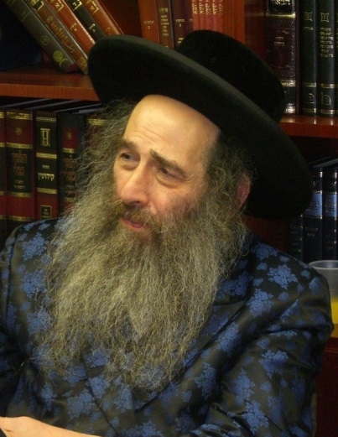

Chanukah a “Culture Clash Over Life’s True Purpose”

We live in a world of great beauty, one that offers tantalizing material benefits and pleasures for humanities taking. But what is the true purpose of these resources, and to what end should mankind exploit them? This question is as old as the world itself and has garnered a myriad of responses from different individuals and peoples throughout the course of human history.
What’s the Purpose of Our Existence?
Is our life’s journey limited to the short time we spend on this earth with the logical conclusion that we should spend our time here in the pursuit of maximum material pleasure while we can yet enjoy it? Is this world, in fact, the be all and end all of our existence?
Or are we here only temporarily with a higher purpose that transcends our fleeting presence in this infinitesimally small corner of the universe? Do we have a mandate to serve a Divine Creator and, thus, connect ourselves to the eternal? Is there an unseen yet palpable, spiritual realm whose beauty and pleasure far surpasses the temporal bounds of the world we see in front of us? These trenchant but diametrically opposed viewpoints form the basis of the Chanukah story and inform the philosophical outlooks of its key protagonists, the Jews and the Greeks.

Our patriarch Abraham (Avraham Avinu) taught the world the truth of the existence of the One Eternal Al-mighty G-d, Creator of heaven and earth. And Hashem rewarded these efforts by entering into a special covenant, a Bris with Avraham and his children for all time. The Bris served to bring us closer to G-d and raised us to a lofty spiritual plane.

An Obligation to be a Priestly and Holy Nation
But at the same time it imposed upon us a new mandate: to live in accordance with G-d’s holy will as a model nation and in so doing, raise all humanity with us into the radiant aura of G-d’s supernal light. We are to be a Mamlechet Kohanim V’Goi Kadosh, a priestly and holy nation.
As heirs to Avraham’s legacy, we recognize that the pleasures we derive from this world are but a means and pathway to a far greater and eternal future in the world to come. And accordingly, we are more than willing to devote our time, energy and resources in the service of our Creator and for the benefit of our fellow man.

A Concept the Greeks Rejected
The Greeks scoffed at this notion. They believed only in that which they could see. But in truth, their rationalistic philosophies were mere excuses to absolve themselves of a greater responsibility and allow themselves to pursue with abandon the momentary gratifications of this limited world.
Perspective and perception in life are so critical to our understanding of pure, ultimate truth. The Greeks allowed themselves to be blinded by the immediate esthetic and refused to acknowledge a greater power which might infringe on his hedonistic predilections. The Jew, however, beholds this world and sees it as a wondrous veil concealing an infinite beyond.
When the Greeks saw the Jews performing the service in the holy temple ”taking healthy bullocks, oxen and sheep and consecrating them as Korbanot, sacrifices to an unseen G-d, it stirred within them pangs of conscience and enraged them against this people that presumed to curtail their quest to satisfy every last desire this world has to offer. The notion of wasting a perfectly good animal that could otherwise provide physical pleasure was antithetical to their pragmatic sensibilities. Consequently, the Greeks decreed that their secular philosophies should supplant Torah study and that the performance of Mitzvos be outlawed.
Many Jews Were Swayed by the Greek Philosophy
The Talmud records that many Jews fell under the spell of the Greek way of life; they tried convincing their brethren to join the Greeks in their new-found freedom, to live moment to moment and seek instant gratification. One prominent Jewish woman, Miriam the daughter of Bilga who hailed from a family of Kohanim, priests who served in our holy Temple, married an officer in the Greek Helenist army.
When he entered the Temple with his garrison to defile its precincts, Miriam entered with him and proceeded straight to the sacrificial altar. She violently kicked the side of the altar and screamed, “Lukus, Lukus, (Oh wolf, wolf) how long will you continue to consume the sacrifices of your people but fail to protect them in their time of need?” She mirrored the attitude of her Greek husband in refusing to acknowledge a higher purpose in life.
Greek Attack Against the Jewish Faith
Against this background we gain profound insight into a cryptic practice the Greeks instituted in their zeal to strip the Jews of their last vestige of Jewish faith and practice. As recorded by our Rabbis, the Greeks decreed that all Jews must inscribe upon the horn of an ox the statement ‘We renounce our connection to the G-d of Israel.”
While we understand their desire to uproot the last trace of Torah observance, what was the significance of inscribing this pronouncement on the ox’s horn. But, as we observed, one of the practices most demonstrative of our willingness to consecrate our possessions to a higher purpose was the sacrifice of a perfectly healthy ox on G-d’s altar. The Greeks took this symbol of our immortality and sought to degrade it to the lowest levels by turning it into a symbol of blasphemy.
Fortunately, with G-d’s help, there arose a tenacious remnant of our holy people who refused to crumble under the Greek influence and who reasserted their undying, unflagging faith in Hashem. Known as the Chashmonaim, they rallied their brethren to their cause and kindled a flame of religious renewal that burned brightly enough to repulse an enemy far greater in numbers, one whose evil darkness could not smother the light of Divine truth. And as the story concludes, the little bit of holy oil remaining in the temple shone luminously for eight days until new holy oil could be manufactured to supply the rededicated service of the restored Bais Hamikdash.
The Spiritual Challenge Remains the Same today
Today, we battle against the same forces of secularism and assimilation that our ancestors prevailed against 2,200 years ago. We musn’t fail in carrying forth the torch in this generation and passing it on to future generations of holy Jewish children.
May your lives be filled with the light of Chanukah bringing true spiritual joy and serenity into all of your endeavors. And may we all merit to see the Divine light of truth justice and love shine forth once again from Yerushalayim and our holy Bais HaMikdash, may it be rebuilt speedily in our days.
Special Thanks to: Rabbi Avraham Shalom Farber & Yehuda Leib Meth, for the Translation

Reprinted from a special email of the Kalever Rebbe’s Gabai – Zalman Rosenberg
Tel: (718) 782-4553 Fax: (718) 486-5918 Email: mail@kaalov.org

It Once Happened

Yemenite Chanuka Menoras

Sa'id and Yihya the sons of Yosef the silversmith, lived in the city of Sanaa, Yemen. They were beautiful children, with brilliant dark eyes and long curly peyot in the style of the Yemenite Jews.
Every morning Sa'id, who was older than Yihya by a year, would take his younger brother to their teacher's house, where they would learn Torah for hours on end. The children sat on mats arranged in a circle, their legs folded under them. Everyone would read from the one book that was placed on a small stool in the center.

Praying Together in the Sallah Synagogue
In the evening, Sa'id and Yihya arrived home at the same time their father was returning from his workshop in the marketplace. Together they would go to pray the evening service at the Sallah synagogue, not far from their home. Afterwards, they would all sit down to enjoy the delicious evening meal their mother Saada had prepared.
Life continued as usual, until rumors began to circulate that giant "metal birds" were taking Jews from Yemen to the Holy Land. Yosef wanted very much to emigrate, but was reluctant to give up his steady source of income for the great unknown. He continued to weigh the pros and cons but could not come to a decision.

Yemen Plunges into a State of Political Turmoil
In the meantime, Yemen was plunged into a state of political turmoil. The king was overthrown in a bloody coup by his second-in-command, who was then promptly overthrown by the murdered king's son, Prince Ahmad. In a beneficent gesture, the new ruler announced that Yemen's Jews were free to leave the country.
The situation in Yemen was very unstable. No one could predict how long the latest regime would last, or if the newly-opened gates to freedom might suddenly come crashing down. It was a very frightening time for Yemen's Jews.
In the end, Saada and Yosef decided that they couldn't leave just yet. But they would send their two children, Sa'id and Yihya, on to Israel ahead of them. It was a daring and brave move, but the anguished parents felt that it was the best alternative. G-d willing, they would join the children soon.
But life in the Holy Land wasn't exactly what the two brothers had anticipated. For a few months the boys were in a temporary transit camp. Then, tragically, the brothers were separated and sent to different kibbutzim. Sa'id, who had meanwhile changed his name to Chaim, was taken to Kibbutz Ein Shemer. From that day on he lost contact with Yihya.
The Small Silver Chanuka Menora
The only memento Chaim had of his former life was a small silver Chanuka menora his father had fashioned especially for him. Right before leaving, Yosef had hastily thrust it into the boy's knapsack. Chaim remembered that his father had also made one for his younger brother. Every year on Chanuka, when Chaim took it out and kindled its lights, he would be filled with sad and distant memories.
Years passed. Chaim grew up and served in the Israeli Defense Force. Soon afterward he married and became a father. Then the Yom Kippur War broke out, and Chaim was again called upon to defend his country. At first his regiment was stationed in the north, but a few days later it was sent to the Egyptian front. With G-d's help, the Jewish soldiers were able to fight off the enemy.
Stationed in the Sinai Desert
When Chanuka arrived, Chaim was still stationed in the Sinai Desert. Luckily, he had remembered to pack in his small silver menora. That night, as he lit the first candle, his thoughts as always returned to the past. He missed his wife and children, but at that moment he longed for his childhood home more than anything. Oh, how he missed his mother and father, his younger brother Yihya, his beloved teacher, his native Sanaa...
For a long time Chaim sat in front of his tent, staring into the candles. Then, when they had almost burnt down, he decided to stretch his legs and go for a walk. Wandering about the campsite, Chaim didn't realize that he had covered quite a distance. Suddenly, he noticed a tiny light flickering in a tent doorway. He ran over and saw that it was a Chanuka menora.
He was about to turn away and return to his tent when he noticed something that stopped him in his tracks. Why, that menora looked very familiar... He bent down to take a closer look and his heart began to pound. The menora before him was the exact duplicate of his own.
"Whose menora is this?" he called out in a trembling voice.
"Yaron's," a soldier answered from within the tent.
"Yaron?" Chaim repeated the name. A moment later a soldier appeared at the entrance and stuck his head outside. "Did someone call me?" he asked.
A Brotherly Reunion
It was the sound of his voice that confirmed it, the familiar inflection that brought back a flood of memories. A second later the two men were staring at each other, their eyes locked. "Yihya?" Chaim whispered. For a split second there was no reaction, then a shiver went through Yaron's body. "Sa'id, my big brother..." he said in a voice choked with emotion. The two brothers fell on each other, crying and embracing. Tears flowed freely throughout the entire camp when word spread of the brothers' reunion.

Reprinted from this week’s edition of “L’Chaim,” a publication of the Lubavitch Youth Organization in Brooklyn, NY. Translated from L'Chaim's sister publication in Israel, Sichat HaShavua.

What's In a Name

MATITYAHU means "gift of my G-d." Matityahu was a priest in the Holy Temple and the father of the five Hasmonean brothers, Judah "the Maccabee" the most famous among them. He encouraged the uprising against the Selucid/Greek rulers and the Hellenization of Jewish life. Matityahu is a variant of Matitya, who was a contemporary of the Jewish leaders Ezra and Nechemya (Ezra 10:43, Nechemya 8:4)
MACHLA means "fat." Machla (Num. 36:11) was one of the five daughters of Tzelafchad, and lived while the Jews were in the desert. Since Tzelafchad died without any sons, Machla and her sisters argued that they should receive their father's inheritance in the Land of Israel. When Moses was consulted, he brought the matter before G-d. A command was established in their merit for all time.

Reprinted from this week’s edition of “L’Chaim.”

Shabbos Stories for
Parshas Miketz 5771
Volume 2, Issue #13

Chassidic Story of the Week #679

Until Saturday
Night, Chanukah
By Rabbi Moishe Gurkow
From the desk of Yerachmiel Tilles

In 1959, I was sent by the Lubavitcher Rebbe to act as his agent to strengthen and encourage Jewish observance in Boston, MA. Due to some health challenges, I was forced in 2006 to take residence in a kosher rehabilitation center near my home in Brighton.
We have a wonderful chaplain here who tries her best to accommodate our religious needs. Earlier today, while it was still afternoon of the Sabbath of Chanukah, she came to conduct the Chanukah menorah lighting service for us. We were all assembled in our sanctuary and the chaplain was ready to light the candles when I noticed that it was only 4 P.M. and well before twilight.
On other days of Chanukah, the menorah may be lit before twilight. But doing so on the Sabbath would constitute a desecration of our holy Day of Rest. So I shouted in protest, for by no means could I sit by idly and allow such a terrible thing to take place. My objections snowballed into a major dispute with threats of calling the police. To calms things down, I told the following story.
When I was still a boy of 6 years old in my home in Communist Russia, I went with my Uncle, Rabbi Michoel Teitelbaum, who later founded the Lubavitch Educational Institute Oholei Torah in Brooklyn, to light the first candle of the Chanukah menorah in an outdoor setting in an effort to publicize the miracle.
All of a sudden from out of nowhere a policeman appeared, wielding a huge knife, with which he attempted to kill us! My uncle and I ran for our lives. We came to a gigantic snow pile and plunged into its snow, but the policeman with his deadly knife was still at our backs. He thrust it deep into the snow; the knifes sharp blade literally reached the throat of Uncle Michoel when he suddenly bit the policemans thumb, causing him to drop the knife to the ground. In the midst of the commotion my uncle and I fled the scene. We returned back to the place where we started out only to find that lone, first Chanukah candle still burning joyously.
In this way, I continued to tell my tale in as much detail as I could, until finally the Day of Rest parted and the proper time to light the Chanukah menorah arrived. After the chaplain lit the candles, I began singing a rousing rendition of the Chanukah hymn, HaNaros Halalu, which describes how the Chanukah lights are sanctified.
Indeed, all those assembled in the sanctuary joined in together, and thank G-d, now it was at the right time. I was gratified that even out of my own element I was still able to perform my commission.

Edited by Yerachmiel Tilles, editor of KabbalahOnline.org
Source: Translated by Refoel Leitner from the hand-written Hebrew original who also added details from oral sources.

Reprinted from this week’s email of KabbalaOnline.org, a project of Ascent of Safed
www.ascentofsafed.com ascent@ascentofsafed.com

RABBIS' MESSAGES
The Importance of One’s Internal and Spiritual Beauty
By Rabbi Reuven Semah

“It happened at the end of two years to the day, Pharaoh was dreaming. (Beresheet 41:1)

Parashat Mikess is traditionally read on Hanukah, when we celebrate the victory of the Maccabees over our Greek oppressors. This is not a mere coincidence; there is a deep connection between them and a lesson that we can apply in our own lives.
As we know, Pharaoh dreamed of beautiful and ugly cows. In his dream he saw seven cows that were of ugly “mar’eh” – appearance. However, when he told the dream to Yosef he changed it to ugly “to’ar” – form. What’s the difference between them and why did he switch it?
Rabbi Ozer Alport explains that to’ar and mar’eh are very different. To’ar refers to the external quality of a person’s physical face. Mar’eh describes the internal spiritual shine which radiates from within. The Torah praises Rachel (29:17) saying that she was both comely in her to’ar and her mar’eh.
Now that we know the linguistic difference between these two words we can appreciate why Pharaoh changed from one to the other. Egyptian society was so absorbed in the hedonistic pleasures of this world that they buried people with their possessions. They couldn’t imagine an afterlife of anything but more physical pleasure.
Pharaoh saw cows that were ugly in mar’eh, meaning he was shown a destruction that would go deep down to the inner core of his corrupt society. But, since he was so physically oriented he wasn’t able to grasp the hint. In his eyes beauty was skin deep and he was unable to describe the animals in anything but their external appearance.
The Ramban writes that the Egyptian exile contained the roots of all other exiles. Therefore it isn’t surprising to us to find that in the time of the Hanukah miracle, the Greeks were so completely absorbed in the worship of external beauty that they reached the point of outlawing the study of the internal and spiritual Torah.
We see that our society reflects the superficial values of the Egyptian and Greek cultures. The triumph of our righteous ancestors was not only winning a physical war, but it was a victory of our world view over theirs. The Maccabees represented inner depth and spiritual beauty, something we should strive to emulate and incorporate into our daily lives.

Everyone Has an Obligation
To Put Out the Fire
By David Bibi

Baruch Hashem, most weeks we are blessed to have wonderful guests in our home. Often they are friends of our children. They add so much to Shabbat bringing perspectives from their various backgrounds, communities and customs.
This past week in addition to all the friends we had Rabbi Mottle Wolfe from Jerusalem who added so much to Shabbat. One of the young men with us this Shabbat, although only in his early twenties is already making his mark on the Jewish people through his dedicated work and chesed. A brilliant boy who can become a great scholar, he expressed a reluctance to take the next step.

A Reluctance from True Humility
This reluctance came from true humility. Who was he, when there were so many greater around him. I reminded him that sometimes we have to live up to the advice and accept that in a place where there is no man, we must step up and do what we can. We spoke for a while and I hope I was able to motivate him to move forward and take his place.
I heard a wonderful story this week from Rabbi Joey Haber in the name of the Chafetz Chaim which illustrates the point. A man had a new servant. He sent him to the well to bring drinking water for the house and the servant returned to the home with his bucket. The man took some of the water and showed the servant the impurities and dirt in the water and explained to him that when he brought water he needed to filter it through different cloths to remove the impurities.

The Man Learned the Lesson of
How to Bring Home Pure Water
The man understood and each day he would go to the well, draw water and then filter it again and again until it sparkled and was pure. The family was very pleased at the servants vigilance.
Then one day there was a fire in the house. The man called to his servant, “Quickly, please get water to put out the fire”. And so the servant quickly went to the well, drew the water and as usually sifted it to remove the impurities finally returning to the home thirty minutes later, by which time the fire had done its damage and the home was now a pile of ashes.
The Chafetz Chaim explained that we are living in a generation where the fire is raging. Just think about the rampant intermarriage and lack of affiliation. The pure water is the Sadik. Given the luxury of time, we would want no other teacher.

Even Impure Water Can Put Out a Fire
But when the fire is raging even impure water does the job. Many of us look at ourselves as the impure water. We push aside our responsibility and say, “let the sadik, let the rabbi, let the righteous handle it”.We believe we don’t know enough and we are unworthy. But when the fire is raging, we have no choice but to step forward.
Rav Ovadiah Yosef once asked us to imagine if each of us simply took one unaffiliated Jew under our wing, what a difference it would make in the world. Its easy to say, let the other guy handle it. But if we stand by and watch the fire without doing a thing to put it out, aren’t we as guilty as the one who started then fire in the first place?

The Effect of a Small Light
In a World of Darkness
This week we begin Chanukah where we celebrate the effect of a small light in a world of darkness. Each of us is that light. Each of us can make a difference. Every child of Israel, whether connected or not, has what they call a Pintele Yid within them.
Sometimes they don’t know its there. Its dormant. It needs to be
ignited. It needs a spark. This year don’t just light the menorah. Spread the miracle and publicize it. Make a commitment to bring light to someone else. All they need is a spark and you’ve got it to give!

Reprinted from last week’s email of Shabbat Shalom from Cyberspace.

As Heard from Rabbi Avigdor Miller, Zt”l
Hashem’s Many Surprises
In Running the World
By Sam Gindi

“The cornerstone which was despised by the builders, became the top (exalted) of the edifice” (Tehillim 118:22).

This week we say the complete ‘Hallel’ for the full eight days of Chanukah. David Hamelech included this principle in the wealth of thoughts of praise, gratitude and excitement found in Hallel.
Yosef Hatzadeek was at the most desperate point in his career. He was sold into slavery, taken to a foreign land, unjustly accused and thrown into jail for 12 years. “The cornerstone which was despised by the builders.” referring to Yosef who was also rejected by his brothers.
Now Pharoh does something unprecedented, irresponsible and unexpected. He could have just given Yosef a great reward for interpreting the dreams. Pharoh takes the King’s ring off of his finger and puts it on Yosef!! This evokes feelings of wild excitement in us. Yosef is King of Egypt!!
Just like the elation experienced by our nation at Chanukah when the single flask of oil miraculously stayed lit for 8 days. And also when we saw that suddenly Haman was hanging on the tree and the King’s ring was placed on Mordecai’s finger. All of these revelations by Hashem are indications that:
“Hashem is with His Jewish People.”
The next verse of the Hallel reveals the true purpose, that of gaining Emunah.
“This (unexpected surprise) is from Hashem, it is (meant to be) a wonder in our eyes.” (ibid.188:23)
Hashem operates the world utilizing 'surprises' throughout history in order to reveal that it is He who manages the affairs of the world with His Providence.
Some examples are, Yishmael was older but Yitzchak was chosen. Esav was the first born but Yaacob was the chosen one. Yosef was younger and despised by the Brothers yet through it all Yosef was chosen. David was the youngest and his lineage was suspected. However he became King David.
The Jewish nation is the most despised and very small in numbers yet we are the Chosen of Hashem and will become "the top of the edifice" at the end.

Reprinted from this week’s email of “As Heard from Rabbi Avigdor Miller, Zt”l.”

Light Dispels Darkness
From a Letter of the
Lubavitcher Rebbe, Zt”l
15 Kislev, 5738 (1977)

In connection with the forthcoming days of Chanuka, I extend to each and every one of you my heartfelt wishes for a bright and inspiring Chanuka, coupled with the fulfillment of your hearts' desires for good in every respect.
Chanuka brings a message of encouragement, in keeping with all the festivals and commemorative days in our Jewish calendar, which are meant to be observed not just for the sake of remembrance, but also for the practical lessons they provide in our daily life. One of the practical teachings of Chanuka follows:

The Special Mitzvah Pertaining to Chanuka
The special mitzva pertaining to Chanuka is, of course, the kindling of the Chanuka lights, which must be lit after sunset--unlike the Sabbath candles, which must be lit before sunset, and unlike the lights of the menora in the Holy Temple, which were kindled even earlier in the day.
This emphasis on kindling the Chanuka lights after sunset teaches that, if a person finds himself in a situation akin to "after sunset," when the light of day has given way to gloom and darkness--as was the case in those ancient days under the oppressive Greek rule--one must not, G-d forbid, despair.
On the contrary, it is necessary to fortify oneself with complete trust in G-d, the Essence of Goodness, and take heart in the firm belief that the darkness is only temporary, soon to be superseded by a bright light which will be seen and felt all the more strongly by the intensity of the contrast.
This, then, is the meaning of the kindling of the Chanuka lights, done in a manner which calls for lighting an additional candle each successive day of Chanuka--demonstrating plainly to oneself and to others passing by in the street that light dispels darkness, and that even a little light dispels a great deal of darkness--how much more so a light that grows steadily in intensity! And if physical light has such power, how much more so eternal spiritual light.

Pertains to the Jewish People, As
Well as to Each Individual Jew
All of this pertains to the Jewish people as a whole, as well as to each individual Jew, man or woman, in particular. Although the Jewish people is still in a state of Exile, and "darkness covers the earth," a time when "nations rage and people speak vain things," etc., there is no reason to be overwhelmed; we have only to strengthen our trust in G-d, the "Guardian of His people Israel, Who slumbers not, nor sleeps," and be confident that He will protect His people wherever they are, and will bless them with success in all things, and in a growing measure; and that He will hasten the coming of our Righteous Moshiach to bring us the true and complete Redemption which is fast approaching.
Similarly, in regard to individuals who find themselves in a state of personal Exile--there is no cause for discouragement and despondency. On the contrary, one must have complete trust in the Creator and Master of the Universe, that personal deliverance from distress and confinement is speedily on the way.

One Will Draw Increasing Strength
Furthermore, one will draw increasing strength when this trust is expressed in a growing commitment to the fulfillment of G-d's will in daily life and conduct in accordance with His Torah and mitzvot--of which the mitzva of kindling the Chanuka lights is particularly significant in that it symbolizes the illumination of the soul, the "lamp of G-d," with the light of the Torah and mitzvot, "for a mitzva is a lamp and the Torah is light"--illuminating it in increasing measure from day to day, to bring about the fulfillment of the prophecy: "The people walking in the darkness of Exile will see a great light"--the light of the Redemption.

Reprinted from Issue #296 of “L’Chaim,” a publication of the Lubavitch Youth Organization that was printed for Parshas Mikeitz edition in 1993/5754.

A Moment with Rabbi Avigdor Miller, Zt”l
Understanding the
Miracles of Chanukah

QUESTION:
What's the relative importance of the miracles of Chanukah in the matters of the victories of the enemies, and the miracle of the cruse of oil?

ANSWER:

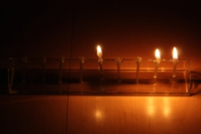
Now, the miracles of the conquest were absolutely no less a miracle than the Pach Shemen. Only, we must admit that the Yetzer Horah will find an opportunity to deceive mankind in miracles of that kind.

Arguments of the Yetzer Horah
Well, you say, it happened they were good fighters, and perhaps the Assyrians were disorganized. It’s not true, they were a very well organized army, but if people are looking for flaws in their Emunah, they'll say it's an accident.
They’ll try to find parallels, a certain small band of people who fought for independence; didn't the Americans fight the British army? No comparison of course, the Americans were here and the British army was only a small number of regiments from across the sea, nevertheless the Yetzer Hora will find ways and means.

A Miracle You Couldn’t Find an Answer For
The Pach Ha'shemen is something you couldn't answer, and therefore when the Gemora asks, Mai Chanukah? What's the miracle for which we celebrate Chanukah? It says, the Ness of Shemen. But it doesn't mean that the other Nissim were smaller Nissim. No, they were also great Nissim, whatever happened, not only one battle, many battles were miracles upon miracles. Only to give us the maximum benefit it was necessary to emphasize the Ness of the Pach Shemen. That must be utilized most fully because that gives us the greatest benefit. Good Shabbos To All

Reprinted from this week’s email of “A Moment with Rabbi Avigdor Miller, Zt”l,” based on a transcription of a question to Rabbi Miller and his answer from a Thursday night hashkafa lecture at his Flatbush shul.

Protecting the Jewish Home
By Rabbi Elazar Meisels

Dear Rabbi,
My husband and I recently really learned about the broader conflict with the Syrian-Greeks during the Hanukah period, and about the oppressive decrees that were imposed on the Jews at the time. Reading the Book of Maccabees, I was shocked to find out that every bride had to spend a night with the Greek governor prior to her marriage! Is there a reason why there no specific celebration dedicated to the abolishment of this decree?
Sincerely,

Melanie (and David)
Marin County, CA
Dear Melanie and David,
Indeed, the Greeks enacted many vile decrees against the Jews. The one you highlighted may be the most loathsome of all, for it struck directly at the time-honored modesty found in the Jewish home and family. Curiously, this characteristic was praised by none other than our arch-enemy Balaam, the evil non-Jewish prophet sent to curse the Jewish people. (Numbers 24:5)
While overlooking the Jewish encampment, Balaam recognized that the Jewish people were different than all other nations simply by the unique manner in which our tents were arranged in the desert. They were staggered, so that no entryway faced that of the next tent. Balaam understood that as long as we retained such modesty, we were virtually indestructible.

Enticing Jews to Sin
He therefore abandoned his original plan and instead urged the daughters of Midian to entice the Jewish men to sin. His plan almost succeeded. Some 24,000 Jewish men died in a plague following this catastrophe. Since that time, numerous enemies of the Jewish people have sought to defeat us by attacking our national modesty.
Chief among them were the Greeks, who incessantly enacted decrees aimed at destabilizing Jewish family life. The Medrash [Batei Medrashot, Perek 5] explains that their first decree was a prohibition against locking the front door, so that no Jewish home would enjoy privacy. Anyone could enter a Jewish home at any time. The Jews responded by removing their front doors. In this way, they would not be misled into believing they had privacy when they really did not, and would protect themselves from being found in compromising situations.

Forbidding Jewish Women
To Go to the Mikvah
Later, the Greeks decreed that no Jewish woman was allowed to go to the mikvah, on pain of execution. Anyone who caught a woman on the way to a mikvah was allowed to kidnap her and her children and hold them as slaves forever. The Jewish people we forced to devise all sorts of solutions, some went as far as digging a mikvah in their own homes. Eventually, the Greek’s insisted that all Jewish brides spend an evening with the Greek governor. This, they felt, would forever taint the Jewish nation and cause us to lose all the purity and modesty inherent in Jewish living.

The Rebellion of the Maccabees
A small group of Maccabees in the little town of Modi’in finally decided that they could take it no longer and rose up in arms to rebel against the Greeks. Certainly the lighting of the Menorah primarily celebrates the miracle of the oil and the victory over the Greeks. Yet, it has been suggested that it also commemorates our self-sacrifice in overcoming the other areas of persecution as well. As is well-known, the ideal location for the Menorah is not by the front window, but by the front door. According to some opinions, this is to commemorate the decree against locking our doors and our willingness to remove them altogether to preserve our modest lifestyles.
Customarily, a married woman relies on her husband’s act of lighting the menorah. One of the ideas inherent in this practice is in response to the Greeks who sought to drive a wedge between husbands and wives and thereby destroy the Jewish family. Our response to them is to draw even closer together. By relying upon her husband’s lighting, the Jewish woman demonstrates that she is inseparable from him. In this manner she symbolizes the Jewish ideal that the union between a man and his wife is sacred and inviolable, and that by clinging to this ideal we merited to be victorious over those who wished to destroy our way of life.
Wishing you and David a joyous and de-lightful Chanukah!

Rabbi Elazar Meisels

Reprinted from this week’s email of Parsha Partner, a publication of Partners in Torah.
A Slice of Life

Heavenly Compensation
By Shoshana Monk

The names in this true story have been changed for reasons of privacy

Mrs. Spitzer answered the door and smiled when she saw her visitor. She had been married for nine years with no children. However, in a miraculous turn of events, the Spitzers had been blessed with quintuplets!
Before their quintuplets, the Spitzers had led a modest lifestyle, but now their expenses had quintupled. The visitor, Mrs. Schiff, had heard about their situation and had raised money and organized other endeavors to help the couple.
Mrs. Spitzer led her visitor into her children's bedroom. Mrs. Schiff looked at the five precious souls with a smile. Her gaze wandered around the room and was drawn to a small photo on the wall.
Suddenly, Mrs. Schiff gasped. She pointed to the photo, asking, "Who is that young woman?"
"She was my mother."
Mrs. Schiff looked at Mrs. Spitzer. "Your mother? Tell me, is she still alive?"
"I'm sorry to say that she passed away last year, just before I fell pregnant. She would have been so happy to see our long-awaited babies."

A Story from Bergen-Belsen
Mrs. Schiff was silent for a moment. Then she said, "I have a story to share with you. When I was 15 I was taken to Bergen-Belsen. I was placed in a barrack together with other girls my age. My four friends and I remained steadfast in our Jewish observance; we said we'd rather die Al Kiddush Hashem (to sanctify G-d's name) than in any other manner. One day, one of my friends, Rivka, called us together excitedly.
"'Tomorrow is Chanuka!' she exclaimed. 'We must light a menora!' We devised a plan. We would trade our daily ration of bread for machine oil from a girl who worked in the factory. Thread from our uniforms would be wicks, and two stones would create fire. Round potato peels could serve as a menora, but it would be risky to get them.
"At midnight, when the guards' shift changed, one of us would sneak into the kitchen through the window, while the others would stand guard.
"That night, all five of us crept stealthily towards the kitchen. Being small, I was chosen to crawl in. I approached the large garbage bin and began to sift through its contents. I could hear the loud grumbling of my hungry stomach. I had given up my ration that day, and I was famished!
"I saw small pieces of food, and stuffed them into my mouth. At last, I found one potato peel with a perfect shape. Then I continued searching. A second perfect potato peel! Suddenly, glancing up at the window, I saw Sarale waving frantically.

Recklessly Looking for One More Peel
"Though my head told me not to, I intently continued looking for at least one more peel. Suddenly, I heard a voice thunder, 'Halt!' I looked up to see a tall Nazi official pointing his gun at my chest. On both sides of him were my four friends, pure terror written across their stricken faces.
"You'll be punished,' he declared with great relish. 'Tomorrow, at noon, all five of you will be hung - in front of the camp, so everyone will learn the punishment for stealing. You know others will be punished if you don't report on time.'
"The darkness seemed even thicker as we trudged back to our barrack. We secretly lit our menora, reminiscing about previous Chanukas in better times. The flame burned very quickly, but it long enough to infuse hope into our deflated souls.

A Plan for Salvation
"Then Sarale came up with a plan. She suggested that we ask Shaina for help. Shaina was a 15-year-old Jewish girl who knew six languages. The Nazis, may their names be blotted out, used Shaina as their interpreter. They gave her a radio and put her in charge of reporting to the Nazi officials any news of the enemy's strategies. She lived in her own little shack in the woods and received a full piece of bread every day.
"'She'll never risk herself to help us!' I said.
"'Let's try anyway,' Sarale reasoned.
"We crept out of the barracks again, this time in the direction of the woods. Rachele spotted light in the distance. We followed the light and soon saw a girl in front of a menora quietly singing Ma'oz Tzur!

Chases the Five Girls Away
"We stood there, entranced; we no longer thought of death, but rather of Mattithias and his sons, marching to victory. Suddenly, Shaina turned around. 'Have you come to spy on me? To tell the Nazis what you see me doing?' she spluttered. 'Do you think that I don't know that you five will be hung tomorrow? You'd better get out of my sight or you'll be in more trouble!'
"'Shaina, we need your help!' I stammered.
"'I said get out of my sight!' Shaina screamed. We ran back to our barrack in fear.

A Deep Resentment Against Shaina
"That night, the fear of dying hovered over us. We resented Shaina deeply. Even if she couldn't help, how could she threaten us in our despair? Where was her Jewish heart?
"The next day, the entire camp was assembled. The Nazi was about to raise our nooses when somebody screamed, 'Stop!'
"He turned around, startled. There stood Shaina, motioning to him frantically and waving her radio wildly in the air. He approached her, grimacing, A few minutes later, he untied us, and with a last kick, sent us back to work, muttering all the while. Miraculously, we had been spared.
"A few days later we were liberated, but we never got a chance to thank Shaina for saving our lives. She had taken such a risk to save us. After the war, no one could trace her. And now I see her face on your wall! Look how G-d runs the world! I thought I was helping a total stranger, but in fact, you are the daughter of the woman who saved my life! You have given me a chance, in a small way, to return the great kindness I owe your mother."

“Finif Neshamos far Finif Neshamos”
"Now I understand!" cried Mrs Spitzer. "During my pregnancy, I dreamt of my mother. With a smile, she kept repeating: 'Finif neshamos far finif neshamos - five souls for five souls.'
"'Mamme, I don't understand!' But she just repeated, 'Finif neshamos far finif neshamos.'
"Now I understand! In the Heavenly court it must have been decided that in the merit of the five neshamos that my mother saved during the war, I would finally be blessed to have her grandchildren - my five beautiful neshamos."

Reprinted from this week’s issue of “L’Chaim,” a publication of the Lubavitch Youth Organization in Brooklyn, NY. Originally published in Women for Life, Sydney, Australia.

It Once Happened

Reb Meir of
Chernobyl’s Menora

For the Chasidim of Rabbi Mordechai of Chernobyl, Chanuka was a special time. Regardless of the distance, thousands would come from all over the country for the privilege of watching the Rebbe kindle the menora.
One year, on the eve of the first night of Chanuka, the Rebbe's shamash (attendant) announced that there would be a small deviation from tradition. Instead of kindling the Chanuka lights in the menora he had inherited from his saintly father, Rabbi Nachum, the Rebbe would be using a different one. He offered no reason. "All I know is that the Rebbe told me to take it out of storage and get it ready," the shamash said. "I don't know where it is from, only that it is exceptionally beautiful."
That evening, when the sun went down, Rabbi Mordechai strode into the huge synagogue to fulfill the mitzva (commandment). Everyone was already waiting eagerly. Thousands of eyes followed the tzadik's every movement.

An Incredibly Beautiful Menora
Indeed, the menora that had been set up was not the Rebbe's usual one. And although the shamash had described it as "exceptionally beautiful," this was truly an understatement. The Rebbe recited the blessing and lit the wick, then stared into the tiny flame for a long time. It was obvious that the Rebbe's thoughts were far away, even though he was physically present.
A few minutes later the Rebbe shook his head slightly, as if returning to the world around him. Then, without even looking up, he started speaking:

Visited the Village of Cherbin
"Many years ago I visited the village of Cherbin," the Rebbe began. "The Chasidim there greeted me very warmly, and I was invited to stay in the home of a certain Reb Meir. This Reb Meir, who had once been a follower of my late father, was the wealthiest man in town. He was a true Chasid in all of his 248 limbs and 365 sinews. His love for the Torah and his desire to perform mitzvot in the most beautiful manner possible knew no bounds.
"Towards the end of my stay in Cherbin Reb Meir led me into his treasury to show me his riches. There, in one corner of the room, was the most extraordinary silver menora I had ever seen. Reb Meir told me that he had paid a fortune for it, and planned on using it the very next Chanuka. I picked it up to admire its workmanship and artistry.

Requests the Special Menora as a Gift
"'Reb Meir,' I said to him suddenly, looking him in the eye. 'Would you give me this menora as a gift?' My question momentarily startled him, and he was silent for a minute. But after considering my request he immediately agreed. 'Yes,' he said. 'I would give all my wealth to the Rebbe.'
"When I got back to Chernobyl I instructed my family to put the menora in storage. When Chanuka arrived I did not ask for it, but continued to use the menora I had inherited from my father. My family was somewhat surprised by this, for why had I brought the other one if I wasn't planning on using it? But as time passed, everyone forgot that the other one even existed.
"This year, however, I decided to change my custom, and now I will tell you why:

Reb Meir Recently Passed Away
"A few days ago, Reb Meir of Cherbin passed away. When he ascended to the heavenly court, it seemed obvious that his rightful place was in Gan Eden [the Garden of Eden]. Thousands of angels testified to all the good deeds Reb Meir had performed throughout his life. One after the other they described his love of Torah and his exceptional performance of mitzvot.
"Reb Meir was about to pass through the gates of Gan Eden when all of a sudden, an angel without any eyes stood up and cried out, 'I object!' Pandemonium broke out. The blind angel was given permission to speak, and proceeded to tell the story of the silver menora Reb Meir had once purchased at great expense.

The Angel’s Explanation
Of the Menora Purchase
"'What you don't know,' the angel explained, 'is that this menora was bought from a poor Jew in Cherbin who was forced to sell it because his wife and children were starving. This menora had been in his family for 13 generations, and was almost as dear to him as his life. For years he refused to sell it. Reb Meir was well aware of the poor man's circumstances. The otherwise generous and charitable Reb Meir had such an intense desire to own the beautiful menora that he deliberately exploited the poor man and offered financial assistance only through the purchase of the menora.'

Case Reviewed by
The Heavenly Court
"The heavenly court decided to review the case. In the end it was ruled that Reb Meir should go to Gan Eden, but not directly. To atone for the anguish he had caused, he would first have to wander around through the celestial spheres accompanied by the blind angel.
"Many years ago, when I visited Reb Meir's house and he showed me the menora, I knew what was going to happen. I took it from him so that when the proper time came, I would be able to help him make amends. Tonight, when I lit the first candle of Chanuka in that menora, it corrected Reb Meir's spiritual defect and allowed him to enter Gan Eden. It also restored the gift of sight to the blind angel..."
Reprinted from the archives of “L’Chaim Weekly.”
Shabbos Stories for Parshas Miketz (Chanukah) 5770

The French Connection

Good Shabbos Everyone. On Chanukah we light candles to celebrate the victory of the Chashmonayim over the Greeks over 2000 years ago. In reality, the kingship which the Chashmonayim established did not last very long, it was quickly eclipsed by the growing Roman Empire. Nevertheless, we celebrate the victory. In a greater sense we celebrate on Chanukah the everlasting victory of the Jewish People over those nations who have sought to destroy us in every generation.
Even the non-Jewish scholars have recognized the everlasting nature of the Jewish people. As the American author and commentator Mark Twain writes in his short essay entitled: Concerning the Jews.

But One Percent of the Human Race
"If the statistics are right, the Jews constitute but one per cent of the human race. It suggests a nebulous dim puff of stardust lost in the blaze of the Milky Way. Properly the Jew ought hardly to be heard of, but he is heard of, has always been heard of. He is as prominent on the planet as any other people, and his commercial importance is extravagantly out of proportion to the smallness of his bulk.
His contributions to the world's list of great names in literature, science, art, music, finance, medicine, and abstruse learning are also away out of proportion to the weakness of his numbers. He has made a marvelous fight in the world, in all the ages; and has done it with his hands tied behind him. He could be vain of himself, and be excused for it.
The Egyptian, the Babylonian, and the Persian rose, filled the planet with sound and splendor, then faded to dream-stuff and passed away; the Greek and the Roman followed, and made a vast noise, and they are gone; other peoples have sprung up and held their torch high for a time, but it burned out, and they sit in twilight now, or have vanished. The Jew saw them all, beat them all, and is now what he always was, exhibiting no decadence, no infirmities of age, no weakening of his parts, no slowing of his energies, no dulling of his alert and aggressive mind. All things are mortal but the Jew; all other forces pass, but he remains. What is the secret of his immortality?"

First Person Story by a Doctor
The following amazing true story, told in the first person by a doctor, illustrates that although we have been persecuted, the Jewish nation has survived all those who sought to destroy us...
"Several years ago, a physician from southern France contacted me. His granddaughter had taken ill with a disease that baffled the physicians there. He called after reading several of my articles on disorders of the autonomic nervous system. His granddaughter's symptoms seemed to match those I had described, and he asked me if I could help. I readily agreed, and for many months, I collaborated with the child's French physicians by telephone and by fax, directing their diagnostic testing. At last we came to a diagnosis, and I prescribed a course of therapy.
During the next several weeks, the child made a seemingly miraculous recovery. Her grandparents expressed their heartfelt thanks and told me to let them know should I ever come to France. In the summer of 1996, I was invited to speak at a large international scientific meeting that was held in Nice, France. I sent word to the physician I had helped years before.

A Message Upon Arriving at the Hotel
Upon my arrival at the hotel, I received a message to contact him. I called him, and we arranged a night to meet for dinner. On the appointed day we met and then drove north to his home in the beautiful southern French countryside. It was humbling to learn his home was older than the United States.
During the drive he told me that his wife had a terminal illness and was not well, but she insisted upon meeting me. When introduced to her, I saw that despite her severe illness, she was still a woman with a noble bearing.
We sat in a 17th-century salon, sipping cognac and chatting. Our conversation must have seemed odd to the young man and woman who served us because it came out in a free-flowing mixture of English, French, and Spanish. After a time the woman asked,
"My husband tells me you are Jewish, no?" "Yes," I said, "I am a Jew." They asked me to tell them about Judaism, especially the holidays. I did my best to explain and was astounded by how little they knew of Judaism. She seemed to be particularly interested in Chanukah.
Once I had finished answering her questions, she suddenly looked me in the eye and said, "I have something I want to give to you." She disappeared and returned several moments later with a package wrapped in cloth. She sat, her tired eyes looking into mine, and she began to speak slowly.

A Little Girl of 8 Years
"When I was a little girl of 8 years, during the Second World War, the authorities came to our village to round up all the Jews. My best friend at that time was a girl of my age named Jeanette. One morning when I came to play, I saw her family being forced at gunpoint into a truck. I ran home and told my mother what had happened and asked where Jeanette was going. 'Don't worry,' she said, 'Jeanette will be back soon.'
"I ran back to Jeanette's house only to find that she was gone and that the other villagers were looting her home of valuables, except for the Judaic items, which were thrown into the street. As I approached, I saw an item from her house lying in the dirt. I picked it up and recognized it as an object that Jeanette and her family would light around December time. In my little girl's mind I said 'I will take this home and keep it for Jeanette, till she comes back,' but she and her family never returned."

To You I Entrust This
She paused and took a slow sip of brandy. "Since that time I have kept it. I hid it from my parents and didn't tell a soul of its existence. Indeed, over the last 50 years the only person who knew of it was my husband. When I found out what really happened to the Jews, and how many of the people I knew had collaborated with the Nazis, I could not bear to look at it. Yet I kept it, hidden, waiting for something, although I wasn't sure what. Now I know what I was waiting for. It was for you, a Jew, who helped cure our granddaughter, and it is to you I entrust this."
Her trembling hands set the package on my lap. I slowly unwrapped the cloth from around it. Inside was a menorah, but one unlike any I had seen before. Made of solid brass, it had eight cups for holding oil and wicks and a ninth cup centered above the others. It had a ring attached to the top, and the woman mentioned that she remembered that Jeanette's family would hang it in the hallway of their home. It looked quite old to me; later, several people told me that it is probably at least 100 years old. As I held it and thought about what it represented, I began to cry.

“It Should Once Again See Light”
All I could manage to say was a garbled "merci." As I left, her last words to me were "Il faudra voir la lumiere encore une fois -- it should once again see light."
I later learned that she died less than a month after our meeting. That Chanukah, the menorah once again saw light. And as I and my family lit it, we said a special prayer in honor of those whose memories it represents. We will not let its lights go out again!
The original owners of that menorah were unfortunately taken as sacrifices during the war. However, the Jewish nation has survived and we continue to light the Chanukah lights to symbolize the everlasting nature of this great nation. Good Shabbos and Happy Chanukah Everyone.

Reprinted from this week’s email of Good Shabbos

Story #629

The Ninth Flame
By Simon Jacobson

As heard from a Holocaust survivor, who was a child in the camps
From the Desk of Yerachmiel Tilles

Chanuka 1944, Auschwitz

I will never forget the last Chanuka in the barracks. Most of us were so consumed with scraping together any morsel while avoiding the attention of the guards that we had no inkling which day in the year it was. Especially in those last weeks before the liberation, the Nazis were particularly unpredictable and cruel, and the chaos only made matters worse.
Yet there were a few who always knew the exact dates. They would tell the rest of us that today is Shabbat, Pesach and other significant days. On this particular day a man would tell me that it was Chanuka.
That morning I went to the infirmary to try smuggling out some balm - anything to help relieve my father's open sores. His disease -- whatever it was -- was eating his body away, and whenever I could sneak over to see him I would see him silently struggling for some relief. As an 11-year-old child, I was completely overcome by the sight of my suffering father.
My Father Was No Longer There
That particular day, when I finally snuck over to my father's bunk, he was no longer there. I became frantic.
An older gentleman, whom I did not know but I had often seen talking to my father, came over to console me. He too did not know when my father was taken, to this day I don't know if it was the disease or a Nazi bullet that took my father to heaven, but his was a calming presence.
He told me that today was Chanuka and we celebrate the victory of the few weak over the many powerful oppressors. We light the candles to demonstrate that our light is stronger than any darkness. "Your father would be very proud to know that you carry on his light despite the blackness around us," he said.
I was so moved by his words -- and all the memories it brought back from my earlier years in Lodz -- that I suggested to him enthusiastically that we should light the menora tonight. He sort of smiled at me, the child -- a smile hardly concealing his deep anguish -- and said that it would be too dangerous to try. I insisted and made off to get some machine oil from the factory.

Putting Together Some Wicks
I was so excited. And for this brief moment I was able to put aside my grief. I slowly made my way back, so as not to be noticed, to the barrack with my treasured bit of oil. Meanwhile the strange gentleman had put together some wicks, apparently from clothing or some other material.
Now we needed fire to light our makeshift menora. I noticed at the end of one building smoldering cinders. We agreed that we would wait till dusk and at an opportune moment we would light our Chanuka lights
Wait we did. As we were walking over to the cinders a guard noticed us and grabbed away the oil and wicks we were concealing. He began cursing and frothing at us. A miracle seemed to happen when his superior barked a command that apparently needed his participation, and he ran off with our precious fuel. The miracle however was short-lived. The animal yelled back at us that he would soon return to "take care of us."

A Light More Powerful than the Chanuka Lights
I was terrified. The gentleman was absolutely serene. And then he said to me words that are etched into my every fiber until this very day:
"Tonight we have lit a flame more powerful than the Chanuka lights. The miracle of Chanuka consisted of finding one crucible of oil, which miraculously burned for eight days. Tonight we performed an even greater miracle: We lit the ninth invisible candle even when we had no oil...
"Make no mistake. We did light the Menora tonight. We did everything in our power to kindle the flames, and every effort is recognized by G-d. He knows that we were deprived by forces that were not in our control, so in some deeper way we lit the Menora. We have lit the ninth flame - the most powerful one of all, so powerful that you can't even see it."

A Promise: “You Will Get Out of Here Alive”
The man then promised me: "You will get out of here alive. And when you do, take this ninth invisible flame with you. Tell G-d that we lit a candle even when we had no oil.
"Tell the world of the light that has emerged even from the darkest of darkness. We had no physical oil and no spiritual oil. We were wretched creatures, treated worse than animals. Yet, in some miraculous way, we forged a 'crucible' where none existed -- in the hell fires of Auschwitz.
"So there was no oil. Not even defiled oil. No oil, period. Yet we still lit a flame -- a flame fueled by the pits of darkness. We never gave up. Let the world know that our ninth flame is alive and shining. Tell every person in despair that the flame never goes out."
As he finished these last words, the Nazi beast returned and viciously led him away behind one of the barracks.
I made my escape. A few weeks later the Russians arrived and we were liberated. Here I am today to tell you the story of the ninth flame.

© 2006 TheMeaningful Life Center. All rights reserved. (Also posted on LChaimWeekly.org #949.)
Rabbi Simon Jacobson is the author of the best-selling Toward a Meaningful Life (meaningfullife.com), as well as two important guidebooks for the Jewish year.

Reprinted from this week’s email of KabbalaOnline.org,
a project of Ascent of Safed
www.ascentofsafed.com ascent@ascentofsafed.com
Chanukah in Iowa
By Miriam Meir

I was the only Jewish child in the auditorium, and sometimes felt I was the only Jewish girl in the entire world.
My younger sister and I were the only Jewish children attending Monroe Elementary school in Davenport, Iowa in the sixties. In most ways I was just like any other little girl in the Midwest. I went sledding in the winter and caught fireflies in the summer. Only a few symbols formed my Jewish identity. For instance, the mezuzah on our front door was my daily reminder that I was part of a Jewish family.

Enjoying the Freedom of
Living in the Melting Pot
Like most red-blooded Americans enjoying the freedom of living in the melting pot, the extended family gathered to celebrate Thanksgiving with all the trimmings (our stuffing actually had farfel, which was purchased across the river in Rock Island, Illinois from the kosher deli). However, this attitude of "when in Rome" did not extend to the next holiday. As the orange, yellow and brown displays in the supermarkets were replaced by green and red, a voice from within said, "This is not mine."
Each year, I would have to break in a new teacher. This happened in the fall. I was just an ordinary student, maybe a bit more gabby than the rest, until Rosh Hashana approached and I would quietly inform the teacher that I'd be missing school.
"Oh, you're Jewish?" was the usual response.

Lighting My Chanukah at the
School X-mas Recital
Once through the Jewish holiday season, my Jewishness was forgotten until the X-mas recital. Suddenly, my Jewish roots were recalled and considered of great educational importance. For this glorious gathering the entire school body was squeezed into the auditorium to hear speeches, a few carols, and view the lighting of my Chanukah candles.

This practice, year after year, tended to be the show stopper. The night before, I would carefully choose the nine candles according to some color pattern that I felt would make the best impression. These candles were promoting the entire Jewish religion and culture, competing with large evergreen trees covered with tinsel, lights and ornaments. As I took center stage and set my menorah onto a tabletop, I was amazed by the total silence around me. It was a silence that impressed upon me -- more than the gratuitous applause that would follow -- that I was doing something important...that being a Jew was important.
Lighting the shamash with a match was not a particularly religious aspect of the menorah lighting, but being nine years old and allowed to use fire added an air of authority to the ceremony. In a loud, clear voice I would recite the blessings according to the tune my father taught me. Then, one by one I would light all eight candles. It was usually not the last day of Chanukah when I made this presentation, but I felt it was important for everyone there to know that Chanukah was celebrated for eight days.

The Question of the Doubting Thomases
After the menorah was lit, my teacher would ask if there were any questions about Chanukah. Inevitably, some doubting Thomas would ask, "Is it true that you get a present each night?" Believing this to be one of the foundations of my holiday, I would announce, "That is correct!" which always got a few oohs and ahhs.
Once in a while a question would be considered out of line, asking if I "believed in" Christmas. My teacher would intervene, explaining that all questions should be about Chanukah. I had no problem announcing that I did not "believe in" Christmas. It was foreign to me. It was them, not me. I knew I was the only Jewish child in the auditorium, and sometimes felt I was the only Jewish girl in the entire world. And yet, like Judah Maccabee, I had no sense of weakness or lack of importance. As I stared at the small dancing flames, I thought of the children's poem, "Twinkle, twinkle little star" and I felt like a small, but precious diamond connected to an eternal People throughout time and space.

The Core of My Present Torah Observance
Today I no longer live in Iowa. And I am definitely not the only Jew around. I live in Jerusalem, with children ranging from still in diapers to recently married. The small twinkling light of Chanukah that built the strong Jewish identity within me in my childhood is the core of my present Torah observance that permeates my consciousness and every action.
I would never recommend anyone to raise their Jewish children in an environment void of the basic Jewish vibrancy that guides a child from his "Modeh Ani" in the morning until his "Shema Yisrael" at bedtime. But any parent who has felt the power of the small flame of Judaism from within the darkness of Jewish ignorance has a grand opportunity approaching. As the Chanukah lights are burning, take the time to tell your story. From a place of safety and light, we can help our children appreciate "BaYamim Hahem, Bazman Hazeh" -- Just as it was in those days, at this time.

Reprinted from Aish.com website

A Message from the Kalever Rebbe Chanukah 5770

Seeing Our Greatness “Through The Eyes of Our Enemies”
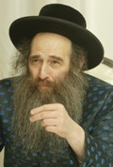
People often take for granted those things most familiar to them. Even the most precious heirlooms can become commonplace - until one is reawakened to their true value. As Jews, our most priceless legacy is our holy Torah and its beautiful Mitzvos. And yet, at various times throughout our history, even until the present day, many of us have taken for granted this dearest of gifts from Hashem. However, when we are forcefully deprived of our birthright we once again recognize what we are missing and fight back to reclaim what is rightfully ours.
In the period of the Chanukah story, some 2.300 years ago, our Syrian-Greek oppressors decreed that Jews abandon the practice and observance of three particular Mitzvos: Shabbos, Declaration of the New Month (Kiddush HaChodesh) and Ritual Circumcision (Bris Milah). What was it about these Mitzvos that the Syrian-Greeks found so objectionable and, conversely, what valuable lessons can we draw from what they saw?

The Special Relationship Between
Hashem and His Chosen Nation
The common characteristic of these Mitzvos is that each highlights the special relationship between Hashem and His chosen nation and the supernatural divine plane upon which the Jewish people exist as a result of it. This idea was anathema to the ancient Greeks who introduced rational philosophical thought to the world and bristled at the notion of divine intervention into the affairs of man.
Shabbos is testimony to Hashem's creation of heaven and earth and His continued active participation in all of nature. On Shabbos we Jews are enjoined from the performance of any creative work to demonstrate our belief that ultimately everything we receive comes directly from Hashem and is dependant upon our commitment to observing His holy Mitzvos.
Indeed, the Zohar expounds that Shabbos is the source of all blessing for all of man’s creative endeavors. Paradoxically, the greater one’s observance and glorification of Shabbos by refraining from work, the greater the material benefits he will reap in the course of the workweek. On the other hand, one who violates Shabbos in pursuit of financial gains will see no benefit from the toil of his labor. In the divine framework of Jewish life, faithful adherence to Hashem’s instructions is the most important key to success.

Symbolizing the Eternal Nature
Of the Children of Israel
The Mitzvah of Kiddush HaChodesh symbolizes the eternal, enduring nature of the Children of Israel. Just as the moon waxes brightly and then wanes but its illumination is always restored, so it is with the Children of Israel, while her enemies ever try to extinguish her supernal luminescence, Hashem always rekindles her holy light.
Ritual circumcision is the sign of our eternal covenant with Hashem. We demonstrate that we will endeavor to sublimate and perfect even our basest impulses in the service of the Almighty. Throughout the ages Jews have performed this Mitzvah even at great sacrifice but always with joy.
Decreeing against these three cardinal observances, the Greeks sought to sever the holy bond between Hashem and the Jewish people and debase them to live strictly in accordance with the laws of nature and the will of the gentiles. The Jews heeded the call of the hour and rose up in rebellion against their oppressors. Though greatly outnumbered, they waged war with selfless sacrifice, the small against the manyplacing their trust in Hashem to deliver them from the hands of their enemies. Thus, they sanctified His holy name and miraculously prevailed.

Commemorating the Supernatural Victory
We commemorate this supernatural victory with the Chanukah candles, themselves, the miraculous product of Hashem’s direct providence over His beloved children. The Chanukah candles allude to the very three Mitzvos which the Greeks failed to abolish. The Chanukah candles obviously remind us of the Shabbos candles. They also reflect the inner soul-light of every Jew who enters into Hashem’s covenant through circumcision. And finally, they recall the ever-renewing light of the moon which represents the inextinguishable light of the Jewish nation.
May the holy Chanukah lamps cast the light of Torah wisdom on Jews everywhere so that we never again take for granted our precious heritage. May they engender profound spiritual growth and abundant material blessing for all of us. And may we merit, once again, to see Hashem’s great miracles with the arrival of Mashiach speedily in our days, Amen.

Special Thanks to: Rabbi Avraham Shalom Farber & Yehuda Leib Meth, for the Translation
Zalmen Rosenberg Gabai of the Kalever Rebbe

The following was President Obama’s message at the Chanukah event:

President Obama Quotes the Novi Zechariah at White
House Chanukah Reception

It was more than 2,000 years ago, in the ancient city of Jerusalem, that a small band of believers led by Judah Maccabee rose up and defeated their foreign oppressors - liberating the city and restoring the faith of its people.
And when it came time to rededicate the Temple, the people of Jerusalem witnessed a second miracle: a small amount of oil - enough to light the Temple for a single night - ended up burning for eight. It was a triumph of the few over the many; of right over might; of the light of freedom over the darkness of despair. And ever since that night, in every corner of the world, Jews have lit the Hanukkah candles as symbols of resilience in times of peace, and in times of persecution - in concentration camps and ghettos; war zones and unfamiliar lands. Their light inspires us to hope beyond hope; to believe that miracles are possible even in the darkest of hours.
It is this message of Hanukkah that speaks to us no matter what faith we practice or what beliefs we cherish. Today, the same yearning for justice that drove the Maccabees so long ago inspires the protestors who march for peace and equality even when they know they will be beaten and arrested for it.
It gives hope to the mother fighting to give her child a bright future even in the face of crushing poverty. And it invites all of us to rededicate ourselves to improving the lives of those around us, spreading the light of freedom and tolerance wherever oppression and prejudice exist.
This is the lesson we remember tonight - that true acts of strength are possible, in the words of the prophet Zechariah, not by might and not by power, but by spirit alone.

Reprinted from the website of Matzav.com

It Once Happened

The Blacksmith’s Desire to Light the Community Menorah

Most of the people of the shtetl of Roshvenitz were very poor, but, being Chasidim, poverty could not detract from their joy of life, as it was derived from their Rebbe, the great Rabbi Avraham Yaakov of Sadigora.
In those days, traveling to the Rebbe was not an easy undertaking. It cost far more than most of them could afford, and so they established a special fund to pay the traveling expenses of one person. Each Jewish family would contribute to the communal pot, and when a special occasion would arise, a raffle would be held. The winner would travel to the Rebbe as an emissary of the community.
At the Rebbe's court, the representative was given a private interview with the Rebbe who would question him about the state of his Chasidim in the little village. But that wasn't all. When the emissary set off, the Rebbe always presented him with a pure, silver coin. These coins became the property of the community and were its prized treasure.

Utilizing the Holy Coins of Their Beloved Rebbe
It was a month before Chanuka and a special meeting was called. The villagers twittered with anticipation of this unexpected event. Finally the caretaker of the shul began to speak: "My dear brethren, we have called you here tonight to discuss the matter of the holy coins of our beloved Rebbe. We have merited to amass many coins, and we have decided to give them all to a G-d-fearing silversmith who will make from them a most beautiful menora."
Excitement rose as the congregants murmured their approval to one another. "The beautiful menora, we will put in our study hall, and each Chanuka we will sell the honor of lighting it to the highest bidder. This money will help pay for the many needs of our community - food and medicine for the sick and poor, dowries for needy brides, salaries for the teachers." The congregants were all very excited, and each of them dreamed about the beautiful silver menora made from the Rebbe's holy coins.

The First Night of Chanuka Arrived
The first night of Chanuka arrived and every corner of the shul was packed tight. At the southern wall stood the Chanuka menora, a masterpiece of the silversmith's art - intricate in design, glowing, and sparkling in the lamplight.
The bidding began, and then rose quickly. It wasn't long before the poor and average homeowners were outbid, leaving only the wealthy to continue the contest. In the end, Reb Lipa, a wealthy wood merchant won the honor. With great emotion he approached the menora. He recited the three blessings, and ignited the wick.
This scene was repeated each night of Chanuka. The same bidding, the same enthusiasm, and in end, the same result: one of the wealthy congregants always emerged the winner.
The poor people of the shtetl realized that the coveted honor would never fall to one of them. They had to content themselves with watching the lighting and answering "amen" to the blessings.

Reb Baruch, the Blacksmith Pursues His Mission
One of them, however, couldn't accept the situation. Reb Baruch, the blacksmith, was a Chasid to the core of his soul. His love for his Rebbe filled his entire being, and he was heartbroken that he couldn't light the menora even once. Chanuka passed and once again life's dreary sameness returned to the inhabitants of the little shtetl.
But for Baruch the blacksmith life was different. He had a mission which filled his nights and days. He began to work a little extra every day, and he hoarded every penny he managed to scrape together - all this for his much longed-for Chanuka lighting. Months went by and he managed to amass a tidy sum.
A month before Chanuka his wife took ill. When all the old remedies failed to cure her, a doctor was summoned from the big city. The doctor's fee was tremendous and the medications very costly. When G-d blessed his wife with a complete recovery, Reb Baruch's entire hard-earned savings were gone.

Watching Each Night of Chanuka with a Pained Heart
Chanuka arrived and Reb Baruch was inconsolable. He had come so close to attaining his heart's desire, and now it was lost.
As the nights of Chanuka passed by, Reb Baruch watched the successive lightings with a pained heart. Finally, the eighth and final night came. The bidding was frenzied, and the poor looked on as their wealthy brethren bid astronomical sums for the honor. Reb Baruch felt that his heart would break.
Suddenly all was still. All eyes focused on the figure ascending the bima. Could it be Reb Baruch, the blacksmith!? With tears running down his face, he turned to the crowd: "My dear friends, this is the second year that I have yearned with my whole soul to kindle the holy menora. All year I saved, but then my wife became ill. G-d has granted her a complete recovery, but my savings are gone. Believe me, my brothers, I cannot continue; my soul is expiring from longing. So, I am making you a proposition. My house is very small - worth about 300 crowns. I am giving it to the community. I will continue to live in it, but as a tenant of the community. Accept my plea and restore the soul of a poor blacksmith."
Reb Baruch's heartfelt words touched everyone. Tears flowed freely, and a great roar came up from the crowd. "Reb Baruch has won the bidding!" was heard from every corner. When he rose to kindle the silver menora, there was not one heart which did not tremble at the sight of the flame that burst forth and rose up from the soul of Reb Baruch, the blacksmith.

Reprinted from this week’s issue of L’Chaim.

Shabbos Stories for
Parshas Vayigash 5775
Volume 6, Issue 15 5 Teves 5775/ December 27, 2014
Printed L’illuy nishmas Nechama bas R’ Noach, a”h

For a free subscription, please forward your request to keren18@juno.com

No Kidding! Your Grandmother was Jewish…
By Rabbi Yoseph Vigler

I was graciously invited by one of our great councilmen to light the menorah at their event yesterday. I was inclined to decline the request because it was a hectic evening: We had a Chanukah party for our 300 "MY Extended Family" kids from single parent families, a late night kumzits with Yitzchok Fuchs at Mayan Yisroel (which by the way all turned out a success Boruch Hashem) and I had to be in Monsey for a simcha in the middle of it all. But all they requested was ten minutes to light the menorah at 4:15 P.M. So I acquiesced. After all, how can you say no to an opportunity of "pirssumei nissa" (publicizing the holiday miracle) on Chanukah!
When I arrived there was a nice crowd, primarily of local public school kids, but I could not detect anything close to a minyan that would allow for major "pirssumei nissa" and to make a bracha on the lighting.
I detected a fellow who introduced himself as Chris. I asked if he was Jewish. He said no. I said, "O.K., great seeing you here". Turns out he is the parks department representative. I don’t know why but I said "you know you look Jewish.
He says, "yeah, i have some Jewish blood. My maternal grandmother was Jewish and converted out the faith. I am Christian." I jumped at the opportunity - found a yid! I told him he is a Jew just like me and nobody can ever change that. I handed him our MitzvahShare Chanukah menorah kit to light at home, which he agreed to do. He then puts on a yarmulka and he did the lighting (without a bracha). The effort was worth it for this one Yid!
I spoke to the crowd about how the goal of Chanukah is to defeat the darkness. When you light one candle it is no longer dark. And we davka light the candles as it turns dark because that is when it matters most. Our task is to light up our inner souls and by extension illuminate the world. I was hoping Chris would get the message along with all the public school kids.
After our menorah lighting the local priest got up to light the tree. I was in the back, ready to leave, when somehow a conversation began with a photographer of the event. Guess what, this guy's mother mother was also Jewish. And I gave him a menorah too, ,though I didn’t have a chance to understand fully because he said something about his grandmother having converted to Judaism.
I was wondering if that was a halachic conversion. Worst case scenario I gave him the menorah for nothing... I couldn't chat with him because I was talking to the priest - a really nice man. He is telling me how his church has the minhag to light the menorah on the altar every year on the Sunday of Chanukah with the requisite amount of candles for that day. He uses crystal that came for Kristalnacht and he reminds the congregants how never again should we allow the slaughter that took place in the holocaust. I thought that was beautiful.
He had not heard the conversation with Chris nor with the photographer. These are three separate conversations going on. And somehow he tells me he too has Jewish blood. His grandmother converted to Christianity - in other words his mother's mother was Jewish. Nu, I embraced one more Yid into the fold. I gave him a Chanukah menorah kit and asked him to light it at home. Make your home a Jewish place. (I got some great photos, but will not post so as to protect their privacy.)
Sitting in a warm kumzits last night for hours into the night, I couldn’t help but remark to all the chevra how fortunate we are to experience the warmth of Yiddishkeit singing niggunim around the menorah. If G-d gave us the ability to be connected to His Torah and Mitzvahs then we have a duty to light up the night
Chazal want us to light the street up until we reach the point that all the rebels, ie those who know nothing about Yiddishkeit, most likely through no fault of their own, reach a state of, a yearning for G-d. Every Jew has a neshama that thirsts for G-d no matter where circumstances led them. It is our job to light up our own lives and to illuminate the souls of all out there.
I don't know the end of the story yet. IYH they will be coming for a Shabbos meal sometime soon!
A lichtigen Chanuka and a a gutten Shabbos!
Rabbi Yoseph Vigler

Reprinted from last week’s email of Maayan Yisroel.
L’Maaseh… A Tale to Remember

The “Magical” Powers
Of the Chanukah Lights

A certain Rosh Yeshiva relates that in addition to his appointment as Rosh Yeshiva, he was also involved in “Peiros Ha’nosharim”, fallen fruit– children that have fallen off the correct path, in order to return them to the correct path.
One particular boy had very much deteriorated and attached himself to a magician.
The boy followed him and became more and more involved with him. On one of the days of Chanukah, as the boy was on the phone with the magician, he absently looked out his window and noticed Chanukah lights in one of the neighboring houses.
At that moment the magician asked him, “Where are you standing?” The boy replied that he had not moved from his place and he is standing in the same room where he was when he began the conversation. But the magician said that this was not possible as he felt that he was losing his connection with the boy.
He demanded that the boy tell him exactly what he was seeing at that moment. Innocently, the boy told him that he was looking out his window and he was observing lights burning opposite him.
Immediately the magician yelled at him and commanded him to look at something else because the lights were causing the bond between them to break! The boy saw with his own eyes the greatness of the days of Chanukah, realized what had happened to him, and immediately broke the connection between him and the magician. He was [thus] saved from falling further away in the merit of seeing the holiness of the Chanukah lights! (Be’er HaChaim)

Reprinted from this week’s email of Torah U’Tefilah: A Collection of Inspiring Insights compiled by Rabbi Yehuda Winzelberg.

My Chanukah
By Larry Gordon

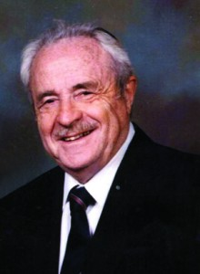
Rabbi Nison Gordon, z’l

It is an ongoing Chanukah dilemma, one that is dealt with annually, not necessarily at this time of year, but rather back in August or September when the summer begins to fade and we take a glimpse at the year ahead.
Those of you following the adventures of this column over the last 15 years are probably aware that my Chanukah was unceremoniously upended in 1989 when my father [Rabbi Nison Gordon, z’l] passed away on the sixth night of the holiday.
Every small detail is still etched into my mind. There is no forgetting the life-changing trauma as it is summoned up in this space as the yahrzeit nears.
I knew that my dad was planning on being interred in Israel, but it was always a distant, almost not relevant, issue that we would not have to deal with for a long time and that we would figure out when we had to figure it out.
As Chanukah approached that year, he experienced some kind of cardiac episode and was scheduled for bypass surgery after New Year’s Day a couple of weeks later. But on December 28, something happened, and he was gone.
My brother Binyomin and I flew to Israel that Thursday afternoon. We arrived on an unusually warm erev Shabbos Chanukah morning for a burial in Bet Shemesh, a then-obscure location about halfway from Ben-Gurion airport to Jerusalem. We would spend Shabbos there before flying back on Saturday night. Those 36 hours in the country over that Shabbos illustrated in extreme terms what it is like to be exhilarated and downtrodden simultaneously. We were new mourners and Shabbos Chanukah in Jerusalem was indeed something else. There would be many more to come.
After shivah, we were told by Dad’s attorney that his will requested that on his yahrzeit one of his children—there are four of us—visit his kever up on that steep, now quite popular, towering mountain. We all had young families in those early years and needless to say it was difficult. That first year we all traveled to Israel for the yahrzeit and it was quite a commemoration. As time went by, I worked my schedule so that one way or another I fulfilled that request and was there at my father’s side on his yahrzeit.
There were years when I did not go specifically at that time, but one of my siblings always managed to be there. Many years have passed, but there is still an internal tug-of-war that takes place between Chanukah, the family, and our dad’s request for us to be there.
While we do not know definitively what it is about, our rabbis say that these requests are not to be taken lightly. I cannot begin to describe the conflict that was conjured up over all those years as I lit the wicks on the fourth night of Chanukah, knowing that this would be the end of the chag—for us anyway—and I would be off to Israel to observe the yahrzeit, by myself or with my wife (and a few times with the children). Many years, Chanukah became a four-day holiday and seemed a bit less than the joyous celebration it’s supposed to be because of the requirement to pull away from the family each year.
The sufganiyot they served in the airport lounge at JFK were no comfort or replacement for a good old-fashioned Shabbos Chanukah or conventional Chanukah celebration at home.
I’ve always made it my business when in Israel for the yahrzeit to daven at the amud at the Kotel early in the morning. Over the last two-and-a-half decades, there have been beautiful, sunny summer-like days and other times when the weather felt like a monsoon. One never knows what he will encounter when it comes to the weather over Chanukah in Israel. The weather is just about as predictable as everything else in that part of the world.
My father left us with an assortment of interesting challenges. Chief amongst those was leading the services on the day of his yahrzeit, which, regardless of which day of the week it falls out on, is no simple davening. This is true when the yahrzeit falls on Shabbos, which means that it is also Rosh Chodesh.
My dad used to struggle to get me up in the morning to get to yeshiva on time for the daily minyan. But then in 11th grade, I took a driver’s-education course and discovered that I was capable of being outside in front of the yeshiva on Coney Island Avenue, wide-eyed at 6:00 a.m., ready to get behind the wheel. I think that is when we both discovered that I could wake up and get out early; the only apparent requirement was that I really want to do it.
I think of this yahrzeit davening as a communication from the other side about an old youthful struggle to make it out on time in the morning. On Shabbos Chanukah, when we daven for the amud and say Kaddish, everything printed in the Siddur has to be said. This means everything above the various lines and below, in the parentheses and in the brackets. It includes Hallel and Mussaf, reading from the Torah every day during the week, and on Shabbos Chanukah/Rosh Chodesh utilizing and reading from three Torah scrolls.
It’s a quarter-century later and I really cannot get over the irony of all this. Talk about last laughs. So let me tell you a little bit about my dad. He came to the U.S. from Russia as a 16-year-old in 1934. His father arrived here in 1932 to set up a new life for his family with my grandmother and her four children. My father was the oldest.
My father developed an interest in writing and journalism early on. He was a prodigious keeper of notes and was said to have transcribed by hand the shiurim of his rebbe in Yeshiva Torah Vodaas, Rav Shlomo Heyman. At the age of 18 years, he convinced a Polish-Jewish newspaper (back in Poland) to carry his stories about life in the New World—that is, life for an immigrant in New York.
Before the age of the Internet and instant communication, in order to penetrate the journalistic market and make an impression, you had to be consistent and credible at your craft. I know he was those things and more because today, 25 years later, I still meet people who recount for me the circumstances of their meeting my dad, Rabbi Nison Gordon, z’l, or what he said or wrote about them or their work in his weekly newspaper columns.
In his prime, he worked at Yiddish newspapers like the Day Morning Journal (which was formed from two daily Yiddish papers—the Day and the Morning Journal—that merged). And then after they closed in the early 1970s, he went to work for the Algemeiner Journal, headed up by his longtime colleague Gershon Jacobson, of blessed memory.
The morning he passed away was surreal. I don’t know how, but I quietly and methodically drove up Ocean Avenue from my home on East 27th Street near Avenue P. It was about 4 a.m. and it was snowing lightly. There were people I observed on some of the street corners when I stopped for the lights. I could not understand what they were doing out there at that hour.
Cell phones were just breaking into the market and, for a change, the car radio was off and all was silent. I thought then and I recall now that what I was actually doing was driving toward a new reality, a point that after I arrived at my parents’ home in Crown Heights, things would never be the same.
And they are not the same anymore. Things in life vary as a matter of routine. I think we survive by believing that things essentially are the same.
Interestingly, the one constant in my life these days is Chanukah and my father’s yahrzeit.
No matter what I think, say, or do, there it is, coming around in my direction again. But this year I am making a small change. I am sending a friend who lives in Israel as my shaliach to represent all of us at my father’s kever on the yahrzeit. My wife and I will leave for Eretz Yisrael a few days after Chanukah.
While I was writing these lines, I texted my friend on WhatsApp to confirm that he would be going to represent us on Monday, the sixth day of Chanukah. He wrote back in Hebrew that he will be there at the kever in Bet Shemesh to say Tehillim on Monday.
I thought long and hard about this change before effecting it. I just thought my father would concur that it is best for us to be home with the children and grandchildren and have a conventional Shabbos Chanukah and a Chanukah party on Sunday without suitcases and running to the airport to catch a flight to Israel.
As the holiday is here, I cannot help but churn this idea in my head over and over. But then I can almost hear my father render his decision on my quiet and isolated thought process on this matter. And the words that I imagine him saying after listening to my position and looking at me contemplatively are, “You did right; you did good. I will see you later. A freilechen Chanukah.”

Reprinted last week’s edition (December 19, 2014) of the 5 Towns Jewish Times.

Hanukkah in Jamaica
Holiday Celebrations Bring Together the Island’s Diverse Jewish Community
By Elissa Goldstein|

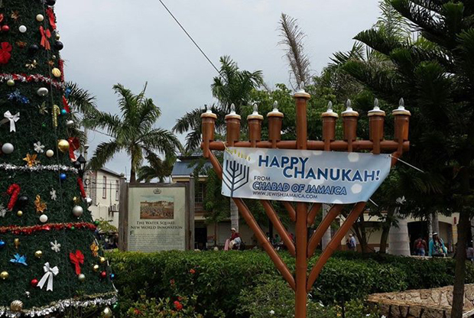
Bringing the spirit of Chanukah to the Caribbean island of Jamaica

“Chabad of Jamaica,” Rabbi Yaakov Raskin declares when he answers his phone, and I think I detect a note of bemused triumph in his voice. Yes, there’s a Chabad house in Jamaica—not exactly a place you would expect to find Orthodox Jews. It opened in July 2014 in Montego Bay, right by the main hotel strip; the latest development in Jamaica’s long, fascinating, and diverse Jewish history.
Jews have resided on the island since the time of the Spanish Inquisition—longer than almost any other community in the Americas or the Caribbean. From a peak of 2,500 in the late 1800s, there are now just 250 Jews (or thereabouts) in Jamaica, but their presence and influence in public life is certainly felt—and appreciated—by the wider population, many of whom express a strong connection to the Hebrew bible and Jewish culture.
So, how did Raskin, who is from Montreal, end up in Jamaica? Through a combination of keen scouting, and, as he told me over the phone last week, “divine providence.” In 2012, he visited the Caribbean islands with a friend and “developed a feeling for these small Jewish communities.” The following year he married Mushkee, a Brooklyn native, and together the couple began looking for a location to conduct shlichut—religious outreach directed towards Jews—which is one of the main undertakings of the Chabad movement.
In March 2014 they visited Jamaica and met with about 30 local Jewish families. It was a “very warm visit,” says Raskin, but he was finally persuaded that it was the right move when he learned that his grandfather, Leibel Raskin, had been sent to the island in 1957 by Rabbi Menachem M. Schneerson, the Lubavitcher Rebbe.
I visited Jamaica this past summer, right before the official opening of the Chabad house, and met with members of the Jewish community in the capital of Kingston, which is located on the opposite side of the island from Montego Bay. Services are held every Shabbat at Shaare Shalom, a gracious, sand-floored synagogue just outside the downtown area, and attended by a small but dedicated coterie of congregants. I wondered how the established community would respond to the arrival of the Raskins, who bring a welcoming but distinctly more Orthodox flavor of Judaism to the country.
The rabbi of Shaare Shalom, Dana Evan Kaplan —who previously led a Reform congregation in Georgia—was circumspect about the possibility of the two rabbis officially working together. Chabad and Reform Judaism, he pointed out, don’t exactly go hand-in-hand—even on a tropical island. But despite their theological differences, Rabbi Kaplan was enthusiastic about the arrival of the Raskins, who he described as “the nicest, most genuine, most sincere people. We get along very well and I have deep respect for him and her.” Over the phone last week, he told me “a little shaking up” and competition would be a good thing for the established community.
Jamaica’s Hanukkah celebrations offer a microcosm of this evolving dynamic. On Sunday afternoon, Chabad hosted “Chanukah in the Sand,” a party for the community at the Bamboo Beach Club in Ocho Rios, which is a 90 minute drive from Kingston. About 50 people attended, partaking in a meal of Jamaican jerk chicken (the hotel’s kitchen was kashered for the occasion). Kids played in the water, and an 8-foot-tall, custom-designed bamboo hanukkiah was lit.
In the crowd were Ainsley Henriques and Margaret Adam, two stalwarts of the Jamaican Jewish community who made the journey from Kingston with several others. Henriques, a jovial 76-year-old who has held various leadership roles in the community, was enthusiastic about the party, which attracted a mix of locals, tourists, and expatriate Jewish-Jamaicans (including his brother, who was visiting from abroad with 15 family members). When I asked him how he felt about the arrival of Chabad, he said, “For us it’s not a competition, they’re providing services which we don’t provide, they’re providing kosher meals for tourists… If they’re putting on a program, there’s no reason I shouldn’t attend.”
Adam, who teaches at Hillel Academy, a private school in Kingston founded by the Jewish community in 1969, was admiring of the Raskins, but careful in her choice of words and her framing of the community’s challenges.“I really do enjoy the energy of the Rabbi Raskin and Mushkee, and anything that brings more [Judaism] to the island is enriching,” she said, but at the same time, “we can’t compete with Chabad, and I do wonder about the future of our community.” Adam, who has served on Shaare Shalom’s board for the past three years, helped to organize the Hanukkah festivities in Kingston. There was a kids’ party on the first night at the home of one of the congregants, a Shabbat Hanukkah service at the synagogue on Friday (latkes, sufganiyot, and pizza were served), and a combined Carol/Hanukkah song hour at Hillel Academy on December 11, which coincided with the end of the term. (Hillel is non-denominational, but students learn about the school’s Jewish history.)
The Raskins travel regularly to various towns across the island and hold Torah classes in Kingston every two weeks. “When we go to Kingston, we try to do programs with the children there,” said Rabbi Raskin, who co-ordinates with Margaret Adam. “Our slogan is ‘Serving the Jewish tourists and locals from A-Z.’” In Jamaica, this means everything from providing kosher meals to visitors, to teaching Torah, to helping Jewish travelers in emergencies. (When a tourist died suddenly on Shabbat a few weeks ago, they assisted in repatriating his body back to New York.) “We’re here to bring light, to clarify what Judaism is to all those who would like to follow or learn without any pressure,” he told me right before Hanukkah. “We are here until the last Jew is on the island.”

Reprinted from the December 24, 2014 email of Tablet Magazine.

The Broken Bottle
By Rabbi Yitzchok Tzvi Schwarz

This story, as told by the great Yerushalmi maggid Rav Shabsi Yudelevitz, goes back many years ago. The old yishuv of Yerushalayim was suffering from hunger. They desperately needed aid from their brethren overseas. The community leaders convened to see what could be done to ease their plight. They decided to send an emissary abroad to appeal to fellow Yidden for help. It would have to be someone dignified, a man of stature capable of articulating clearly just how hard the situation was. It was decided that a certain Yid, Rav Avrohom, should make the journey on behalf of his community.

The voyage was fraught with great danger, as the ships of old were not well-equipped to handle the raging ocean waves. But Rav Avrohom, who was so dedicated to his people, was more than willing to be moser nefesh for them. After a few days of preparation, he was off with the blessings of the gedolei Yerushalayim. The journey itself passed without incident, but much to his chagrin, the ship arrived at port right before Shabbos. There he was, a lone Jew with his suitcase, having nowhere to go, no place to stay, and the holy Shabbos was soon arriving.
With a heart full of emotion, he cried out to heaven, “Ribono Shel Olam, please help me! If not for my merit, then for the merit of Your beloved children of the Holy City who are starving. For the sake of the dear people of Yerushalayim who sent me on this difficult mission and are depending on me. I don’t know where to turn for help, so my eyes turn to You, Hakadosh Boruch Hu. Please, please help me!”
Suddenly, a most elegant wagon drawn by two mighty horses pulled up right in front of him. Its door opened and a man looking obviously Jewish and wealthy stepped out. He asked Rav Avrohom about his whereabouts and quickly used this opportunity for chesed to invite him as his guest for Shabbos. He also promised to do everything in his power to make sure that the emissary from Yerushalayim would be successful in his mission.
With a heart full of gratitude to Hashem and his mouth showering blessings on his savior, he climbed into the wagon. It wasn’t long before he found himself in a palatial residence. The furnishings were ornate, the designs on the walls and ceilings exquisite. Rav Avrohom, who had never before left the city of Yerushalayim, was never exposed to such opulence before. Strangely enough, one area of the house, centrally located, gave the impression that the designers of the house had totally neglected it. Perhaps more accurately, it looked like it was transplanted from a dilapidated house belonging to paupers, so far removed from the lifestyle of this family.
There was a beautiful table in that forsaken area. On top of it was an old broken glass bottle, with jagged edges. It was dusty and filthy, and, with old age, had turned green. What in the world was this strange object doing sitting prominently in a house filled with such luxury? Today, we might call it “modern art,” but that wasn’t existent in those days. Rav Avrohom wondered about this strange artifact, but he was hesitant to ask about it at the seudah with so many guests there.
It was a beautiful seudah, with savory delicacies, zemiros and divrei Torah. The table was adorned with gold and silver dishes and sparkling silverware. During the seudah, the host could not help but notice Rav Avrohom eying the table with the broken bottle on the other side of the dining room. He thought that his curiosity about the broken vessel was distracting him from the marvelous seudah, so he decided to explain to his guest what it was all about.
“Listen, my friend, I see that you are wondering about the broken bottle and cannot understand what it is doing in this house at all, let alone in such a prominent place. I want you to know that it serves a very important purpose. I put it there to constantly remind me of something that I never want to forget, a story that changed my entire life.” Now the curiosity of the guest was really piqued. The host continued and addressed all of his guests.
“My friends, at this moment, you see me sitting at the top of the world, surrounded by wealth, owning an estate worth millions. But it wasn’t always like this. My life in this country started with meager earnings. I was sent here as a young lad by my father to help out my aging grandfather, who was trying to maintain his small family business. My family lived in Amsterdam, Holland, and I was sent here to Rome away from my parents, my siblings, and my friends. It was so lonely here for me, so difficult, but I had to listen to my father’s request and my grandfather needed me.”
At first, running the business was difficult. My grandfather, who was aging and becoming weaker, couldn’t keep it going properly. As I got involved, I learned about running the enterprise. Pretty soon, it began to flourish. After about a year, the business had expanded and I was totally in charge. A few years later, grandfather passed away, a wealthy man, with the satisfaction of knowing that his grandson would own his business.
“After his death, everything continued as usual - everything regarding the business that is. My own personal life changed drastically. As long as my grandfather was alive, I remained a religious Jew. Despite the hard work of running a business, I davened three tefillos a day in shul, learned some Torah, and kept all the mitzvos. After my grandfather’s passing, I started to slacken off in my observance of Torah. It began with missing Minchah with a minyan. I reasoned that it’s not so bad, because running a business by myself is difficult and missing tefillah was an oneis. But then it morphed into missing a Shacharis and a Maariv and finally, with the passing of time, not davening at all during the week and on Shabbos.
“Yes, I felt I had an excuse for all of this and was oblivious to the fact that this was all the work of the yeitzer hara, who little by little was tearing apart my Yiddishkeit. It didn’t take very long for the mitzvos of tefillin, Shabbos and kashrus to fall by the wayside. In the beginning, my conscience bothered me, but eventually I didn’t even give it a thought. The business became my religion and the wealth allowed me to enjoy life in a way that I had never enjoyed it before.
“My grandfather looking down at me from the Olam Ha’emes undoubtedly didn’t get much nachas from my way of life. That’s putting it mildly. He was most definitely terribly agitated. He had many merits, and I believe that he went before the Bais Din Shel Maalah to plead for me to be given an opportunity to turn my life around and to return to Yiddishkeit.
“I was already married to a Jewish woman whose attachment to Yiddishkeit was about the same as mine. We had two children together and were living a life of splendor, but we were spiritually bankrupt. My children went to a secular school together with goyim. They knew that they were Jews, but nothing at all about Yiddishkeit. We all would have continued on this route…but then it happened. An incident that revolutionized our lives occurred.
“One day, I was walking in the street and I saw a little boy crying bitterly. In his hand, he held a broken glass bottle. Jews, by nature, are compassionate, so I stopped to see what was bothering the child. He was inconsolable. It took me a while to get him to stop crying and to tell me what troubled him so. Finally, he was able to talk amidst sobs.
“‘Tonight is a Jewish holiday,’ he said. ‘It’s Chanukah, when we light candles and relive a great miracle that took place with our people a long time ago. My parents are very poor and cannot afford to buy oil for lighting. For a long time now, my father put away penny after penny that he saved for this occasion. Finally, we had enough for a bottle of oil. My father gave me the coins to buy the oil and instructed me to be careful with the bottle and not to let it drop.
“‘I felt so important carrying out this sacred mission. Off I went to the store and proudly paid for the precious commodity. Now all I had to do was bring it home. I held on tightly to the bottle, envisioning the happiness on my father’s face when I brought him this cherished oil. I could already see the simcha in my mother’s eyes and in the eyes of my siblings as we lit the menorah, with the beautiful little flames rising upwards towards the heavens. But then, engrossed in my thoughts, I didn’t notice a little stone in my way. Suddenly, I stumbled and found myself flat on the ground, my precious bottle broken and the oil all over my clothing.
“‘Since then, I have been here crying. I can’t return home. How can I face my father? What can I answer when he asks me why I didn’t follow his instructions? How can I see the sad look on my father’s face when I return empty-handed?’ And then the boy broke out again in sobs.
“When I heard the heartfelt words of the child, feelings that were in my heart years before when I was first leaving the straight path suddenly emerged. I am a Jew just like that child, I thought. Look at where he is and look at where I am. Look at what troubles him as compared to the trivialities on my mind. He is crying bitterly because his father doesn’t have the means to light the Chanukah candles, while I have the wherewithal to easily fulfill all of the mitzvos and I threw them all away. At that moment, I decided to rethink my ways, objectively examine my conduct, and come to the desired conclusions.
“Quickly, I pulled out a hundred dollar bill and gave it to the child. His eyes lit up with a special radiance, a glow that I vaguely remembered from my youth, one that is reserved for those whose souls are enveloped with spirituality. The boy thanked me with heartfelt words and quickly set out for the market to buy more oil. I went back home, taking with me the broken bottle as a memory of this encounter.
“Perhaps this incident alone wasn’t enough to bring me to action. Yes, I had thoughts of doing teshuvah, but I didn’t act immediately to better my ways. A couple of days later, I received another message from heaven. I happened to see a sign posted near my home inviting the Jewish public to attend a drashah to be given by a famous maggid visiting from Yerushalayim. What did I have to lose by going? So I went and listened attentively.
“It was the week of Parshas Vayigash and the drashah centered around the story of Yehudah beseeching Yosef to allow Binyomin to go back home with the brothers to the land of Canaan. Yehudah pleaded with Yosef with great emotion, ‘For how can I go up to my father if the youth is not with me, lest I see the evil that will befall my father’ (44:34).
“The maggid proclaimed these words in a loud voice and said, ‘My dear brothers, precious Yidden, let us say these words to ourselves and contemplate, ‘How will we return to our Father in heaven with the youth no longer with us? We were given a pure, pristine neshamah, young and full of potential, and what did we do with it? We have sullied it with our aveiros. We have stained it. It is filthy with sin. What are we going to answer to the Ribono Shel Olam, who has sent us down to earth on a mission that we have failed? This is a question we must always ask ourselves: ‘How will we go back up to our Father?’
“The entire tzibbur started crying. At that moment, I became a complete baal teshuvah. I swore to immediately change my ways and to bring my family back to the ways of Torah. Boruch Hashem, my wife supported me in going on this new path and today my family is totally steeped in the ways of the Torah. As a commemoration of this miracle of my return, I kept the broken bottle and put it in a prominent place in my home. Whenever I face hardships and nisyonos, whenever the yeitzer hara tempts me to do something contrary to the Will of Hashem, that bottle reminds me, ‘How can I go up to my father…’?”

Reprinted from last week’s email of the Yated Ne’eman.

A Slice of Life

The Power of a
Chanuka Stamp
By Rabbi Mordechai Hecht

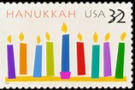

It was Chanuka 2007, my first year as an emissary of the Lubavitcher Rebbe in my home town of Forest Hills, New York. As I stood in line in the local post office waiting to buy some stamps, I noticed a woman at the counter was quite upset after learning that there were no more Christmas stamps. "What do you have then?" she asked, "We have first class and Chanuka ones," the clerk replied. "I don't want Chanuka stamps!" she responded. Immediately, the man in front of me shouted out "I'll take the Chanuka stamps, give me a whole bunch of them!"
Matt was a proud Jew! In public he did not care to proclaim his Judaism and his Jewish pride. And so I introduced myself, "My name is Mordechai from Chabad, nice to meet you." He replied emphatically, "I put on Tefilin every Friday with those guys on 108th Street and I put a few dollars in the pushkie" - referring to the charity box - "all the time."
Matt had had some downs in his life; through a difficult divorce and loss of his business. But my impression of Matt was that he was optimistic for the future. We would talk from time to time about life, business, the neighborhood and more. Matt often joined us for Friday night dinners in our Chabad Home and he enjoyed them very much.
One day Matt called and said, "The most frightening thing in my life happened to me." He told me that his next door neighbor, an elderly lady who he would check on quite often, was very ill. The other day she told Matt that she was not feeling well and he immediately called an ambulance. Before the ambulance arrived, she passed away right next to him in his hands. He said, "Rabbi, it was so scary. I feel so bad for her, and I don't know what to do, and I didn't know who to call, so I called you."

Encouraging Matt to Put Mezuzas Up in His House
Wow! After a few minutes of conversation I said, "Matt, I was always taught that the Mezuza serves as a protection not just for the home but for the well being of the people in it. Perhaps you might consider getting Mezuzas in your home to serve as protection and a little peace of mind."
"Rabbi," he began, "I know there are Mezuzas on our door but they are probably not kosher. Go ahead and get me two new Mezuzas - one for my door and one for the main door." When Matt came over the next day I explained to him how to put up the Mezuzas, and he gladly listened, leaving our Chabad Home on a mission.
A few weeks later Matt called. "Rabbi, you're not going to believe it. For years my mom was practically deaf in one ear and she suddenly started to get her hearing back! The doctors were astonished; they said that they had no medical explanation for it. Rabbi, I have no doubt that my mom got her hearing back because of the Mezuza. Thank you so much for what you've done."

Getting Another Mezuza for His Mom’s Bedroom
"Not me, G-d!" I said. "But I am so glad that you told me this."
A little later Matt called back. "My mom asked if you could get her a Mezuza for her bedroom."
From Chanuka stamps to Tefilin and charity, to Mezuzas and honoring his mother, Matt was a true and concerned Jew who not only believed, but also practiced what he believed. He was a man with a big heart and an open mind.
A few weeks later, which happened to be almost a year after Matt and I first met, he called. "Rabbi, we need to talk." After asking what the matter was, all he could say was that we had to talk. When I told him I would come over, he said not to bother. A couple of days later, his sister called, "Matt is in a coma." Over the next few weeks, we visited Matt to pray at his bedside and performed acts of kindness in his merit. After being hospitalized for only a few weeks, Matt passed away from pneumonia. My wife and I were shocked; we had only just started to get to know Matt. It was clear G-d had other plans for him.

Everyone at the Funeral was Impressed by Matt’s Story
At the funeral, it seemed as though the entire Italian mob was present. I soon learned that these guys were Matt's friends. I shared with them the story you have just read, and everyone was very moved. People were shocked to hear a side of Matt they had never known, including his mother and sister.
After the funeral, I started to get calls from family members wishing to make donations in Matt's memory, and I had an epiphany. Matt's story was all about good deeds, but the Mezuza was at the epicenter of it all. I suggested to a family member that we make a fund for Matt - A Mezuza fund - and that perhaps the family could put together $1,800 to create it in his memory.
The relative explained that such an amount would be a stretch, but she would get her family on board in contributing. Over the next few days, a few checks came in totaling $500. That was very nice, but it was not the $1,800 I had "epiphanied."

A Generous Check from Matt’s Sister
Two weeks later, our doorbell rang. When I got to the door no one was there, but I saw an envelope in the mailbox. At first I noticed the address was wrong, and it had been reposted three times. Being that it was a Sunday, I knew the mailman hadn't dropped it off. I opened the envelope and was shocked and elated to find an $1,800 check made out to Chabad of the Gardens, Forest Hills from Matt's sister.
I picked up the phone to tell her how glad I was that we would be able to perpetuate Matt's memory in such a special way. When I began to thank her for the money for the fund, she asked, "Which fund?" I said, "The Matt Colwes Mezuza Fund that we spoke about!" Confused, she replied that she did not know what I was talking about. I told her that I had discussed the fund with her cousin. She explained that she had not heard about the fund: "I just knew that Matt was enthusiastic about you and Chabad and I wanted to contribute and say 'thank you.' "
The previous night, my wife and I had had a serious conversation about the general direction of our work. I had pitched the idea of the Matt Colwes Mezuza Fund explaining how the Mezuza is not only such an easy mitzva, it is also such a great way to meet people and one of the Mitzva Campaigns of the Rebbe, so why not start there? And now we had the resources to establish the Fund and it had arrived at just the right moment!
The Matt Colwes Mezuza Fund is now the Matt Colwes Mezuza and Tefilin Fund and is stronger than ever. The fund has provided hundreds of Mezuzas and Tefilin to dozens of people in our neighborhood and to others throughout the New York area.
All of this because of the Chanuka Stamp - a piece of paper worth less that 40 cents at the time and less than a square inch in diameter!

This article was reprinted from the recent Parshas Miketz 5774 edition of “L’Chaim,” a publication of the Lubavitch Youth Organization. This article is dedicated to Moshe Duvid Ben Devorah (Matt) obm.

The Secret Brit Milah
In Turkey
By Tzvi Ben Gedalyahu

(Israelnationalnews.com) Antakya, Turkey was home to about 50 Jews – until last week when a father overcame his fears of anti-Semitism and allowed a secret circumcision on Chanukah of his 30-day-old baby boy, the city's newest Jew.
Antakya is a Mediterranean coastal city located near Syria. The father, whose identity cannot be revealed, is a “secret” Jew but was afraid his neighbors would discover his religion if he allowed his new-born baby boy to be circumcised, in one of the most ancient and sacred Jewish commandments that is a symbol of the covenant between G-d and the Jewish people.

A Mitzvah for the Eighth Day
Jewish law states that the circumcision – “brit mila” in Hebrew – should take place on the eighth day of a boy's life unless there are medical reasons for delaying the procedure. Circumcisions are performed on older males who convert and on those whose Jewish parents did not observe the Jewish law. The baby in Antalya was 30-days old when he was circumcised.
The story of the secret Turkish Jew and his newborn son was not even known to the local Chabad rabbi but was related to Rabbi Aharon Kramer, head of the “Covenant of the Fathers’ group that works to make sure Jewish males are circumcised, even if they are adults.

The Fear of the Father to Light a Chanukah Menorah
One of the father’s relatives is Rabbi Shmuel Siman Tov, who turned to Rabbi Kramer. He told Arutz 7 that the father did not want him to fly to Turkey and perform the circumcision before the end of Chanukah, apparently afraid that the rabbi would light the Chanukah menorah, a sign that Jews live in the house.
Rabbi Kramer said he explained to the family that the circumcision must be done during the daytime, despite the father’s fears that neighbors might peek through the windows and discover he is Jewish.
The father agreed to Rabbi Kramer's flying to Antalya, where he also met the local Chabad rabbi, who now was privy to the secret. The father took us to his house, Rabbi Kramer related. “I asked him if there were any other Jews in the area, and he used the Internet to find one more Jew, who arrived at the house."
The father closed the curtains, and Rabbi Kramer performed the circumcision at his house, without a "minyan," the necessary quorum of 10 Jews over the age of Bar Mitzvah. The name of the new Jew was not revealed for publication.

A Rare Feeling of Sanctifying the Creator
“There was a rare feeling of sanctifying the Creator,” Rabbi Kramer said. “In the middle of the circumcision, a neighbor knocked on the door. The father took off his kippa and went to the door, went outside to talk to him and them came back and put his kippa back on his head.”
The father not only arranged for the circumcision of his son but also lit the candles for the seventh night of Chanukah for the first time in his life. The occasion was so special that he recited a special blessing that is recited only on the first night.
Despite the father’s fears, apparently an outgrowth of his resistance to letting anyone know he is Jewish, Rabbi Kramer said that he himself freely strolled the streets of Antalya with his long beard and forelocks without detecting any anti-Semitism.

Reprinted from the December 15th email of Arutz Sheva’s News Report on Events in Eretz Yisroel.
Brooklyn torah gazette
For parshas vayigash 5778
Volume 2, Issue 16 (Whole Number 59) 5 Teveth 5778/ December 23, 2017
Printed L’illuy nishmas Nechama bas R’ Noach, a”h

For a free subscription, please forward your request to keren18@juno.com

The Chabad House Across From Hitler’s House
By Menachem Posner

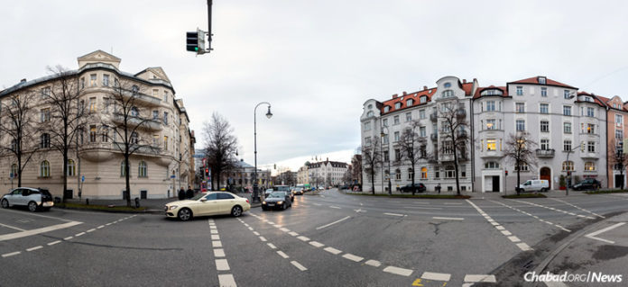The Chabad center in Munich, Germany, sits directly across the street from the nine-room luxury apartment at Prinzregentenplatz 16, left, which became home to Adolf Hitler in 1929.

The Chabad center in Munich, Germany, seems like thousands of others in 100 countries and territories around the globe. Located in the center of town, it is the site of busy Jewish activity—prayers, holiday celebrations, Torah classes—from morning until evening.
What sets it apart is that it sits directly across the street from the nine-room luxury apartment at Prinzregentenplatz 16, which became home to Adolf Hitler in 1929. It was there that he conducted high-level negotiations prior to the start of World War II with such leaders as Prime Minister of the United Kingdom Neville Chamberlain, Italian Prime Minister and leader of the National Fascist Party Benito Mussolini, and others.

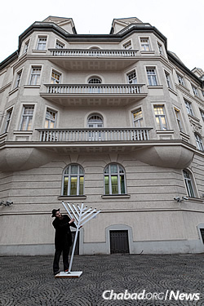
Rabbi Yochanan Gordon sets up an oversized outdoor menorah for Chanukah. (Photo: Mitya Kolomiyets)

Following Germany’s defeat and Hitler’s death, the building was eventually occupied by the Munich Financing Office for the state of Bavaria. The second floor (third floor in American convention), including Hitler’s apartment, now houses the headquarters of the regional police of Munich and is not open to the public.
“We always knew about the history of that building,” says Robert Rajber, who grew up in Munich in the 1960s and is now president of the city’s Maccabi sports club. “But we made nothing of it. Every other building in this city has a dark Holocaust history, and if you cannot live with that, you cannot live in Munich.”

Rajber, whose parents were Polish-born Holocaust survivors, says “in those days, Judaism kept a low profile in city. The synagogue was in the backyard; there were no signs. If you were not Jewish, you could almost not know that there was Jewish life here.”
He says all that changed when Rabbi Yisroel and Chana Diskin came to establish Chabad Lubawitsch Munich in 1988. They had arrived after decades of dedicated work by Rabbi Avrohom Yitzchak Glick of London, a roving Chabad emissary, who initiated a Chabad presence in many European nations.
“The Diskins taught us to celebrate our Judaism—to be proud and positive about our identity, not to shy away from it or pretend it does not exist,” says Rajber. “Before they came, I wondered what they could possibly add to our community, but they have really changed everything here for the better.”
Chabad moved in across the way from Hitler’s penthouse apartment in 1993. Also located on the second floor, the Chabad center’s presence is clearly marked by a sign next to the street-level entrance and does not hide that it houses Jewish activity.

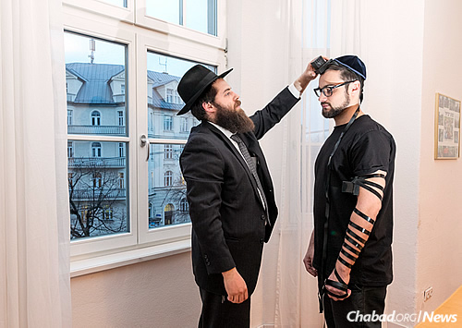
Gordon wraps tefillin with photographer Mitya Kolomiyets. In the background is the building in which Hitler once lived.

In the years since, it has become a magnet for the city’s Jewish residents and tourists. The youngest Jewish Münchner comes with their parents for children’s programs, youth minyan and bar and bat mitzvah preparation, while the older set is attracted to lectures, holiday meals and other events that take place regularly.

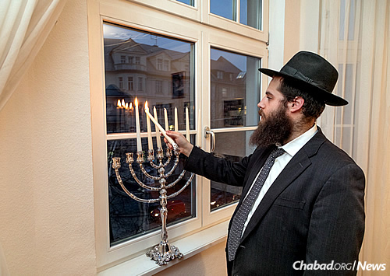
Lighting candles for the eight-day holiday of Chanukah. (Photo: Mitya Kolomiyets)

At the time the Diskins arrived, the Jewish community was estimated at about 3,000 people. With the fall of the Iron Curtain in neighboring Russia to the east, that number swelled to 10,000. In addition, many thousands of Israelis living there who have not officially joined the community participate regularly in Chabad activities.
In 2010, the Diskins’ activities expanded to the point that they were joined by their grown daughter, Chaya Mushka, and her husband, Rabbi Yochanan Gordon, who focus on children’s activities and advanced programs geared for people who have embraced Jewish observance. In 2015, their team grew again when their daughter Malky and her husband, Rabbi Levi Freedman, opened a division focusing specifically on teens and students.
“For the most part, we’re all oblivious to the fact that the building across the way has such a dark past,” says the British-born Gordon. “That is our ultimate triumph. Hitler schemed to snuff out Judaism in every part of the world. And here we are across the street from his home, thriving and growing, barely conscious of the fact that he once lived so close by.”
He reports that in his years at the center, they have never experienced any fallout from neo-Nazis, white supremacists or other groups with racist undertones who may be attracted to the former residence of history’s most diabolical statesman. On the contrary, he says that the only time he even thinks of Hitler’s apartment is when he shows it to visitors as a demonstration of Judaism’s triumph in Germany.

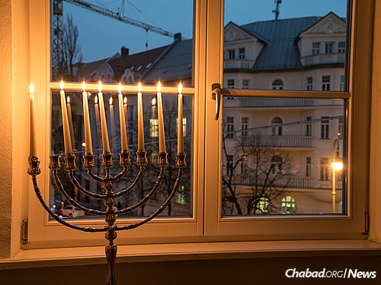
Chabad moved in across the way from Hitler’s penthouse apartment in 1993. In the years since, it has become a magnet for Jewish residents and tourists. (Photo: Mitya Kolomiyets)

“From Chabad, we learned to be proud of our Judaism and to live it up,” attests Rajber. “It feels good to have our Chabad House there.”

Reprinted from the December 18, 2017 website of Yeshiva World News courtesy of Chabad.Org News.
Milkman Who Showed
A Lot of Bottle
By Marcus Dysch

A milkman who helped to save the life of a Jewish pensioner who collapsed in a hedge has received an award.
George Debesay was on his delivery round in north-west London last winter when he spotted an object in the darkness. Stopping his float to investigate, he found an unconscious elderly man.
Mr Debesay immediately rang volunteers from the Shomrim community security group for assistance. Doctors said his actions had saved the pensioner’s life.
The Eritrea-born milkman, who works for the kosher Charedi Dairies company, regularly assists Shomrim by looking out for suspicious activity while on his early-morning rounds.

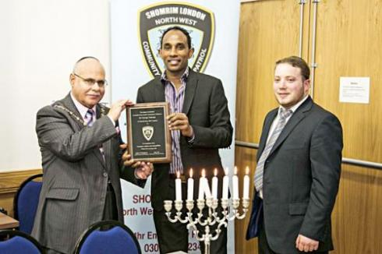
George Debesay with Barnet Mayor Melvin Cohen
and Shomrim's Gavriel Ost

Mr Debesay immediately rang volunteers from the Shomrim community security group for assistance. Doctors said his actions had saved the pensioner’s life.
The Eritrea-born milkman, who works for the kosher Charedi Dairies company, regularly assists Shomrim by looking out for suspicious activity while on his early-morning rounds.
He was presented with the organisation’s first Exemplary Citizen Award at its Chanucah party in Golders Green on Tuesday evening. Charedi Dairies director Eli Stern said: “George is a helping hand for the Shomrim, a good neighbourhood watch man.”
Around 50 people attended the celebration, including police chaplain Rabbi Alan Plancey and Barnet’s deputy borough commander, Superintendent Mark Strugnell.

Reprinted from the December 9, 2013 website of the Jewish Chronicle Online (London, U.K.)

Brooklyn torah gazette
Parshas Mikeitz 5777
Volume 1, Issue 5 (Whole Number 5) 9 Teveth 5777/ January 7, 2017
Printed L’illuy nishmas Nechama bas R’ Noach, a”h

For a free subscription, please forward your request to keren18@juno.com

Lighting Menorah in Sydney, Australian Prime Minister Pledges His Support
Malcolm Turnbull praises Israel and the Jewish people
By Chabad.org Staff
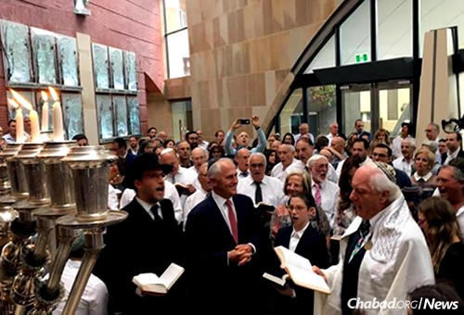
Australian Prime Minister Malcolm Turnbull took part in a Dec. 30 Chanukah menorah-lighting ceremony at Central Synagogue in Sydney. He also condemned the recent U.N. Security Council resolution against Israel. (Photo: The Australian Jewish News)
Australian Prime Minister Malcolm Turnbull helped light the menorah on Friday afternoon at Central Synagogue in Sydney on the seventh day of Chanukah. Chabad-Lubavitch emissary Rabbi Levi Wolff, rabbi of the congregation, and others watched as Turnbull in lit the shamash (“helper” or “attendant”) candle on the menorah so that the others, in turn, could be ignited.
“As the candles of the Chanukah are lit each night, we are reminded of the enduring resilience and courage of the Jewish people in the face of the darkest adversity,” said Turnbull. “Australia would not be the remarkable nation it is—the most successful multicultural society in the world—without the extraordinary contribution of the Jewish community.”
Wolff reported that the visit was prompted after he received a phone call from the prime minister earlier in the day. “He related that our Jewish community was in his thoughts during this turbulent week for Israel and the Jewish people,” said the rabbi.
At the event, Turnbull criticized the recent U.N. Security Council resolution against Israel, calling it “one-sided” and “deeply unsettling.”
Stating that a solution “can only be negotiated between the parties,” he added that “it is not assisted by one-sided resolutions made at the councils of the United Nations or anywhere else.”
“Above all,” he concluded, “we stand shoulder to shoulder with Israel in the fight against terrorists.”
Trumbull then danced with the congregation during the Chanukah celebration, which took place before the onset of Shabbat.

Reprinted from the January 1, 2017 news release of Chabad.Org

